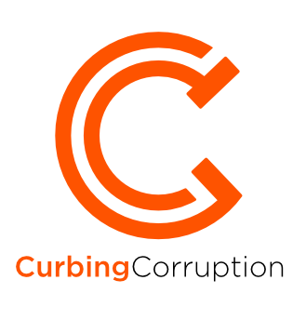

Sector | Construction, Public Works & Infrastructure

INTRODUCTION
The value of this sector is huge, with roughly half of all fixed capital investment by governments being in the construction of public infrastructure. The volume is increasing every year and is expected to reach $17.5 trillion per annum by 2030. The value of losses through corruption is estimated at between 10 and 30% of this total, and others believe that a similar amount could be lost through mismanagement and inefficiency. (Wells 2015, Matthews 2016). This means that by 2030, unless measures are introduced that effectively improve this situation, close to $6 trillion could be being lost annually through corruption, mismanagement and inefficiency. Losses on this scale cannot be tolerated in any sector, but losses in infrastructure investment have particular significance, because infrastructure underpins almost every aspect of economic growth and human development. ‘Engineering and construction’ is the sector with the most reported bribery and corruption in advanced economies – see below.
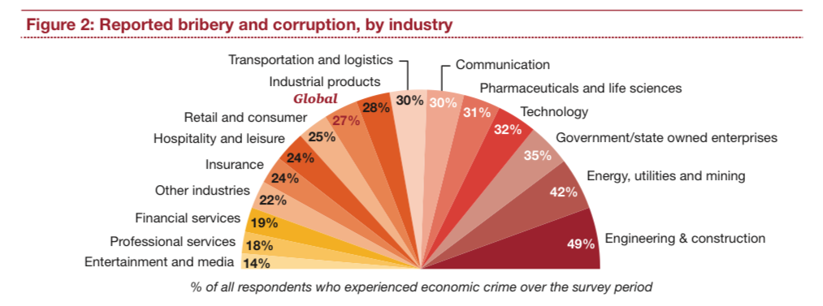
The corruption in construction is as evident in advanced economies as in developing countries. Whether it be sub-standard cement used in construction of department stores in Korea or in housing projects in New York City, the examples are as regular as in poorer countries. It is also systemic rather than occasional. For example, in the UK, 49% of a sample of 701 UK construction professionals believe that corruption is common throughout the British construction industry (CIOB 2013). And 49% of executives from international engineering and construction companies report significant corruption in their industry in 2014, more than in any other industry sector (Price Waterhouse Coopers (2014) Fighting corruption and bribery in the construction industry).
Two levels of anti-corruption action: Ministry-level and Project-level
Construction, Public Works and infrastructure is a complicated subject in government. It can be the responsibility of a Ministry in its own right, such as the Ministry of Public Works or Urban Development, or a Ministry dealing with Public-Private partnerships. It can be a major part of other ministries, such as within the Ministries of Transport or Energy. Alternatively, large projects might be separated out from government as Public-Private Partnerships or placed under the supervision of a national Major Projects Agency. In developing countries, major donors may bear part of the responsibility.
There are many corruption issues arising at this ‘Ministry-level’. At the same time, individual projects can be enormous, sometimes larger than a whole country’s GDP, with immense complexities. There is thus another block of corruption issues at this ‘Project level’.

1. Ministry-level corruption & reforms

Guidance summary
STEP 1 is to make a list of the specific corruption types that you are faced with and then analyse the scale and context of each one. We suggest that you do that in the following way:
- First, look at the template of sector corruption types in our review, and adjust these according to your situation.
- Then gather available data. We suggest that you do this first at a macro level, to get a sense of which corruption issues are big or small across the sector, across countries, across different regions. Often there is a lot of such macro data publicly available. Then, gather available data at the micro level, local to you.
- Then decide if you need to do a formal analysis of the corruption types and the levels of corruption risk. This may take time, but it gives you a more thorough baseline for your reforms. It also serves as a way to show the level of danger and damage from corruption to staff and to the public.
- Finally, it will help you to do an analysis of the levels of support and opposition that you can expect. This is called a ‘political economy analysis’.

Ministry-level overview
At the policy-making and regulation level, there is great scope for constraining the corruption that can arise from uncontrolled projects and developments. The scope is greater than during later phases, such as at the tendering, construction or payment stages. The table below showing an overview of perceived corruption risks along the construction value chain illustrates this point (Goldie Scott (2012):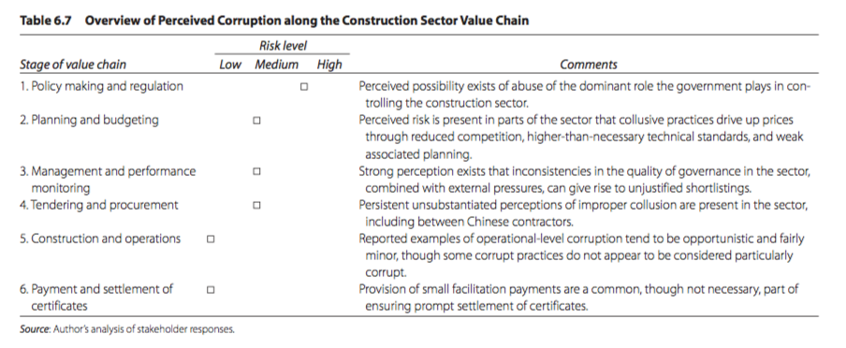
Similarly, a 2016 analysis by the Hertie School of Governance in Germany concludes that the way in which infrastructure policy is governed has more impact in reducing corruption than ‘traditional’ measures such as tight regulation. They identify four key reasons for poor infrastructure performance – Analytical capacity, Delivery, Regulation and Coordination. They point most of all to insufficient coordination across government as the major reason for both poor efficiency and corruption.

1.1 MINISTRY-LEVEL CORRUPTION PREVENTION
At the high level of decision making that is associated with policy on major public works and infrastructure projects, the corruption type itself is rather simple – it is collusion, favouritism and illicit influence in the decision making. The variation is not so much in the corruption type as in the different ways that the opportunity for corruption arise and are constrained and controlled, or not. Besides capture of the decision-making process by elites, other factors allowing illicit influence to remain unchecked or unobserved include poor coordination across the many bodies involved, endless complexity and biased intermediate-level decision making.

1.2 GOVERNMENT COMMITMENT TO OPEN CONTRACTING
Many governments are moving to adopt ‘Open Government’ standards in respect of public procurement, and particularly in respect of construction. One major aspect of this is ‘Open Contracting’ where the government commits to much greater transparency in respect of all aspects of public infrastructure contracting. These organisations are discussed in Section 4 Transnational initiatives.
Improved public procurement, including for construction, has seen huge advances in anti-corruption and transparency in the last ten years, from electronic procurement in multiple countries (See herefor one of many such initiatives in Korea) across to radical reform in conflict countries (See here for Afghanistan’s National Procurement Authority example, which includes re-review of numerous construction tenders). The Open Contracting Partnershipalso has numerous examples.

1.3 CLARITY OF MINISTRY ORGANISATION STRUCTURE & PROCESS
In some countries, a significant part of the construction and public works corruption problems lie with Ministry officials, both low level ones and at the most senior levels. Ministries can easily become corrupted in whole or in part, or, at the least, tolerant of dubious behaviour. In countries with high and endemic levels of corruption, this problem may reach the point where the Ministry is ‘captured’ by corrupt interests.
If the problem is deep rooted, changing the mandate and structure of the Ministry and its related agencies might be necessary. Two current examples are from Afghanistan, a country that is recognised as deeply corrupt, but at the same time is making huge efforts against corruption.
Example: Afghanistan and the National Procurement Council
Afghanistan has had chronic corruption problems with its public procurement system. Through this system passed all the major public works and construction contracts, and this was well recognised as the epicentre of large scale elite corruption. After a brief review of alternatives in 2016, the Afghan government decided on a radical reform based on a single regulatory body and a centralized procurement system. At the apex of this system is the National Procurement Commission (NPC). The NPC is chaired by the President of Afghanistan, with membership of the Chief Executive Officer, the Second Vice President, and the Ministers of Finance, Justice and Economy, together with the President’s Senior Advisor on Infrastructure Affairs. Also in attendance as observers are civil society, SIGAR (the US watchdog on US spending in Afghanistan), and NATO’s Resolute Support Mission. Under the NPC is the National Procurement Authority (NPA), located within the Administrative Office of the President. The NPA is the “engine” of the procurement system; its team (currently around 280 staffers) links with the Procurement Departments in every Ministry, which are responsible for the administering the tender process.

1.4 TRANSPARENCY OF DECISION-MAKING AT SENIOR LEVELS
Confidence is built from knowing that it is possible for the senior decision-making process and results to be scrutinised by others. One such example was given above, where the President plus relevant Ministers, plus outside stakeholders all participate in real time in the decision-making on each of the large procurements. They all have opportunities to ask questions.

1.5 A FORMAL INTEGRITY FRAMEWORK
Integrity approaches are a known part of the ways to constrain corruption – by improving the behaviour of staff rather than by compliance. In most national anti-corruption strategies, efforts to build integrity across the public sector are part of the mix of measures.
In respect of public works and infrastructure, OECD have been putting effort into elaborating this approach. The OECD 2016 report Integrity framework for public infrastructure is a contribution to developing policy and regulatory guidance for controlling integrity and corruption in construction. The table opposite is taken from that report. It shows possible policy responses both to promote integrity and to constrain corruption opportunities.

1.6 CLARITY OF DELIVERY STRUCTURE MODALITY
OECD gives guidance in their integrity framework report on the relative benefits different sorts of delivery structures for major government infrastructure projects.
Decisions on how to deliver infrastructure projects involve a close assessment and careful balancing between risk allocation and value for money. the choice of a delivery modality is often criticised for being based on habit rather than on project and market characteristics. Some 15 OECD countries responding to the survey (54%) do not have a specific entity in charge of developing policies for infrastructure projects, including choosing delivery modes. this could hinder the application of a consistent methodology in choosing delivery modes for infrastructure projects. Some 13 OECD countries (46%) have a dedicated entity (or entities) for developing policies for infrastructure projects. these entities are mostly dedicated units in central government. Greece has put in place a dedicated sectoral unit. In Denmark, the central purchasing body is in charge of developing policies for infrastructure projects.’
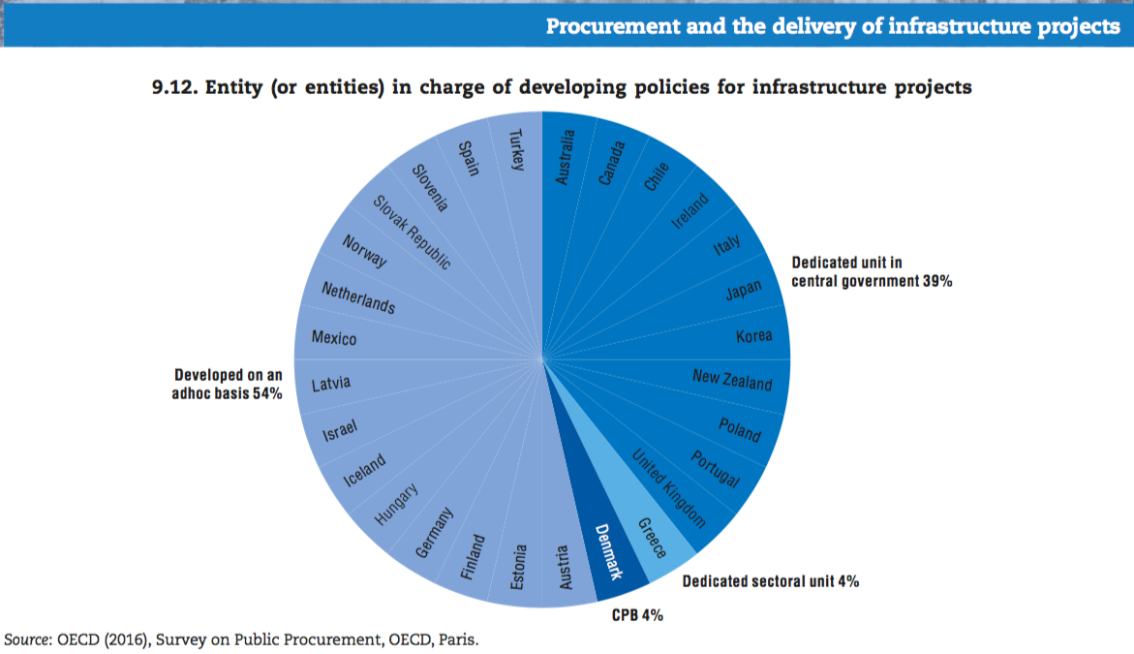
Example: Australia. The 2016 analysis by the Hertie School of Governance in Germany quotes the positive experience of Australia, who set up ‘Infrastructure Australia’ as a cross government agency to better coordinate government infrastructure planning (p46).

1.7 ANALYSIS OF REGULATORY IMPACT
The World Economic Forum has many good observations about how nations can strengthen themselves by way of policy measures in the infrastructure sector. Opposite, in an example from Mexico, is a policy-maker’s approach to different ways of controlling corruption in permits and licenses (WEF, 2017).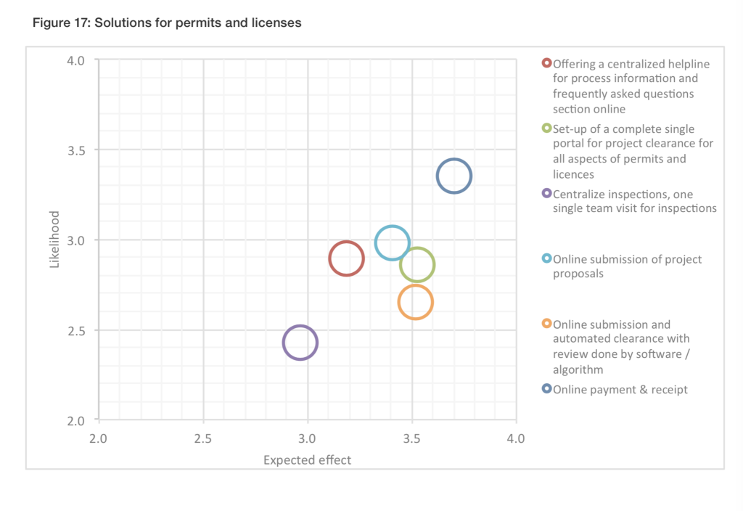

1.8 CONSTRUCTION INDUSTRY ENGAGEMENT
There is much to be learnt from talking to the executives of the large construction and infrastructure companies. The Price Waterhouse Coopers 2014 report finds that 70% of all corruption related to their projects is caused by insiders within their companies; most of them senior management.
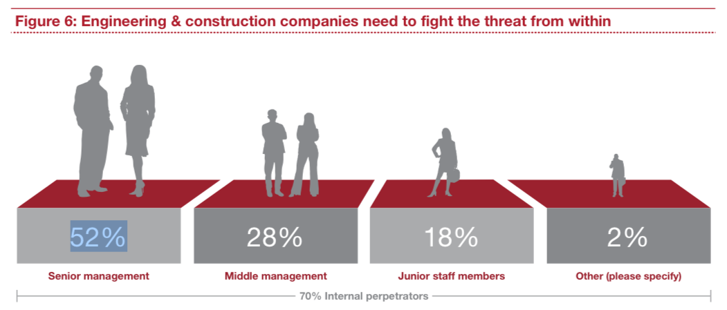
In cases where companies have been exposed in large corruption scandals, one of the industry responses, in mitigation, is to establish an advisory council of worthy people to advise the company on how to behave better in future. Two recent examples are from Airbus in Europe and Odebrecht in Brazil. There is no known evidence, however, on whether such councils are effective or perform merely as a whitewash.

1.9 ATTENTION TO PUBLIC-PRIVATE PARTNERSHIPS
Public-Private Partnerships (PPP) are a major feature of infrastructure projects, and likely to get larger still in view of the current gap in infrastructure investment. The World Bank has a whole toolkit on PPPs, giving detailed guidance on how to do them well and effectively. COST is also involved, having just started a project on PPPs in Honduras, in cooperation with the World Bank. This extends to multiple subsidiary tools, for example:
- Assistance on laws and regulations via the PPP Infrastructure resource centre (PPPIRC)
- An International Infrastructure Support System (IISS) that is being developed by the Sustainable Infrastructure Foundation in association with a number of multilateral development banks. The IISS is an online project preparation platform that provides resources to improve project preparation and encourage collaboration between investors and government. It will be accessible to investors and the public and is intended to provide a high-quality, consistent and systematic approach to early-stage project development.

1.10 INTERNATIONAL AID-FUNDED PROJECTS
One of the biggest funders of infrastructure projects in the developing countries are the Development Agencies. They have long had an interest in how to develop such projects to minimise corruption: one such example,How to reduce corruption in infrastructure sectors, written for the UK Development Agency DFID (Hawkins, 2013). Other Aid agencies also have extensive knowledge of corruption issues in public works and construction, such as USAID.

There is also a lot of knowledge on how and why construction projects went wrong. The diagram below, for example, shows an analysis of time and cost overruns for seven developing countries plus the UK. This shows the average time and cost overruns on a sample of 145 public sector construction projects in eight countries (Construction Sector Transparency Briefing Note 5 from COST).

1.11 OTHER REFORM APPROACHES
There are other approaches that you can take to shape the construction and public works environment. The actual reform measure in each case will be specific to your local context. You can read about different reform approaches that you can take and see how/whether they apply in your environment here.
2. Project level corruption & reforms
The Head of the Global Infrastructure Anti-Corruption Centre identifies 13 features that make construction projects particularly prone to corruption. Besides the large size of the projects, he notes Uniqueness – No two construction projects are the same making comparisons difficult and providing opportunities to inflate costs and conceal bribes; Complex transaction chains – The delivery of infrastructure involves many professional disciplines and tradespeople and numerous contractual relationships that make control measures difficult to implement; the fact that work is concealed – Materials and workmanship are often hidden, e.g. steel reinforcing is cast in concrete, masonry is covered with plaster and cables and pipes enclosed in service ducts; and official bureaucracy – numerous approvals are required from government in the form of licenses and permits at various stages of the delivery cycle, each one providing an opportunity for bribery.

2.1 PROJECT-LEVEL CORRUPTION TYPOLOGY
At the early stage of a project – the concept and appraisal phase – the corruption opportunities are for politicians, senior officials or major companies to acquire public resources via political influence, collusion or similar. Such large-scale corruption takes place during the early stages of the project cycle, particularly during project identification, project preparation and procurement, where the financial rewards for a one-off act of corruption are potentially highest. Examples of these forms of corruption include selection of high value uneconomical projects (to allow for kickbacks and political patronage, designs that favour particular firms, and kickbacks for contract award.
At the project design, tender and construction phases, more operational forms of corruption are the norm, where payments are extracted by public officials from the users of a service or offered by a company to speed up or overcome an administrative or legal procedure during the later stages of the project cycle. Fees are paid to secure routine services such as provision of electricity or access to clean water. For a company, such corruption can include a fee to get an invoice paid, to certify completion of the works or obtaining customs clearance for equipment and materials.
A good template typology for construction projects comes from the Anti-Corruption Resource Centre U4 in Norway (2015), with the corruption issues listed according to the stage of contracting
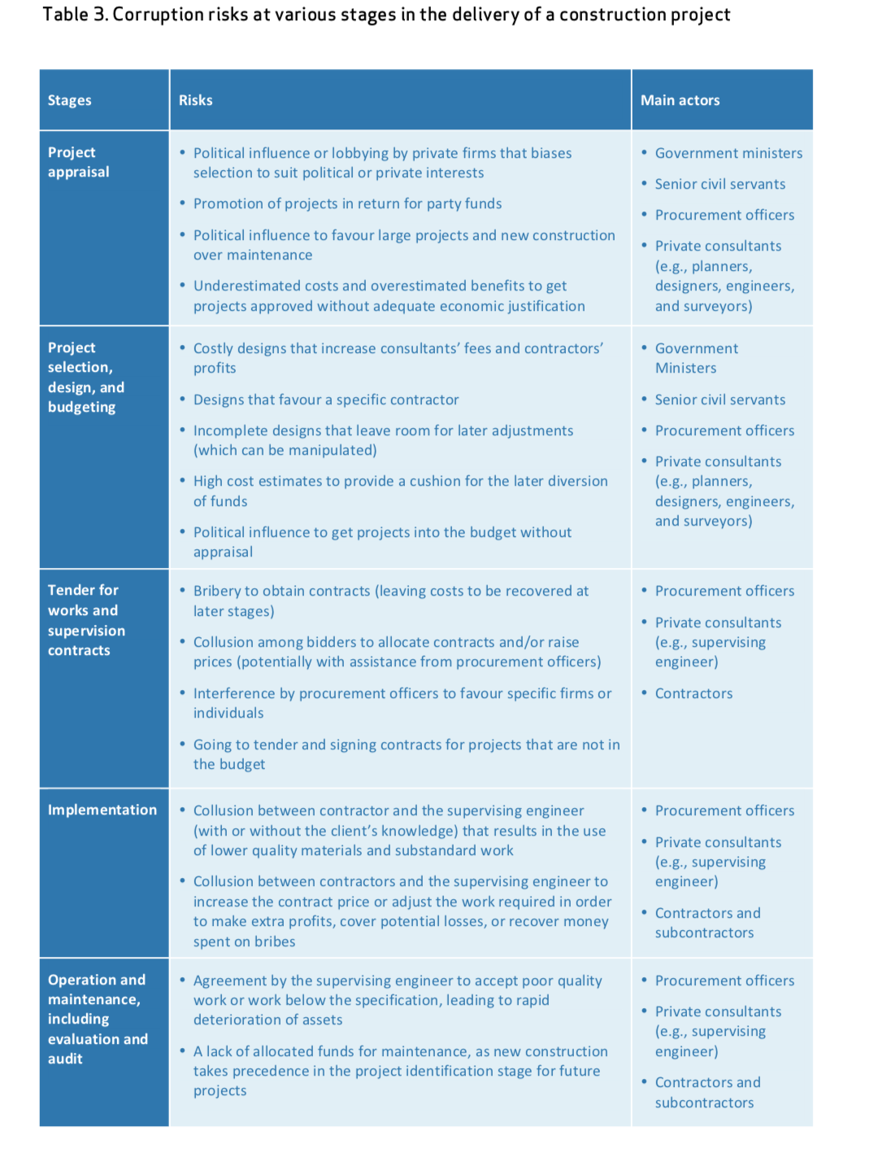
Example: Canada and collusion in the construction industry. Collusion among clients, consultants, and contractors is in fact believed to be widespread in the construction industry in many parts of the world, including in highly developed countries. Evidence is difficult to obtain, but the work of the Charbonneau Commission in Quebec (2017)is throwing a bright light on the corrupt relationships among the actors in public construction. The Commission’s findings … revealed complex webs of collusion, as well as highly sophisticated stratagems for the extraction of funds from public construction projects. Politicians, high level public officials, consultants, and contractors are all involved.’ (Wells (2015) Corruption in the construction of public infrastructure).

2.2 PROJECT-LEVEL GUIDANCE
There is a great deal of guidance available to both governments and to companies for controlling construction corruption at the project level. The most focused resource is the Global Infrastructure Anti-Corruption Centre (GIACC) (See Section 4). Most commercial consultancies also provide guidance. Here are two examples:
- Price Waterhouse Cooper (2016) Corruption and public works: Maintaining an integrity edge
- Ernst & Young (2014) Managing bribery and construction risks. The real estate, construction and infrastructure industry.

3. Developing an overall strategy
How you develop your strategy for tackling corruption in construction projects depends on which of the two different situations that we described earlier you are in: Working at ministry level or working on a construction project. For example, your strategic objective in a public works ministry could be to raise the trust of the public in the construction of public infrastructure, or to ensure that all construction professionals and officials operate to high ethical standards, or to reduce the average cost of all Ministry-sponsored construction. However, at ministry-level, there is no published overall strategy that we are aware of (although we understand that Afghanistan Ministry of Public Works has recently set out one, as at mid 2018). At project-level, your strategy objective might be to eliminate bribery in all the aspects of project design and construction, or to stop price inflation due to collusion among construction companies and the sub-contractors, or to enable all professionals involved in the project to safely report corruption by, without fear for their job or family. Most of the sources quoted in the previous section (here) also give guidance at the more strategic level.

Guidance summary
STEP 3. After you have reviewed the specific corruption types and identified possible reform measures, you can develop an overall strategy, along with other stakeholders. Because curbing corruption is about changing the status quo, so you need to be thinking about how to build support, how to spread the benefits, how to bring opponents on board or how to outflank them. This is where judgement and political skill are important. You also need to think carefully as to which combination of measures and management is likely to result in the most impact within the limited resources and time available. We suggest that you develop an overall strategy in the following way:
- Thinking through what impact you really want to achieve
- Challenging yourselves by considering strategic opposites
- Considering the people and the politics; where to build support
- Setting up a sound implementation programme
- Maximising supportive structures across government & stakeholders
4. Transnational construction initiatives & expertise

4.1 GLOBAL INFRASTRUCTURE ANTI-CORRUPTION CENTRE (GIACC)
This is a UK-based centre run by two construction lawyers, both dedicated to reducing corruption in construction, with a huge database of supportive material and templates that you can pick up and use. Since its launch in 2008, the GIACC Resource Centre has been visited on-line by organisations and individuals from 190 countries. They provide free on-line information, advice and tools, for both governments and companies, including:
- Corruption information: Detailed analysis of what is corruption, why corruption occurs, how corruption occurs, why avoid corruption, liability for corruption, and cost of corruption.
- Examples of corruption: Hypothetical examples of how different types of corruption take place through the project phases.
- Anti-corruption programmesfor organisations, governments, funders, project owners and business associations/professional institutions.
- Project Anti-Corruption System(PACS): A set of measures designed to help prevent corruption on major projects. See the box below.
- Anti-corruption measures:Specific anti-corruption measures which an organisation can implement, either separately, or as part of an anti-corruption programme. See index on left of page to access these measures.
- Anti-corruption training:On-line anti-corruption training module (available in English, Spanish, French, German, Italian, Polish and Romanian). Anti-corruption training manual (available in English, Spanish and Chinese).
- Dealing with corruption: Advice on how organisations, individuals and the publiccan deal with corrupt situations.
- Informationon anti-corruption conventions, forums, indices and surveys, and initiatives.

4.2 CONSTRUCTION SECTOR TRANSPARENCY INITIATIVE (COST)
COST is a multi-stakeholder sector-specific initiative, currently with 15 participating nations. Launched in 2012, ‘COST grew out of the lessons learnt from a three-year pilot programme which tested the viability of a new transparency and accountability process in eight countries. COST promotes transparency by disclosing data from public infrastructure investment.’ The COST initiative is gradually extending its footprint and now has four categories of activity:
- Disclosure of information (from relevant state procurement agencies, e.g. road, health). This consists of 40 data points of information over the lifecycle of the programme. It starts on a voluntary basis for nations, then sets up formal disclosure requirement. Guatemala has recently done this.
- Each COST project works via ‘Multi-stakeholder working’ comprising representatives of government, the private sector and civil society.
- Assurance is the 3rd COST can organise independent assurance of one or more national projects. COST prefers that government do this role, e.g. through audit, but in general public trust is low, so this is not useful. COST may therefore select a small sample of projects to monitor. For example, there are some 5000 projects within the COST project in Guatemala).
- COST achieves its impact by strengthening Social accountability. This often means working with existing institutions. For example, in Honduras there are hundreds of citizen monitoring groups at municipal level and COST has been training them.

4.3 OPEN CONTRACTING PARTNERSHIP (OCP)
The Open Contracting Partnership started in 2012, and in 2015 was spun out of the World Bank to become an independent programme. A secretariat is based in Washington, D.C. and OCP are now governed by an independent Advisory Board, made up of individuals from government, the private sector, civil society, the technology sector and development organizations. OCP works across sectors and along the whole process of government contracting to use the power of open data to save governments money and time, deliver better goods and services for citizens, prevent corruption, and to create a better business environment for all. It works to change the global norm in public contracting from closed to open. OCP supports a network of partners who implement open contracting projects and the adoption of the Open Contracting Data Standard. OCP gathers evidence of what open contracting can achieve.
OCP has a whole methodology for how a Ministry, or nation, can develop its policy for cleaner contracting. The technical basis for the guidance is a standard for open data, so that all parties can see the key data related to any contract. Country evidence so far, for progress with general procurement from Ukraine, Nigeria, Latin America and the UK. Read OCP’s website here.
There is also a ‘subset’ of OCP, the ‘Contracting 5 ’initiative. Colombia, France, Mexico, United Kingdom, and Ukraine officially launched the Contracting 5 (C5) initiative during the OGP Paris Summit in 2017.

4.4 OPEN GOVERNMENT PARTNERSHIP (OGP)
OGP is broader than either construction or contracting: it is a multi-nation platform dedicated to enhancing cooperation between governments and civil society. OGP was launched in 2011 to provide an international platform for domestic reformers committed to making their governments more open, accountable, and responsive to citizens. Since then, OGP has grown from 8 countries to over 70 participating countries and 15 subnational governments. In all of these countries, government and civil society are working together to develop and implement ambitious open government reforms.
If your country is a member of OGP, then you should be able to harness resources from OGP, and to ensure that public works reform is contained within the ‘National Action Plan’ that your government will be implementing in respect of getting more benefits from civil society engagement.In general, OGP’s engagement on infrastructure transparency tends to run through COST and OCP, with which OGP has cooperation agreements. Read OGP’s website here.

4.5 UNITED NATIONS DEVELOPMENT PROGRAMME (UNDP)
UNDP is well aware of the importance of tackling corruption in construction. See this, for example after the ‘Agenda 2030’ was adopted in New York at the end of 2015: ‘Given the magnitude of potential losses to corruption in the infrastructure sector, mounting to trillions of dollars annually on a global scale, clean construction is also of paramount importance for achieving Goal 16 on building peaceful, just and inclusive societies. …We will fail on both these aspirations if we remain unable to substantively reduce all forms of corruption…Increased transparency and accountability in the construction sector is thus a sine qua non for a successful outcome of the 2030 development agenda’.

4.6 U4 ANTI-CORRUPTION RESOURCE CENTRE, NORWAY
U4 has a 2015 guide on how to oversee and/or monitor corruption risks in large infrastructure projects, ‘Corruption in the construction of public infrastructure. Critical issues in project preparation’. The diagram below, for example, shows their representation of how a government can obtain assurance about integrity at the project preparation phase.

Reading and bibliography

ADDITIONAL READING
In this review, we have assembled all the useful guidance that we know of, together with country experiences in construction, infrastructure and public works anti-corruption reform. Read it first. The following are also very informative:
- Matthews, Peter (2016) This is why construction is so corrupt.World Economic Forum.
- World Economic Forum (2017) Partnering Against Corruption Initiative: Building foundations for trust and integrity – infrastructure and urban development.A good discussion of progress being made by Mexico
- OECD (2016). Integrity framework for public infrastructure.
- Price Waterhouse Coopers (2014) Fighting corruption and bribery in the construction industry.

WEBSITES
These websites have useful material, especially GIACC for addressing corruption at project level:
Global Infrastructure Anti-Corruption Centre (GIACC)
Construction Industry Transparency Initiative (COST)
Open Contracting Partnership (OCP)

