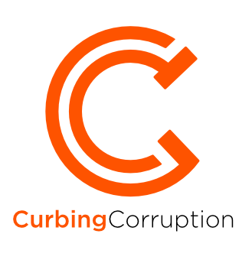

Sector | Sub-National Government

INTRODUCTION
Sub-National Government is huge and comes in many shapes and sizes. There can be one layer of government beneath the national government (31% of countries), two layers (47% of countries), three layers (23%), or more complex forms; The size of a local government entity varies from a few hundred inhabitants up to 500,000; Local government spending as a % of national spending varies from zero to 85 %, averaging 24%. Most spending is in education, social protection, economic affairs, transport and expenses relating to the operation of the authority (For more on the diversity of local government, see here).
Often a large, devolved administration or a national city is many times larger than the economies of whole countries. Cities are the pre-eminent local organisation form in many countries and some of the best innovations in anti-corruption are coming from cities rather than from national-level.
You can read this sector review from beginning to end, or you can jump to any part of it:
- Corruption types in local government
- Reforms in local government
- Developing an overall strategy
- Transnational initiatives
Plus an Annex elaborating on the extraordinary diversity of sub-national government worldwide
Plus recommended additional reading and a fullest of sources in Reading and Bibliography
Or you can download the whole review as a pdf document:
XXXXXXXX
Author and contributors: The originating author of this sector review is Mark Pyman, who is the managing editor of CurbingCorruption. Additional contributions have been made by Dessi Hristova; Alan Doig; (others)
Terminology note: We use the terms ‘Sub-National Government’ and ‘local government’ interchangeably. The abbreviation is ‘SNG’.

1. Corruption types

Guidance summary
STEP 1. We suggest you start by understanding in detail the different corruption types that you are faced with. You can do this in the following way:
- Look at the template of sector corruption types in our review and adjust these according to your situation.
- Gather available data. We suggest that you do this first at a macro level, to get a sense of which corruption issues are big or small across the sector, across countries, across different regions. Often there is a lot of such macro data publicly available. Then, gather available data at the micro level, local to you.
- Decide if it would help to do a formal analysis of the corruption types and the levels of corruption risk. This takes time but gives you a thorough baseline for your reforms. It also serves to show the level of danger and damage from corruption to staff and to the public.
- Finally, consider doing an analysis of the levels of support and opposition that you can expect. This is called a ‘political economy analysis’.

Sub national government is a complex sector
Because it comprises many of the multi-sector functions of a national government – education, social services, transport, construction, elections and tax collection, for example. But it is useful to consider it nonetheless as a discrete sector because councils manage the totality of the services as a whole, and they have a clear accountability to their citizens for providing these services. The specificities of tackling corruption in local governments, especially in cities, also often may have more in common with other cities and local governments around the world that within their country.
The specific corruption types in local government are of two broad kinds:
- Those specific to local government or not common at national level. On the spending side, these include waste collection and disposal services, housing services, planning controls, environmental management services, and maintenance service. On the revenue side they include grants and subsidies, business taxes, local penalties.
- Those similar to the equivalent national sectors. You can see the 20-40 corruption types in each of these sectors in the other sector reviews: Education, Health, Police Services, etc.
You can also see below a description of the very general forms of corruption (bribery, collusion, conflict of interest, cronyism, etc) as they apply to sub-national government, in a publication from Transparency International.
Transparency International definitions of forms of local government corruption

Forms of corruption | Definition
Bribery | The offering, promising, giving, accepting or soliciting of an advantage as an inducement for an action which is illegal, unethical or a breach of trust.  Inducements can take the form of gifts, loans, fees, rewards or other advantages (taxes, services, donations, etc.)
Collusion | A secret agreement between parties, in the public and/or private sector, to conspire to commit actions aimed to deceive or commit fraud with the objective of illicit financial gain. The parties involved are often referred to as ‘cartels’.
Conflict of interest | A situation where an individual or the entity for which they work, whether a government, business, media outlet or civil society organisation, faces a conflict between the duties and demands of one or more positions that they hold and their private interests.
Cronyism and nepotism | Form of favouritism whereby someone in public office exploits his or her power and authority to provide a job or favour to a family member (nepotism), friend or associate (cronyism), even though he or she may not be qualified or has not gone through the appropriate application procedures.
Fraud | To cheat. The act of intentionally deceiving someone in order to gain an unfair or illegal advantage (financial, political or otherwise).
Gifts and hospitality | The provision of gifts, entertainment, charity or other hospitality that could affect or be perceived to affect the outcome of business transactions and are not reasonable and bona fide.
Lobbying | Any activity carried out by companies, associations, organisations and individuals to influence a government or institution’s policies and decisions in favour of a specific cause or outcome. Even when allowed by law, these acts can become distortionary if influence is disproportionate or non-transparent.
Revolving door | An individual who moves back and forth between public office and private companies, exploiting information or connections gained in government service for the benefit of companies
Trading in influence | Abuse of knowledge of council in exchange for personal benefits.
Vote rigging | Abuse of power to influence council decisions and policies with a view to affecting voting behaviour. This may not involve tangible personal benefits for the individual, but the benefits accrue to the political group rather than serving the public interest.

2.1 GATHER OVERVIEW DATA
There is an immense diversity to the types of Sub-National Governments. You might like first to see how your municipality or province fits within the range of size/autonomy/functions/etc. There is a detailed Annex that explores this further.
There is often a lot of data available on the scale and nature of local government corruption. We suggest that you first use this to develop an overview, for example comparing across municipalities or across services, or aggregating across municipalities. Here are some examples:
Example 1: Perceptions of regional corruption in France
68 % of respondents across France consider corruption to be widespread in their country (EU-27 average: 76 %). Their perception varies quite widely from one Département to another (see diagram), with the greatest perceived corruption in the North East and the South East.
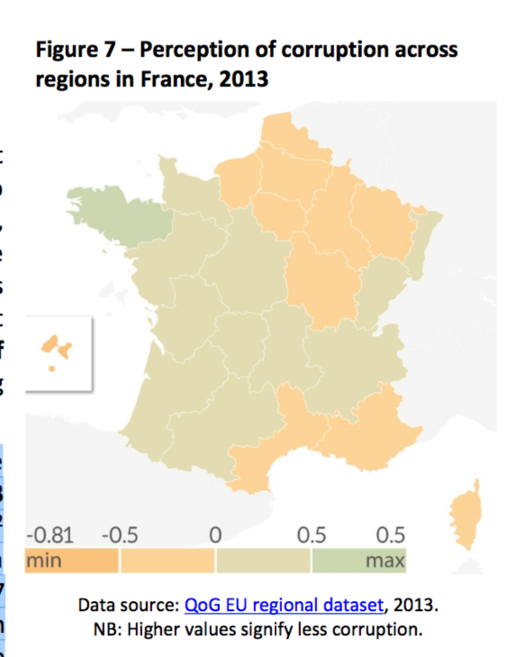
Nevertheless, only 6 % mention to have been personally affected by corruption in their daily life (far below the EU-27 average of 20 % and at the same level as Germany). Similarly, when asked about their personal experience of bribery, only 2 % (less than the EU-27 average of 4 %) say they have been asked or expected to pay a bribe in the last 12 month, and 6 % (EU-27: 8 %) to have experienced or witnessed a case of corruption. Interestingly, 16 % report to personally know someone giving or taking bribes (EU-27 average: 12 %). (EPRS 2017 report p45)
To read more on France and on other EU countries, see European Parliamentary Research Service on Corruption in the European Union(2017).
Example 2: Perceptions of regional corruption in Italy
‘Public perception of corruption in Italy is very high: according to the 2013 Special Eurobarometer on corruption,97 % of respondents (EU-27 average: 76 %), believe that corruption is widespread in their country. A relatively high number of respondents (42 %), compared to an EU- 27 average of 26 %, attest to having been personally affected by corruption in their daily life.
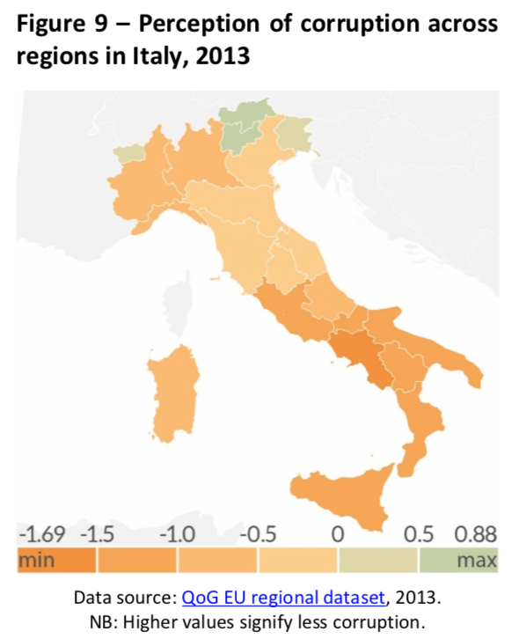
However, only 2 % of respondents had a direct experience involving bribery, compared to an EU-27 average of 4 %. In addition, only 6 % of respondents declared to have experienced or witnessed a case of corruption in the previous 12 months, against an EU-27 average of 8 %. The personal knowledge of someone who takes or has taken bribes (9 %) is slightly below the EU-27 average (12 %). When it comes to the perception of corruption in local or regional public institutions (92 %), it is almost equal to that for national institutions (93 %). Furthermore, the perception of the government’s efforts to combat corruption is far from positive, given that 75 % of respondents disagree overall with the statement that such efforts are effective. ‘(EPRS 2017 report, p59)
To read more on Italy and on other EU countries, see European Parliamentary Research Service on Corruption in the European Union(2017).
Example 3: Comparing transparency of municipalities in Ireland
Another such analysis comes from the Republic of Ireland, where Transparency International Ireland (2018)has ranked all the 31 local authorities on three criteria: Transparency, Accountability and Ethics. The best ranked council, Galway City, scored 21 out of a possible 30 points, whilst the worst ranked, confusingly called Galway County, scored only 5 out of 30 points.
Example 4: Measuring local government transparency in Portugal
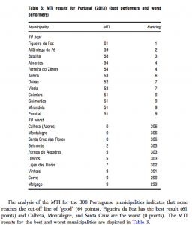This Portuguese local government index was based on 76 indicators grouped under seven headings: 1) Organizational information, social composition, and operation of the municipality (18 indicators); 2) Plans and planning (13 indicators); 3) Local taxes, rates, service charges, and regulations (5 indicators); 4) Relationship with citizens as customers (8 indicators); 5) Public procurement (10 indicators); 6) Economic and financial transparency (12 indicators); 7) Urban planning and land use management (10 indicators). The summary table below shows the best and the worst performers across all 306 municipalities. The analysis is from da Nuno et al (2015).
Example 5:Survey data on anti-corruption capabilities in twenty municipalities in Albania
Here is another type of survey exercise, looking to see which reform measures have been set up in each municipality across 20 municipalities (Local Government Units, or LGUs) in Albania.
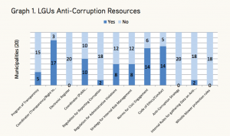
From the Institute for Democracy and Mediation in Albania (2016).
Example 6: Provincial information from Local Government Auditors in the UK
The UK’s Local Government association leads on anti-fraud and anti-corruption efforts for all local authorities. Their overall analysis of the scale of the problem in the UK is that it costs local municipalities £2.1billion each year, divided as follows:

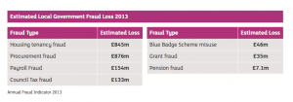
The Local Government Auditors association in the UK also has a useful list of types of corruption in UK local government:
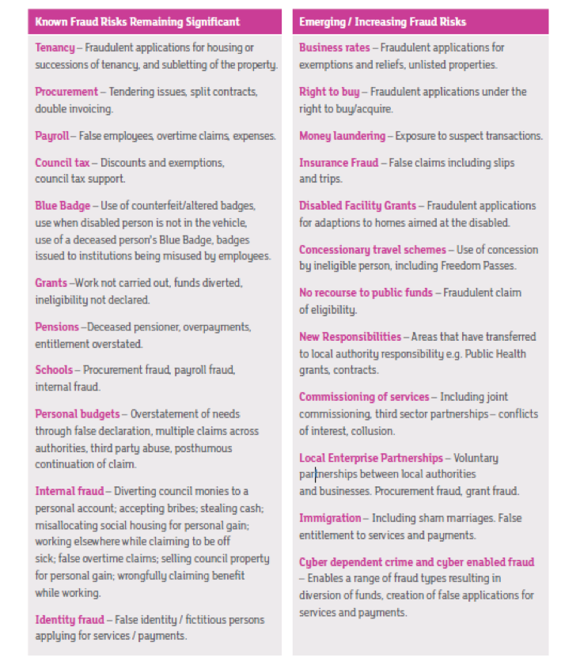

2.2 GATHER LOCAL DATA
Local data may already be available but usually you will need to obtain it specifically. There is some guidance available on how you can do this in local government. See, for example, Transparency International (2014),Local integrity system assessment toolkit, and theCouncil of Europe Centre of Expertise for Local Government Reform (2017) Strengthening public ethics and preventing corruption in public administration: toolkit for public authorities.Or you can browse the following examples:
Example 1: Gathering leadership opinions on corruption extent in the city of the La Paz, Bolivia (1985-) One easy mechanism is to bring together experienced people across your administration to discuss their knowledge of local corruption and to ask their estimates of the magnitude of it. Here, for example, is such an exercise from early reforms by the mayor of La Paz, Bolivia, where they review seven main types of corruption in the city, its approximate value, who it hurts and helps, and possible solutions. Analysis by Klitgaard et al.(2000)
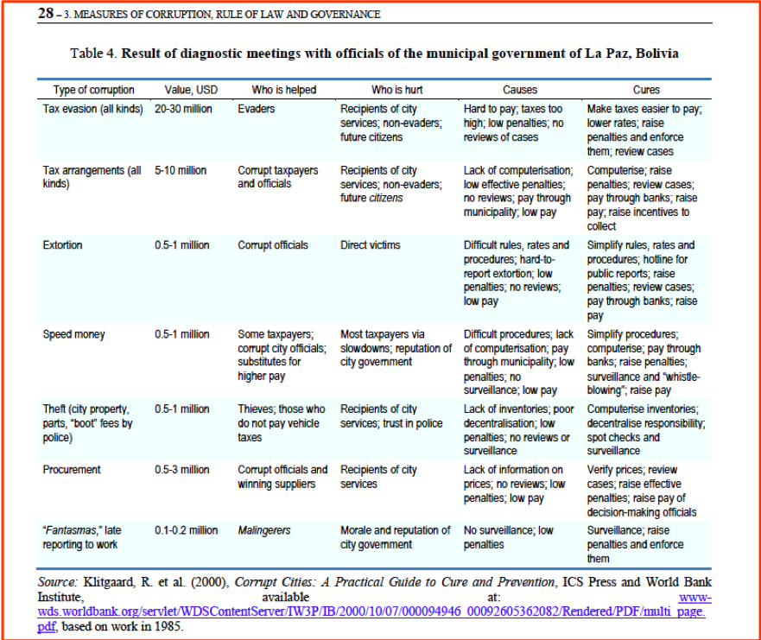
Example 2: Gathering leadership opinions on corruption extent in the city of the La Paz, Bolivia (1999-)
There was a second wave of corruption reform in La Paz in 2015 under a subsequent mayor. This is described in the strategy section of this review here, or you can read the full analysis in Zuniga and Heywood (2015) Cleaning up La Paz.How Bolivia’s biggest city freed itself from a ubiquitous culture of corruption.
Example 3: Integrity surveys of public organisations in the city of Seoul, South Korea
Seoul uses regular integrity assessment surveys of the multiple public organisations. The Integrity Assessment measures the levels of integrity in public organisations based on surveys of citizens and employees. It serves to encourage public organisations to make voluntary efforts to prevent corruption and promote citizens’ rights in a transparent government. The number of the public organisations subject to the Integrity Assessment increased from 70 in 2002 to about 700 in 2012. The initial model of the Integrity Assessment was designed to measure integrity in the public sector solely based on a survey of citizens who experienced public services. However, since citizens cannot easily get information about corruption in internal affairs of public organisations, the assessment model was changed to also cover “internal integrity” in 2007 by conducting an additional survey of employees of public organisations. Called the Integrity Assessment of Public Organisations. This example is quoted in OECD (2005) Public Sector Integrity: a framework for assessment.
Example 4: Using audit to gather city corruption risk policies in the municipality of Martin, Slovakia
Another mechanism is to commission an audit or review. Often there are NGOs in the district or in the country that are capable of doing such reviews, at much lower cost than from established consultancies. The new mayor of the municipality of Martin, Slovakia, commissioned an audit from Transparency International Slovakia. The town hall showed limitations in almost all of the 17 policy areas (see list below). The public had previously had only very limited options to control, check and hold their elected representatives or Town Hall employees accountable. For example, tenders had previously been won only be a small group of contractors and were heavily overpriced.
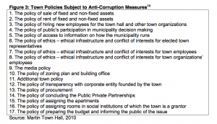
Example 5: Micro level, hyper-local analysis of corruption in the city of Lviv, Ukraine
“]
This is a quite different example, where a small group of reformers, led by one of the city’s businessmen, sought to build a constituency for change. They did not need an ‘overview’ – they all knew all too well the forms of corruption in the city and the country – but they needed to build a confidence in the city that change was possible. They were successful in this, through a series of grass roots local improvements, and this led to the leader, Andriy Sadovyi, being elected mayor, after which the reforms accelerated. They focused on ‘micro-level, hyper-local analysis’ as the only way to really defeat Ukraine’s corruption. They were doubtful about the large-scale, national efforts to combat the problem, believing that the problem must be tackled city by city, department by department. See Legatum Institute (2015) The spirit of Lviv.
Example 6: Surveys about corruption in accessing services in municipalities in Ghana, Philippines & Serbia
Another mechanism is to ask citizens directly, and to do this by commissioning a survey company. Here are three examples of the same survey being used in municipalities in Ghana, Philippines and Serbia on whether citizens are able to access services on their own or whether they need to seek help to get past the ‘barriers’ put in their way (Camargo and Baez (2013), Communities against corruption: Assessment framework and methodological toolkit).Citizens were first asked questions about accessing 20 services and asked whether they could get those services on their own like the ones shown for Ghana below.
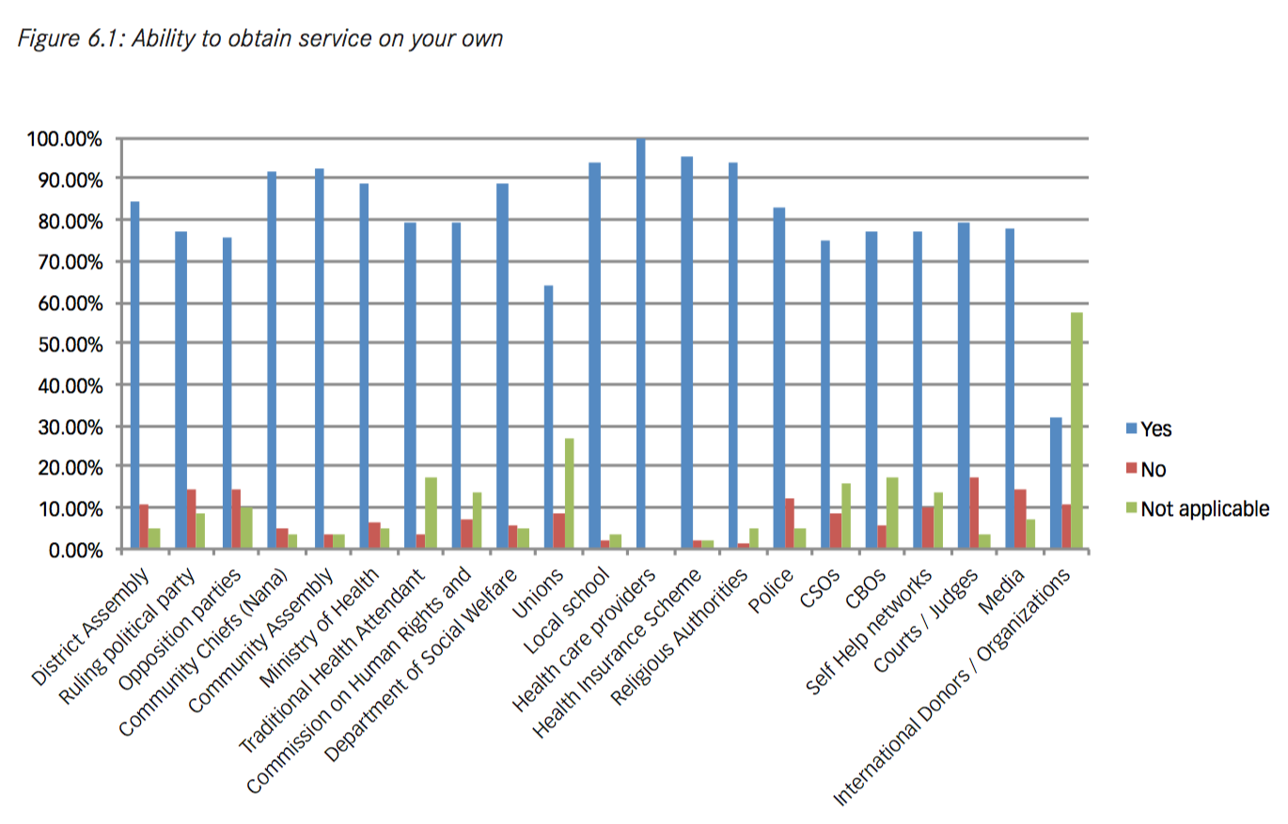
The citizens were then asked how they solved the problem when they had not been able to get the servicer on their own. Here were the answers from the three municipalities:

Serbia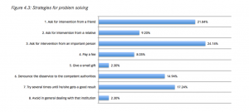

Philippines San Miguel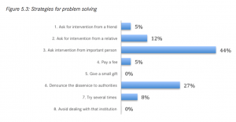

Ghana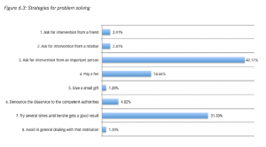

2. Reforms in local government

Guidance summary
STEP 2. Reform measures will always be specific to the particular circumstances. Nonetheless, in order to get ideas and insights, it helps greatly to learn about reforms employed elsewhere and to have a mental model of the type of possible reforms. We recommend you consider each of these ten reform approaches:
- Functional approaches: improvement of institutions, processes, systems and controls
- People-centred approaches: building committed supporters, networks and coalitions
- Monitoring approaches: strengthen oversight groups and their independence
- Justice & rule of law approaches: prosecuting, raising confidence, improving laws
- Transparency approaches: making visible what others wish to keep hidden
- Integrity approaches: motivating and instilling pride
- Whistleblowing approaches: finding safe ways for people to speak up
- Civil society and media: external voices are essential
- Incentive approaches: aligning the different interests of stakeholders
- Nudge approaches: new science show how small changes can make a big difference
Talking through with colleagues and stakeholders how each of them might work in your environment enables you to ‘circle around’ the problem, looking at different ways and combinations to tackle it. A reform strategy might, for example, consist of some institutional improvement projects, plus strengthening integrity among staff, plus strengthened sanctions and discipline.
This is the second part of the process of developing an anti-corruption initiative in local government. The first partwas to analyse the issues and problems. The third part will be to bring together the range of chosen reform measures into an overall strategy, and the fourth will be to review what transnational expertise there is around. Here we bring examples of local government reforms under each of the ten reform approaches.

2.1 FUNCTIONAL REFORMS
Simplification, reducing procedural complexities, automating cumbersome procedures, removing the need for person to person exchanges with the procedures, are all part of such institutional improvement. This is often the largest part of any anti-corruption strategy, and it is where most prioritisation decisions have to be made.
Local government services comprise a wide range of activities. On average, about 90% of local government spending is taken up by seven categories of services (Read more). In order of spending magnitude these are: Education; Social protection (social services and benefits, plus social infrastructure); Economic affairs and transport; General public services, which covers all expenses relating to the organisation and operation of government; Health; Housing and community services; Recreation, culture and religion; and Other (environment protection, defence, police and public order..). Several of these are major activities that are treated elsewhere in Curbing Corruption, such as in the sector reviews on Education,Health, or Police. These major functions are of course both national AND local.
On the income side, local government revenue usually consists of local revenue collection, local tax collection and subsidies from central government. One of the most promising revenue reforms has been Participatory Budgeting. Participatory Budgeting has been implemented in Brazil for several years, but different forms of participatory budgeting can be found today in many countries, including Brazil, Argentina, Uruguay, Chile, Peru, Dominican Republic, Nicaragua, El Salvador, Mexico, Spain, Italy, Germany, France, Belgium, Portugal, Switzerland, Albania, Bosnia and Herzegovina, Portugal, Switzerland, Cameroon, India, Sri Lanka, Indonesia, South Africa, and the Philippines. Most PB experiences are at the urban and rural municipal levels. Some provincial governments have recently introduced Participatory Budgeting in Latin America. For more analysis of participatory budgetting, see the World Bank report from Shah (2007) Participatory Budgeting, and Camargo et al (2017) Hidden agendas, social norms and why we need to re-think anti-corruption.
Here are some examples of functional reforms in local government:
Example: The procurement anti-corruption initiative in Seoul metropolitan government
The OPEN System in Seoul The OPEN system (On-line Procedures Enhancement for Civil Applications) is a web-based tool that allows citizens to track in real time the progress of applications made to the Seoul Metropolitan Government. It is designed, in part, to alert citizens of any unjust or corrupt action in processing requests for licences and other authorisations. The system also allows citizens to ask questions if they believe that there have been irregularities in their application processes. See the analysis by Bertot et al (2010) Using ICTs to create a culture of transparency: E-government and social media as openness and anti-corruption tools for societies.
Example: An ‘accounting clinic’ in the city of Jakarta, Indonesia
This clinic is said to provide ‘a complete and efficient integrated financial information management system for all departments of the municipality’. It has three fundamental objectives: (i) the improvement of policies, system and standard procedures; ii) the improvement of the quality and capacity of human resources, as consultative and educational means for the implementation of accrual-based accounting; and (iii) the improvement of the technology to develop the System itself, such as e-budgets, e-retributions and e-assets. For more detail, see URAIA (2017) Transparent and accountable cities: innovative solutions for municipal management and finance.
Example: Analysis of municipal revenues and shortfalls in Afghanistan
A different reform approach was adopted in Afghanistan. The review team estimated the 2014 revenue of each province, then compared this with the actual revenue for the year. The local government Minister and the President then discussed the results with each of the provincial governors. The results are shown in the table below.
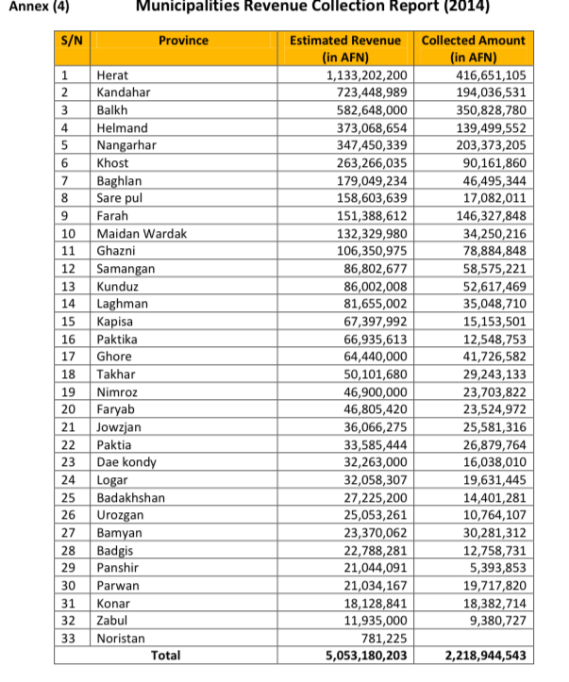
The actual amounts were on average less than half the estimates, and in as low as 20-25% in others. See Afghanistan Independent Monitoring and Evaluation Committee (2016)Vulnerability to Corruption Assessment of Municipalities Revenue Collection.

2.2 PEOPLE-CENTRED REFORMS
Building a team of officials across the municipality (or city of province) who come to share the vision of what can be achieved with less corruption is a key place to start. Here are two examples:
Example: People-centred reforms in the city of Lviv, Ukraine
In Lviv, Ukraine, an energetic group of reformers have made huge improvements in this Ukrainian city, despite all the continuing national corruption problems. They had a strong message of self-reliance, as one of the original group of activists describes: “It was the first two years after the Orange Revolution. People had high expectations from the national level, and we started to tell them: No, no, no! Don’t look only there! You have to look to your building, your street, your town. Organise yourself, and don’t expect that [Orange Revolution leader Viktor] Yushchenko will come and clean up your city.” Such sentiments may seem self-evident, even banal, by Western standards. In oligarch-ridden Ukraine, they add up to a radical message.
Specific reforms included Small neighbourhood level improvements, Getting more young people into the city government, Hiring administrators from other cities, A massive internship program (thousands of students), Encouraging businesses and tourism, including in former council locations; and Technology outsourcing and a technology hub. From Legatum Institute (2015), The Spirit of Lviv.
Example: Radical people-centred reforms in the city of La Paz, Bolivia, Ukraine
In La Paz, Bolivia, the new mayor, Del Granado and his team established a zero-tolerance approach to graft. Del Granado and his team reinforced this message by translating their principles into a comprehensive policy program. The program had three main components. First, the reformers made it clear that the fight against corruption would entail rigorous prosecution of corrupt acts, supported by codes of conduct for public officials. Second, the new administration planned to foster economic recovery by reforming the city’s fiscal policies, including collecting due revenues and restoring credibility with external funders and aid agencies. Third, Del Granado and his colleagues aimed to reshape the relationship between public institutions and citizens by establishing greater transparency and more participative mechanisms aimed at building trust. The policy also stipulated pay cuts for members of the executive alongside statutory declarations of individual assets designed to restore the credibility of government
At the same time, the city government was also encouraging the citizens of La Paz to become more involved in running the city and to take more responsibility for the quality of urban life. The effort focused on increasing popular participation in municipal affairs and fostering a sense of common ownership and responsibility. The La Paz city government also created the La Paz Assembly, a citizen body that is supposed to provide public scrutiny of medium- and long-term policies. In addition, the city created a network of discussion forums (mesas de diálogo) and other bodies to allow city officials and citizens to jointly explore more strategic topics, such as the Municipal Development Plan.
Active discussion of corruption and corruption reform is important
Building supportive teams and coalitions is clearly very important. But there is also a deeper rationale at work here. In general, corruption is a subject that is sometimes actively avoided among professional groups. There is the fear that you might be showing yourself to be naïve, or that you will show yourself not to care about the topic, or that your colleagues may be involved, or that you may be outcast for raising such a sensitive topic. I have been in numerous professional leadership groups, from global companies to military leadership teams, from clean Scandinavian countries to conflict countries. It has been difficult to generate open discussion about corruption in all of them. So, do take this ‘building commitment’ stage seriously. Do start a dialogue about corruption. Or ask someone to open up these discussions both across the political leadership and across the organisation, as happened in La Paz in the Bolivian example above.
You can also consider using a questionnaire to bring out peoples’ opinions. There is one example below, from UN Habitat (2006),which it presents as an ‘Informal, Do-It-Yourself, Corruption-IQ Test for Local Government and Community Leaders’.
Example: UN habitat questionnaire on peoples' opinions about corruption in their organisation
In the form below, there are four choices for each of ten statements. To register whether you agree (score 1) or disagree (score 4) with the statement, and how strongly. The results indicate to the respondent and to you just how big a barrier there may be to tackling corruption.
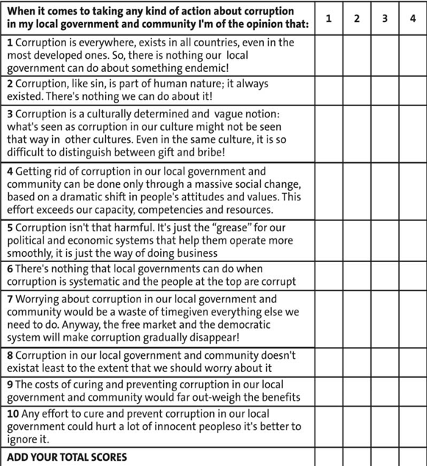

2.3 MONITORING REFORMS
Active monitoring – mechanisms that allow the municipal executive, legislature and/or citizens to have accurate oversight of the actual or potential corruption issues – is always a central approach in corruption reform initiatives. There are multiple types of monitoring: State-authorised watchdogs, local legislative oversight committees, ad-hoc legislative committees, local government auditors or comptrollers, executive units like ‘Transparency units’, citizen groups like ‘Independent Citizens Commissions’. Usually, the issue is not whether such entities are present, but whether they are effective or toothless, strong or weak. One good action to take is to carry out – or to commission – an analysis. Here, for example, is an analysis of the effectiveness of the local government monitoring entities in the states of the Unites States of America.
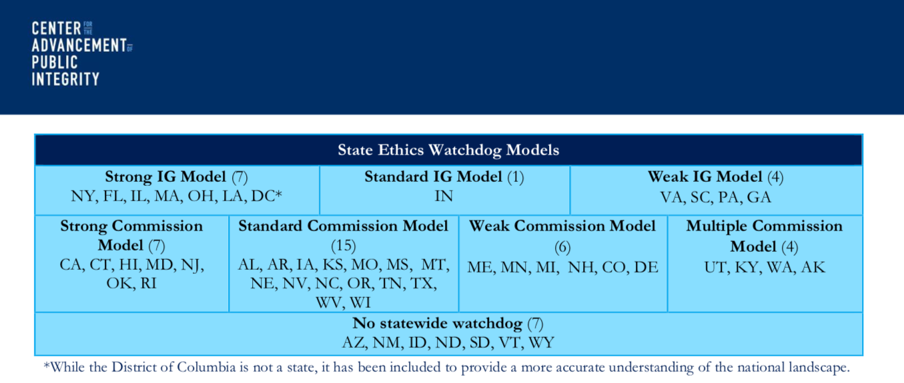
It comes from an analysis by the Center for American Public Integrity (2016) An overview of the State and Local Anti-Corruption Oversight in the United States.(CAPI). They find that US has a complex and highly diverse system of anti-corruption oversight at local level, with some states, cities and counties having multiple agencies whilst others have none at all. CAPI concludes that there is no ‘best model’
Read more on US local government oversight from CAPI
2.3.1 Use and strengthen the local government Internal Audit Department
The Internal Audit department can be a major resource. They have the analytical skills and the knowledge to dig below the surface of the corruption issues, and the mandate to look across the whole organisation. Internal audit is the ‘Third line of defence’ in organisations, the first line being management and line management controls, the second line being broader management control measures, such as quality control and inspection.
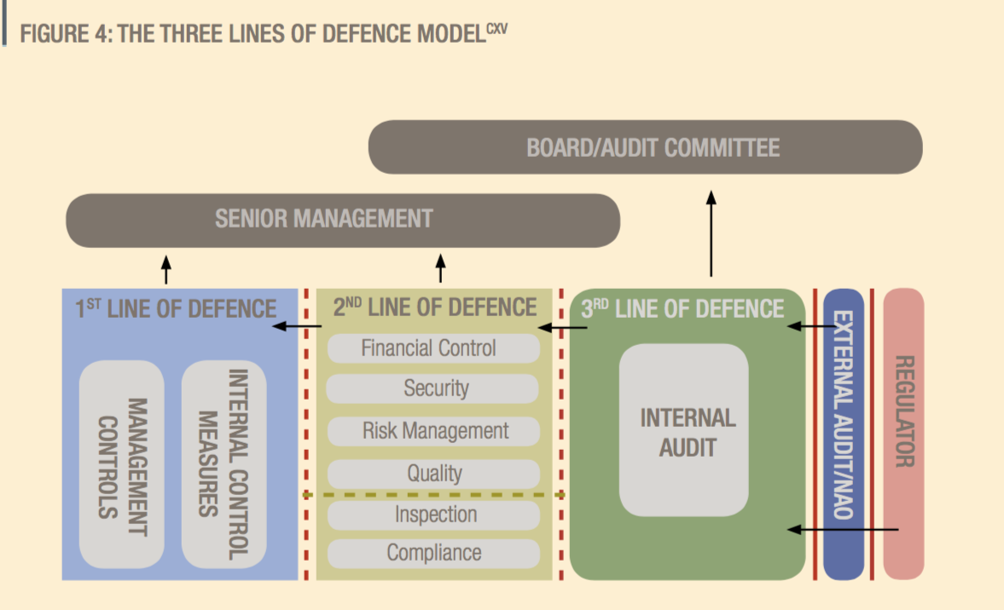
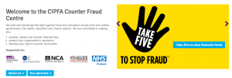One of such resource is in the UK, where the Chartered Institute of Public Finance and Accountancy (CIPFA) has a ‘Counter-Fraud Centre’. This is a useful centre to access, with many case examples. There is also a useful book from the UK on the topic of internal audit and fighting fraud, called The successful frauditorby Peter Tickner (2010)and a following book The successful frauditor’s casebook (Tickner, 2012).
Another good example of the active use of internal audit to inventories the problem and to open up routes for reform, though not in local government but in the defence ministry, is from Barynina and Pyman in The third line of defence: The experience of Ukraine.
Example: Detecting local health corruption through «fraud audit» in Calabria, Italy
Here is another example of an audit specifically targeting corruption and fraud, this time in local government healthcare. With a budget of around EUR 12 000 a year and 8 staff, the ‘fraud audit’ of Catanzaro employs internal controls and a set of IT-centred procedures and techniques to programme and subsequently monitor business operations in order to find clues to the possible mechanisms of corruption, in three areas. First, systematic analysis was made of accounting documents and supplier invoices to discover double-billing, invoices not due, and higher-than-contractual invoiced amounts. Second, tenders for the supply of goods and services were evaluated where the number of participating companies was less than three, to discover contract awards at risk of illegitimacy. Finally, monitoring of violations of the computer network through a special “sniffer” programme uncovered data theft and hacking by both internal and external sources. This exposed two healthcare services company that were bypassing the system of firewalls and proxies, and which was referred to the police for investigation. Quoted in OECD (2017) Integrity Review of Colombia; originally from: European Commission (2015), Quality of Public Administration-A Toolbox for Practitioners.
2.3.2 Establishing a Commission of Enquiry
Another possibility, if you do not have effective monitoring institutions and you have sufficient authority or advocacy, may be to set up a Commission of Enquiry. There is a very interesting analysis by Monica Kirya (2011) Performing “good governance” Commissions of Inquiry and the Fight against Corruption in Uganda of the legitimacy and potential of Commissions of Enquiry, especially in countries where monitoring is weak, which shows their negative side – appeasement without action – but also shows how they can be useful.
Analysis of the utility of Commissions of Enquiry in weak governance environments
‘The findings suggest that the global anti-corruption framework signified by the good governance agenda is hindered by various factors such as the self-interest of donors, the moral hazard inherent in aid and the illegitimacy of conditionality; all of which contribute to the weak enforcement of governance-related conditionalities. This in turn causes aid-recipient countries such as Uganda to do only the minimum necessary to keep up appearances in implementing governance reforms. National anti-corruption is further hindered by the government tendency to undermine anti-corruption by selective or non-enforcement of the law, the rationale being to insulate the patronage networks that form the basis of its political support from being dismantled by the prosecution of key patrons involved in corruption. Ad hoc commissions of inquiry chaired by judges, which facilitate a highly publicised inquisitorial truth-finding process, therefore emerge as the ideal way of tackling corruption because they facilitate ―a trial in which no-one is sent to jail. …
They also served to appease a public that was appalled by the various corruption scandals perpetrated by a regime that had claimed to introduce ―a fundamental change and not a mere change of guard in Uganda politics. Nevertheless, while they enabled the regime to consolidate power by appeasing donors and the public, they also constituted significant democratic moments in Uganda history by allowing the public – acting through judges and the media – to participate in holding their leaders accountable for their actions in a manner hitherto unseen in a country whose history had been characterised by dictatorial rule.

2.4 JUSTICE AND RULE OF LAW REFORMS
You need to apply the ‘stick’ as well as the carrot. High profile investigation or referral of known corrupt people – where it is feasible – can jolt the system and show that there is a change of tolerance. This could be known corrupt officials, incompetent but protected doctors or surgeons, politicians involved in healthy corruption, health company officials, etc. Where prosecution may be too slow or too difficult, more active use of sanctioning, discipline or penalty procedures sends a strong signal of change, that corruption is no longer acquiesced to. One good example already referred to is the Mayoral initiative of zero tolerance in La Paz, Bolivia in 2002. But…an anti-corruption strategy focused only on punitive measures is usually not successful, and is not the norm internationally (See, for example, Pyman et al (2017) Research comparing 41 national anti-corruption strategies. Insights and guidance for leaders. This failure is usually attributed to two reasons: 1) the investigations are usually complex, prosecution is invariably slow, and the judicial process is often itself corrupted; and 2) Most people want to behave with integrity, so you are likely to get a larger take-up of changed behaviour with positive and nudging measures.

2.5 TRANSPARENCY REFORMS
The more resistance there is to publishing data, the more likely it is that there is some corruption reason behind it. In all such data cases the related question is about which forum you use to present the data. Is it electronic, or via meetings, or in journals, or in newspapers?
Example: Transparency effect on local receipt of primary education budgets in Uganda. Below is a famous campaign diagram from the 1990s where one region in Uganda, working with the World Bank, was able to dramatically show how its local education budgets had been stolen by the central government and to change that situation. See the write up of this experience in Reinikka and Svensson (2002) Measuring and understanding corruption at the micro level.
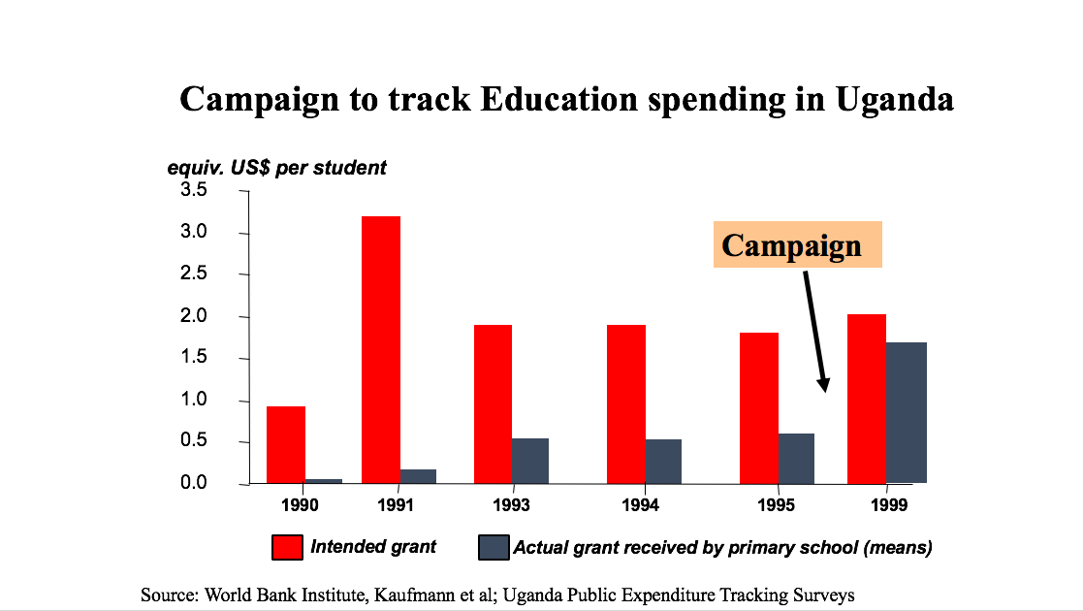
Transparency International Norway has developed a handbook for tackling corruption in Norwegian municipalities.
Example: Establishing a Transparency Unit in the city of La Paz, Bolivia
In a pioneering move in 2004, the city administration of La Paz created a Transparency Unit. Starting with just five civil servants, it has since grown to employ more than 30 people. The unit made use of a number of innovative anti- corruption tools. Among these were varied mechanisms for reporting allegations of corrupt acts committed by public officials, including a special telephone tip line, an email address, and an online complaints procedure. The La Paz city government also created “Continuous Improvement Units” which aimed, among other tasks, to simplify and speed up procedures for planning applications and business permits. This was achieved by putting part of the application process online. The city created web pages that provided detailed information about requirements, deadlines, and timeframes, as well as step-by-step guides to various procedures. The city government also introduced a system for texting citizens to let them know when their applications were completed. These tools increased transparency and thus reduced opportunities for bribery and corruption. The city government also set out to implement transparent procurement policies (including a system for awarding public contracts and tenders on a genuinely competitive basis), to conduct intensified monitoring of public projects (sending inspectors to supervise works and check that the quality of materials complies with the contract and that deadlines are met), and to appoint public officials on the basis of performance rather than political or personal affiliations. All of these measures contributed greatly to restoring the credibility of local government by enhancing transparency and accountability and helping to establish clean governance. See Zuniga and Heywood (2015) Cleaning up La Paz. How Bolivia’s biggest city freed itself from a ubiquitous culture of corruption.
2.5.1 Transparency through regional comparisons: indexes
The anti-corruption world is no different from most other walks of life, in that people always want to know how they are doing compared with their peers. Indexes in anti-corruption are most common at the national level, like the Transparency International Corruption Perceptions Index, but they also exist – or can be created – at the sub national level. Metrics that can compare the corruption extent from one region to another, or from one service to another, or simply a trend within a region or a city, have a natural value to campaigners. Countries have been using such metrics to compare the relative corruption in different Ministries (e.g. Colombia), and between regions of a country (e.g. Ireland, France, Albania). This is a useful trend and one that you might consider copying. There are several methodologies available, and often there are NGOs in a country have the capability to carry out the surveys behind such indexes.
In late 2010, TI Slovakia ranked the hundred largest cities in Slovakia for their transparency – Martin came in third. Similarly, TI national chapters in Spain and South Korea have utilised local municipal indices to capture and promote transparency and integrity. TI Korea uses an integrity index, which is produced by the national anticorruption agency, to bring local stakeholders to the table to discuss policy options for municipalities to better address corruption risks. The selection and design of local governance indicators and indices have been helped by international best practice and the sharing of country experiences. You can see more in local government transparency indexes in Section 1 of this review for Albania, France, Ireland, Portugal and Ukraine.
2.5.2 Transparency through citizen report cards
Citizen report cards (CRCs) are used in situations where demand side data, such as user perceptions on quality and satisfaction with public services is absent. By systematically gathering and disseminating public feedback, CRCs serve as a “surrogate for competition” for state-owned monopolies that lack the incentive to be as responsive as private enterprises to their client’s needs. They are a useful medium through which citizens can credibly and collectively ‘signal’ to agencies about their performance and advocate for change. Specific CRC methodologies may vary depending on the local context. A clear pre-requisite is the availability of local technical capacity to develop the questionnaires, conduct the surveys and analyse results. There are some basic steps that apply to all CRC methodologies:
- Deciding on agencies/ services to be evaluated;
- Identification of scope and key actors that will be involved;
- Design of questionnaires in a manner that is simple enough for ordinary citizens to understand;
- Careful demographic assessment to select the appropriate sample and size for survey;
- Raising awareness of the survey respondents to the process;
- Providing training to the individuals involved in conducting the survey;
- Analysing the data: compilation and analysis of the responses to survey questionnaires;
- Dissemination of findings with due consideration of the power relationships and political economy of the situation; and,
- Institutionalizing the process of providing citizen feedback to service providers on a periodic basis.
Examples: Use of Citizen Report Cards in local government in India, Peru, Indonesia and Papua New Guinea
Rajasthan, India. An initiative by MKSS, a local NGO, has resulted in the release of local government records and the organisation of public hearings to have communities verify whether there are any irregularities between what was budgeted and delivered.29 As demonstrated in India, these types of social audits empower citizens to take part in the ‘bottom-up’ monitoring of service provision and challenge corrupt officials or institutions. Civil society actors in Kenya have utilised a range of social audit tools including citizen score cards, checklists and public hearings to question how the country’s Constituency Development Fund has been managed and to monitor where its resources have been spent.30 The potential of information technology (IT) has also been harnessed to promote transparency in local government administration by engaging citizens in the oversight of services. For example, the city of Seoul in South Korea has introduced online monitoring of licences and other applications by citizens.
Bangalore, India. The Public Affairs Center in Bangalore, India, has been a major factor in curbing corruption in that city and region with their periodic citizen feedback Report Cards that, among other things, highlight corruption in public service delivery. You can learn more about this strategy from their web site: http://pacindia.org
Peru. Anti-corruption work being done in six regions in Peru is also the result of a champion within the regional government supporting it. Moreover, training on corruption risks for local civil servants in Peru has been possible only after the national comptroller’s office decided to back it.
Jakarta, Indonesia. OECD give this example of Passport Simplification and Modernisation Process Obtaining a passport at the South Jakarta Immigration Office often proved to be a slow and cumbersome process. It was prone to corruption, cronyism and the use of middlemen. With this in mind, a modernisation and simplification programme was initiated, which redesigned core business processes when obtaining a passport.
Papua New Guinea. OECD give this example of Phones Against Corruption In 2014, UNDP partnered with Australian telecom MobiMedia to develop a SMS-based reporting system that allows citizens to anonymously monitor corruption. The initiative was tested within the Papua New Guinea Department of Finance at the national level, i.e. approximately 1,200 department staff and it was proved to be an alternative safe space for reporting corrupt practices.

2.6 INTEGRITY REFORMS
Local officials easily can be both part of the problem and an essential part of the solution. Attention to the basics – the legality and reality of hiring, firing, promoting and disciplining staff is always necessary. In addition, there is usually a need to regulate official discretion, maintain or improve an ethical employee culture, have clear standards and codes of conduct, have credible internal reporting procedures, have mechanisms for identification and resolution of conflicts of interest, and mechanisms for disclosure of assets. ‘Officials’ is perhaps too bland a term: the reality of local government is that it is shaped jointly by the local leaders – the 1% – and the myriad of officials who interact with citizens. Working to improve integrity is a question of working at both levels, and, in the case of ‘street level’ officials, working sector by sector. There is a helpful diagram below showing a three-level hierarchy of bureaucratic actors in a Chinese city:
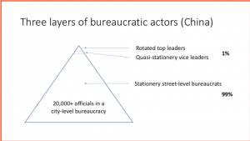
There is an insightful account of the evolution of the public services in five Latin American countries, showing how patronage was gradually squeezed out from government, in a seminal book by Merilee Grindle 2012 Jobs for the boys.
Improving the knowledge, behaviour and integrity of local government officials is likely to be a significant part of most anti-corruption initiatives. There is a lot of material available, covering almost all aspects of public official behaviour, such as: Regulating official discretion, Maintaining ethical employee culture, Clear standards and codes of conduct, Internal reporting procedures, Identification and resolution of conflicts of interest, and Disclosure of assets and political contributions. Sources of such integrity-building material can be found in the following:
- European Commission (2015) Quality of public administration, a toolbox for practitioners. Theme 2: Embedding ethical and anti-corruption practices.
- OECD (2017) Integrity review of Mexico. Taking a stronger stance against corruption.
- Transparency International (2015) Standards and principles for local government
- CIPFA Counter Fraud Centre, UK Local Government Association, UK
- U4 Anti-Corruption Resource Center, Norway Sub-National corruption measurement tools
- UK Government (2015) Local government transparency code 2015.
You might like to use this checklist from CIPFA in the UK to measure the integrity culture and response in your own organisation:
Example: Checklist to measure local government integrity culture, from the UK
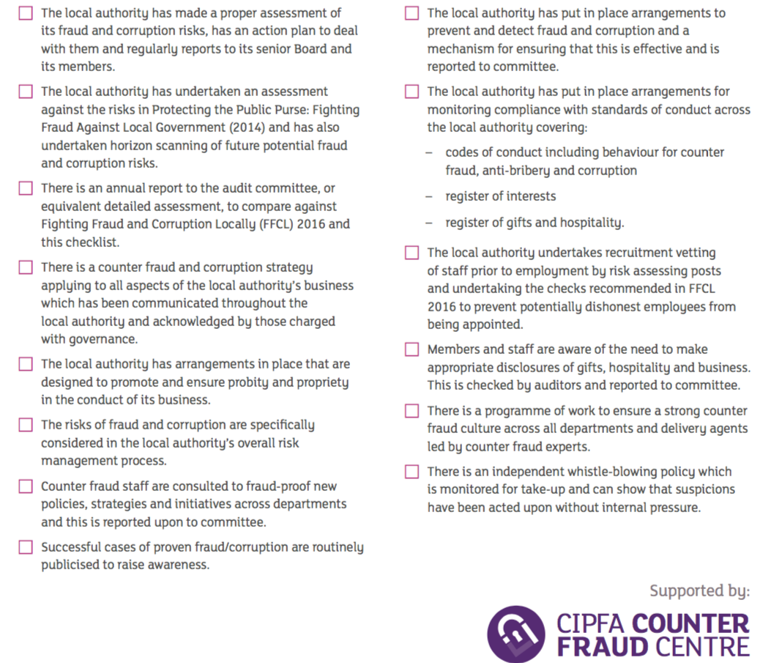

2.7 WHISTLEBLOWING REFORMS
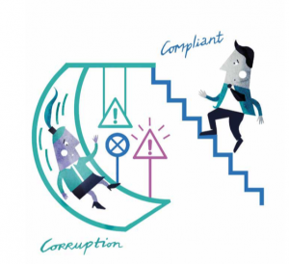Almost all large bureaucracies have mechanisms for complaints and or whistle-blowers. At the same time, these mechanisms often exist on paper only. Civil society has often shown that it can be a more honest and independent way of checking performance and/or being a trusted place that complainants speak with. Today, many complaint systems are actually run by NGOs for this reason. Besides feeling confident to make the complaint to someone, the other half of the complaint system is assurance that there will be prompt and accountable complaint investigation. There needs to be a range of sanctions (fines, loss of contract renewal) which can be implemented without going to the judiciary.

2.8 CIVIL SOCIETY AND MEDIA REFORMS
At local level, you have much more opportunity to enlist citizens for change, or to be pushed forward by citizens who are determined to achieve change. This may involve a ‘call to action’ for citizen involvement, or it may happen naturally. There are also endless opportunities for citizens to monitor whether things are working correctly or not; such mechanisms are often better, and cheaper, than official mechanisms. Much of the anti-corruption effort of the last twenty years have been focused on civil society efforts working on local government deficiencies as much, or more than, on central government corruption issues.
Nonetheless, an analysis of some 471 civil society projects in Eastern Europe found that almost all had failed to have any impact. The distinguishing feature of the 10% that had some impact was that they had developed their projects integrally with media involvement. For further detail, see Mungiu-Pippidi (2015) The quest for good governance, pp172-174. One solution to both these constraints is that the local government can become the engine of permanent, ongoing collaboration with citizens; not just talking to each other on projects, but with citizens as an integral part of the decision and policy environments. Many such mechanisms already exist around the world – such as school committees, patient organisations and police committees of citizens. But they are certainly not yet integral to the world of good governance and anti-corruption.
This emphasis on social participation is much broader than anti-corruption. There are examples in local government all round the world. More and more governments recognise that service users and communities know things that many staff commissioning and delivering public services may not and can help enormously to improve outcomes. The OECD’s ‘Observatory for Public Sector Innovation’ (OPSI) is active in acting as an incubator of this trend and holds multiple country examples. You can read more of their good practice examples here, and there is more theoretical underpinning of the approach in this blog from OPSI in February 2016 on Citizen Powered Cities.
An analysis of 200 civil society anti-corruption projects world-wide, supported by the ‘Partnership for Transparency Fund (PTF)’, found that most of their projects succeeded and were cost effective. The reasons for the success, as explained by one of the founders (Pierre Landell-Mills 2013 Citizens against corruption: report from the front line): Their projects targeting well-identified cases of corruption, understanding exactly what was going on, designing an action plan with a credible chance of success, and structured monitoring of the impact. (Landell Mills, p229). However, many of the projects were not sustainable, and it proved so difficult as to be almost impossible to scale up the projects to a larger scale.
Example: Civil society working on local government corruption issues in Slovakia
Slovakia counts corruption as one of its biggest problems (7th worst country in Europe according to Transparency International Corruption Index). This scenario has been possible due a dysfunctional police and prosecution systems (fostering impunity); the historical disengaged public (lack of interest of the citizens in public affairs); and weak democratic practices due to the transition from communism. In order to solve these issues, Transparency International Slovakia has tried a few solutions, such as: Promoting citizens control by having documents and public documents online e.g. from contract to receipts; Measuring transparency ranking of municipalities; Promoting public awareness raising activities to educate citizens on how to be involved in the local fight against corruption; Ranking local media regarding access, analysing and benchmarking information; Involving mayor and deputies in anti-corruption initiatives; Analysing public documents and helping to start local watchdogs. See more detail at Transparency International Slovakia.
You can also read more of the work in Slovakia at the recent SMART cities conference, Madrid 2017 Transparent and accountable cities: innovative solutions for municipal management and finance’. Session 4 – innovative solutions to increase local capacities in the fight against corruption. Transparency International Slovakia highlighted four aspects that can help improve the work of Slovakian cities in the fight against corruption: (i) more investment in transparency initiatives by national government; (ii) more robust decentralization system; (iii) improved access to information, making sure data is not only published but most importantly readable; and (iv) better channels of communication with citizens.
Example: Community-based NGOs working on local government corruption- Integrity Action
There are thousands of such local action groups and NGOs working to reduce corruption. Here is the approach from one of them, Integrity Action. They have a community approach to improve the quality of public services and infrastructure that has provided benefits to over 5 million people across countries in Africa, Asia and the Middle East. The approach has five phases, outlined in the diagram below.
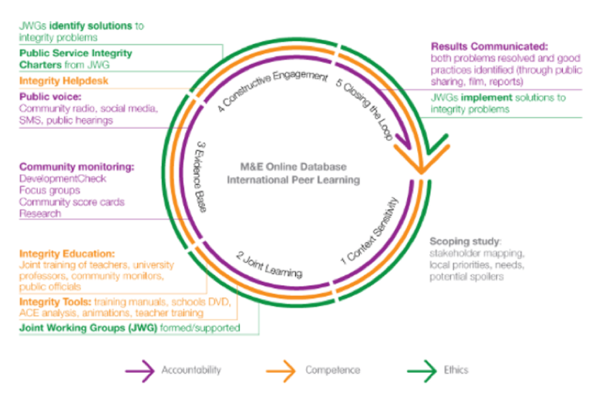
Their collaborative method for local citizens and public officials to work together on improving the provision and performance of public services focuses on i) context sensitivity through mapping of stakeholders and their needs and priorities, ii) joint learning between government, civil society and business, iii) building the evidence base, including acting on the right to information, and community monitoring, iv) constructive engagement in joint working groups and v) closing the loop by integrating citizen feedback and implementing solutions. They have many examples on their website.

2.9 INCENTIVE REFORMS
We don’t have any good examples – do you?

2.10 NUDGE REFORMS
We don’t have any good examples – do you?

3. Developing an overall strategy
Now that you have done the analysis of the specific corruption issues (Section 1), and you have brainstormed with colleagues and others on what reform approaches and specific reform measures may be feasible in your context (Section 2), the third part is to think through and develop your overall strategy.

Guidance summary
STEP 3. After you have reviewed the specific corruption types and identified possible reform measures, you can develop an overall strategy. Because curbing corruption is about changing the status quo, so you need to be thinking about how to build support, how to spread the benefits, how to bring opponents on board or how to outflank them. This is where judgement and political skill are important. You also need to think carefully as to which combination of measures and management is likely to result in the most impact within the limited resources and time available. We suggest that you develop an overall strategy – in collaboration with those who can also own it with you – in the following way:
- Thinking through what impact you really want to achieve
- Challenging yourselves by considering strategic opposites
- Considering the people and the politics; where to build support
- Setting up a sound implementation programme
- Maximising supportive structures across government & stakeholders.

3.1 EXAMPLES OF CITY STRATEGIES
Cities pre-date nation-states by millennia, and the process of urbanisation – particularly when it occurs quickly, and in places where natural and civic resources are limited – has always created opportunities for those willing and able to bend the rules. “A high-density and expanding population puts pressure on space, on water, on public services like health and education, and that causes shortages. Whenever you have shortages, you have big corruption risks; one has to ask oneself ‘who are the gatekeepers of these resources, and how are they being allotted?’ Of course, this can exist in the countryside too, but it plays out in the urban theatre in a more concentrated and drastic way.”(Which are the Most Corrupt Cities in the World?).
We all know this, and there are never-ending corruption cases that go through the courts involving city mayors and officials, whether in Chicago or Colombia, where 1380 Mayors have been charged with corruption over an eight-year period (Quoted inWhich are the Most Corrupt Cities in the World?). But the opposite is also true – thatcities are a fruitful focus for anti-corruption reform: They have a well-defined political leadership and administration; Citizens naturally have a sense of belonging and connection with their home city; It is much easier to show connections between local, grass-roots improvement sand how this can translate across the city, than at national level; Reforms may be possible in individual cities even though the situation at national level is bleak. Two of the best-known global examples of successful corruption reform – Singapore and Hong Kong – are city-states. Furthermore, cities are arguably the most important future locus for corruption reform, with 70% of the world’s population projected to live in cities by 2050 (Zinnbauer, 2017)
In this section we have collected together the reform strategies from four cities: La Paz (Bolivia), Martin (Slovakia), Lviv (Ukraine), Ciudada Juarrez and Monterrey (Mexico). The common feature between all four cases was a reformist group that was able to build support by demonstrating small reforms and an emphasis on self-reliance.

Reform in la Paz, Bolivia.
This radical change experience uses many of the reform approaches. It is of radical reforms in La Paz, Bolivia from 1999 to today, started by Mayor Del Granado. It was not the first reform in La Paz, as there was an earlier effort, under Mayor Ronald Maclean-Abaroa in 1985 that had some impressive successes, but the city returned to its old corrupt habits after his departure. This initiative in Bolivia was a radical one, which won’t work in all environments. But it has many other features that we do think are translatable to other contexts:
- Clear political leadership
- Working with a committed team
- Emphasis on instilling pride, as well as sanctions, in the local government officials
- A serious administrative group, the ‘Transparency unit’, that organises and responds on anti-corruption
- Establishing more participative mechanisms aimed at building trust: discussion forums, scrutinising policies
- Utilising a major event (a flood) to publicly demonstrate the new style of public engagement
- Establishing Improvement units for each of the corrupt bits of bureaucracy, like permits; Online feedback mechanisms for completion of bureaucratic processes
- A changing conception of the council as social participant, not just to direct spending
Reform strategy lessons from La Paz This initiative in Bolivia was a radical one, which won’t work in all environments. But it has many other features that we do think are translatable to other contexts:
- Clear political leadership
- Working with a committed team
- Emphasis on instilling pride, as well as sanctions, in the local government officials
- A serious administrative group, the ‘Transparency unit’, that organises and responds on anti-corruption
- Establishing more participative mechanisms aimed at building trust: discussion forums, scrutinising policies
- Utilising a major event (the flood) to publicly demonstrate the new style of public engagement
- Establishing Improvement units for each of the corrupt bits of bureaucracy, like permits; Online feedback mechanisms for completion of bureaucratic processes
- A changing conception of the council as social participant, not just to direct spending
Be aware that there are also lessons about what did not go so well. In particular, Bolivia sought to scale up this initiative to towns across Bolivia, and in lessons for the national government, neither of which went particularly well. You can read more about this in the Zuniga (2015) article.
Be aware that there are also lessons about what did not go so well. In particular, Bolivia sought to scale up this initiative to towns across Bolivia, and in lessons for the national government, neither of which went particularly well. You can read more about this in the article by Zuniga and Heywood (2015) Cleaning up La Paz.How Bolivia’s biggest city freed itself from a ubiquitous culture of corruption.
A more detailed account of the reforms in La Paz, Bolivia
This description is an abridged text, taken from Zuniga and Heywood (2015).
“The day after he took office, Del Granado realised that none of the municipal vehicles and machines had fuel,” recalls Pedro Susz, a key Del Granado aide. “He ordered the purchase of $10,000 of gasoline to make them functional. Some days later, the vendor insisted on talking face to face with Del Granado. Once in his office, and accustomed to the old practices, he extended a check for $1,000 to Del Granado, saying, ‘Mayor, here’s your 10 percent.’ Those were the last words he managed to utter before being forcibly expelled from the town hall.”
During his first two years in office, Del Granado established a zero-tolerance approach to graft. It was so comprehensive and so strict that Susz, jokingly, called it a “policy of terror,” noting that the administration would “shoot first and ask questions later.” According to Susz, the new administration vowed to take action at the slightest hint of corruption, though always in line with proper legal procedures. As a result, the city’s previous mayors, were prosecuted and imprisoned. The Del Granado administration’s message to the people of La Paz was clear: the days of official impunity were over.
Del Granado and his team reinforced this message by translating their principles into a comprehensive policy program. The program had three main components. First, the reformers made it clear that the fight against corruption would entail rigorous prosecution of corrupt acts, supported by codes of conduct for public officials. Second, the new administration planned to foster economic recovery by reforming the city’s fiscal policies, including collecting due revenues and restoring credibility with external funders and aid agencies. Third, Del Granado and his colleagues aimed to reshape the relationship between public institutions and citizens by establishing greater transparency and more participative mechanisms aimed at building trust. The policy also stipulated pay cuts for members of the executive alongside statutory declarations of individual assets designed to restore the credibility of government.
In a pioneering move in 2004, his city administration created a Transparency Unit. Initially, it operated on a very small budget. (Starting with just five civil servants, it has since grown to employ more than 30 people.) The unit made use of a number of innovative anti- corruption tools. Among these were varied mechanisms for reporting allegations of corrupt acts committed by public officials, including a special telephone tip line, an email address, and an online complaints procedure
The unit also made frequent use of what it called “simulated users,” a form of mystery shopping in which one of its members pretended to be a normal user of a public service in order to detect irregularities in how that service was provided. “There have been cases in which business owners have reported civil servants who were demanding fees in return for blocking possible audits,” says Jorge Dulon, the La Paz Transparency Unit’s current head. “Once the city government receives a complaint of this kind, it then takes coordinated action to catch the civil servant when he meets with the businessperson to receive the money.”
Del Granado’s strategy made use of carrots as well as sticks to incentivise ethical behaviour by public officials. The positive incentives included rewards and recognition for good practice. Once or twice a year, the city government hosted ceremonies in which it presented awards to the most efficient, transparent, cordial, and honest civil servants. Such measures were important above all because they contributed to a positive change in the image and self-perception of public officials.
This process was helped by Del Granado’s public relations acumen and his ability to use events (even natural disasters) to foster a sense of pride among municipal officials and workers. In early 2002, for instance, a food caused by two weeks of heavy rain killed 68 people and left a total of 1,581 victims in the city. La Paz proved highly vulnerable, due largely to decades of unregulated, poor-quality construction on its steep hillsides. A massive communal effort was required to help food victims and repair the damage, and Del Granado’s city employees made an enormous, highly visible contribution. The resulting public gratitude for their efforts bolstered the morale of city officials, who had long been derided by the public for their rent-seeking and predatory behaviour. The experience encouraged them to put public good before individual self-interest. The characteristic yellow vest worn by municipal workers became a symbol of pride, helping to create a sense of loyalty to the city and marking a shift in the way civil servants thought about their role.
Under Del Granado, city officials also vowed to improve the performance of a bureaucracy widely regarded as both inefficient and corrupt. To this end, the La Paz city government created “Continuous Improvement Units” which aimed, among other tasks, to simplify and speed up procedures for planning applications and business permits. This was achieved by putting part of the application process online. The city created web pages that provided detailed information about requirements, deadlines, and timeframes, as well as step-by-step guides to various procedures. The city government also introduced a system for texting citizens to let them know when their applications were completed. These tools increased transparency and thus reduced opportunities for bribery and corruption. The city government also set out to implement transparent procurement policies (including a system for awarding public contracts and tenders on a genuinely competitive basis), to conduct intensified monitoring of public projects (sending inspectors to supervise works and check that the quality of materials complies with the contract and that deadlines are met), and to appoint public officials on the basis of performance rather than political or personal affiliations. All of these measures contributed greatly to restoring the credibility of local government by enhancing transparency and accountability and helping to establish clean governance.
At the same time, the city government was also encouraging the citizens of La Paz to become more involved in running the city and to take more responsibility for the quality of urban life. The effort focused on increasing popular participation in municipal affairs and fostering a sense of common ownership and responsibility. ..The La Paz city government also created the La Paz Assembly , a citizen body that is supposed to provide public scrutiny of medium- and long-term policies. In addition, the city created a network of discussion forums (mesas de diálogo) and other bodies to allow city officials and citizens to jointly explore more strategic topics, such as the Municipal Development Plan. All of these measures exemplified the city government’s changing conception of its purpose. No longer was its function merely to direct municipal spending; from now on it sought to explore new ways of encouraging social participation as well. Such efforts, administrators believed, were essential to building an environment of social trust in which both citizens and officials see themselves as stakeholders, thereby reducing both the opportunity and the need for corruption.

Reform strategy in Lviv, Ukraine
An energetic group of reformers have made huge improvements in this Ukrainian city, despite all the continuing national corruption problems. They had a strong message of self-reliance and chose specifically to focus their reforms on small neighbourhood issues. Examples included: Getting more young people into the city government; Hiring administrators from other cities; A massive internship program (thousands of students); Encouraging businesses and tourism, including in former council locations; Technology outsourcing and a technology hub; and Pressing an integrity message that the city and city officials can and should be honest and open. For more information, see Lozovsky (2015) The Spirit of Lviv.

Reform strategy lessons from Martin, Slovakia
The northern Slovak city of Martin was given the prestigious UN Public Service Award for its anti-corruption reforms. It is the first time that a Slovak institution was awarded such a prize, which is given to public institutions such as ministries or cities. Martin’s example drew interest from other municipalities, especially in the election year of 2010. Meanwhile, late last year, Hrciar was soundly re-elected as a mayor of Martin. For more detail, see Jacko (2016)Bottom-up versus top-down local governance: local government anti-corruption approaches in the Slovak towns of Sala and Martin compared (case study).

Reform strategy in Guadalajara, Mexico
Guadalajara is the second megalopolis in Mexico with 1.5 million habitants. The metropolitan area has 4.5 million people distributed in nine municipalities. The local government of Guadalajara has made important efforts to foster transparency in its fight against corruption with four main strategies: 1) Open data – strategy to make local government information primarily accessible; 2) Accessible performance and infrastructure information – through the development of “El Mapa de Guadalajara”, a site that made information about infrastructure available, so it can be understood for its habitants in terms of indicators and performance; 3) Enhanced citizen participation – Guadalajara has 14 mechanisms of participation that promote the involvement of its citizens in local decisions, and 4) Improved Management System – through the Integral City Management Platform. For more detail, see Smart Cities conference (2017) Transparent and accountable cities: innovative solutions for municipal management and finance Madrid, 2017. Session 4 – innovative solutions to increase local capacities in the fight against corruption

Reform strategies in other cities
A recent report by the Anti-Corruption Resource Centre U4, entitled Corruption and the Citysummarises the positive anti-corruption reforms in a number of other cities. Read the U4 report or the references below for more details. In addition, the ways in which the Mexican cities of Ciudad Juarez and Monterrey managed to claw their way out of a terrible security situation – in which corruption was a real but lesser problem – is also well worth reading. See Conger (2014).
- Medellin, Colombia. See also Which are the most corrupt cities in the world? (Schenker 2016), and Urban uncertainty: Governing cities in turbulent times. Zaiderman (2017)
- Bucharest, Romania. See also We must fight on Gillet (2017) and The anti-corruption package (Sampson 2015)
- Monrovia, Liberia. See also Zinnbauer (2016)
- Abra de Ilog, Philippines. See also Zinnbauer (2016)

3.2 CHINA’S PROVINCES AND DIRECTED IMPROVISATION
A recent analysis of the economic development of China’s provinces, especially the less favoured inland provinces, offers a valuable perspective of how economic development has been, and can be, achieved, alongside gradual control o0f corruption. In her book, Yuen Yuen Ang (2017) charts how China and some other countries developed by a ‘co-evolutionary mechanism’, in which ‘good governance’ mechanisms alternated with periods of relatively uncontrolled economic growth. At the heart of the analysis – ‘how did they do this?’ – is what she calls ‘Directed improvisation’. This comprises three linked processes: Variation – encouraging provincial variation by a deliberate mixture of strict mandates and flexible guidelines. Encourages local boldness; Selection – clearly rewarding success among bureaucratic leaders. Encourages entrepreneurship but also corruption; and Niche creation – encouraging niches and looking for mechanisms to connect successful cities and provinces with laggard ones. In relation to corruption, provinces experience surges in corruption alternating with periods of penalisation and gradual implementation of institutional checks. She gives many examples, such as unauthorised and uncontrolled collection of school fees by local government officials in Forest Hill City, Fujian province, which causes local outrage, which leads to periods of penalisation. After some cycles of this, gradually, institutional checks developed (Ang (2017),p165). She makes the argument that historically most countries developed via this co-evolutionary mechanism, with discussion of medieval Europe, the USA and a Nigerian success story, the Nigerian film industry. This is a different approach than the single-measure approach mostly presented in this chapter. It serves as a good reminder that reducing corruption may not be a linear process, but that success may come through more complex approaches.

4. Transnational initiatives in sub-national government
The task of curbing corruption in local government might seem not to require any trans-national initiatives. But in fact, as corruption knowledge slowly builds beyond purely national-level approaches, various international organisations and transnational initiatives are researching and publishing on how local government reform can be approached. There are now several organisations who have initiatives on raising integrity and reducing corruption in sub-national government. Here are details of three that we know of.

4.1 Council of Europe: Centre of Expertise for Local Government Reform
‘The Centre of Expertise helps European countries deliver good local and regional governance and promotes European standards and best practice in the field. It continuously invests in research and expertise, creates partnerships with national and international actors, develops practical tools and enlarges its offer of programmes by adapting them to the specific needs of the countries.
The Centre provides capacity-building programmes and policy and legal advice to local, regional and national authorities, in order to support on-going processes of reform of public administration and local government. It is directly connected to the European Committee on Democracy and Governance (CDDG) and therefore has a ready access to high-level government officials from the 47 member States and a reservoir of knowledge.
The Centre builds on a unique set of European standards and the 12 Principles of Good Democratic Governance. It has a repertoire of 18 capacity-building toolkits representing the practical crystallisation of the Council of Europe standards and best European practice, enabling the evaluation and reinforcement of the capacities of local authorities.’

4.2 Open Government Partnership
The Open Government Partnership (OGP) is a broad initiative involving 70 nations and is working to increase open government and transparency in some 50 subject areas. One of their new programmes is for improving the transparency and effectiveness of sub-national government. Called ‘Local’, the program recognizes and supports the role that municipal, city, metropolitan, state, regional, and provincial entities play in advancing open government, due to their close proximity to citizens and the crucial public services they provide.
‘OGP launched a Subnational Pilot in 2016, with 15 pioneering subnational governments submitting and implementing their first Action Plans 2016-2017. Moving forward, the program will be known as OGP Local, and will prioritize the participation of diverse range of entities. The OGP Local program aims to harness the innovation and momentum demonstrated by local governments and civil society partners across the world. OGP is a platform for these governments and civil society to come together to make their governments more open, inclusive and responsive, modelling the values and principles of the Open Government Declaration and processes’.
Read more here on the OGP Local Government plan.

4.3 UN Habitat
This UN organisation for a better urban future has some focus on corruption. For example, they published a report in 2006 Restore the Health of your Organisation – A Practical Guide to Curing and Preventing Corruption in Local Government and Communities, Volume 1 Concepts and Strategies. UN Habitat is also involved in more recent anti-corruption support and debate in cities. See for example the report of their Smart Cities conference Transparent and accountable cities: innovative solutions for municipal management and finance Madrid, 2017.

ANNEX: The diversity of sub-national government
Sub-National Government (SNG) varies markedly around the world and therefore also in the nature and types of corruption. In this Chapter we lay out the major variations. The principal source of information is a large OECD 2016 report, ‘Subnational governments around the world, structure and finance’. This detailed survey covers 101 countries that, together, covers 82% of the global population and 87.5% of global GDP.

1. Layers of government
Sub national government varies from a single layer beneath the national government, down to governments with three layers of sub-national government.
Thirty-one per cent of the countries studied by OECD have only one subnational level (municipal). 47% are two-tiered (municipal and regional/ federated state levels), and 23% have three layers of SNGs, with an intermediate level between the municipal and regional/federated state levels.
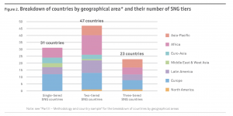
The SNG system can be even more complex in some countries, with additional levels or sub-categories within the same layer, such as in China and India.

Size
The average size of municipalities is 56, 000 inhabitants. Size varies from just a few hundred, up to 500,000 in Malawi and Indonesia. On average, municipalities are larger in Africa and Asia-Pacific than in Europe, Eurasia and North America, see diagram below:
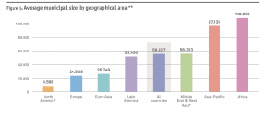

Responsibilities
SNGs can differ greatly in terms of responsibilities, but the OECD analysis shows up some general schemes. The diagram below shows the general split of responsibilities:
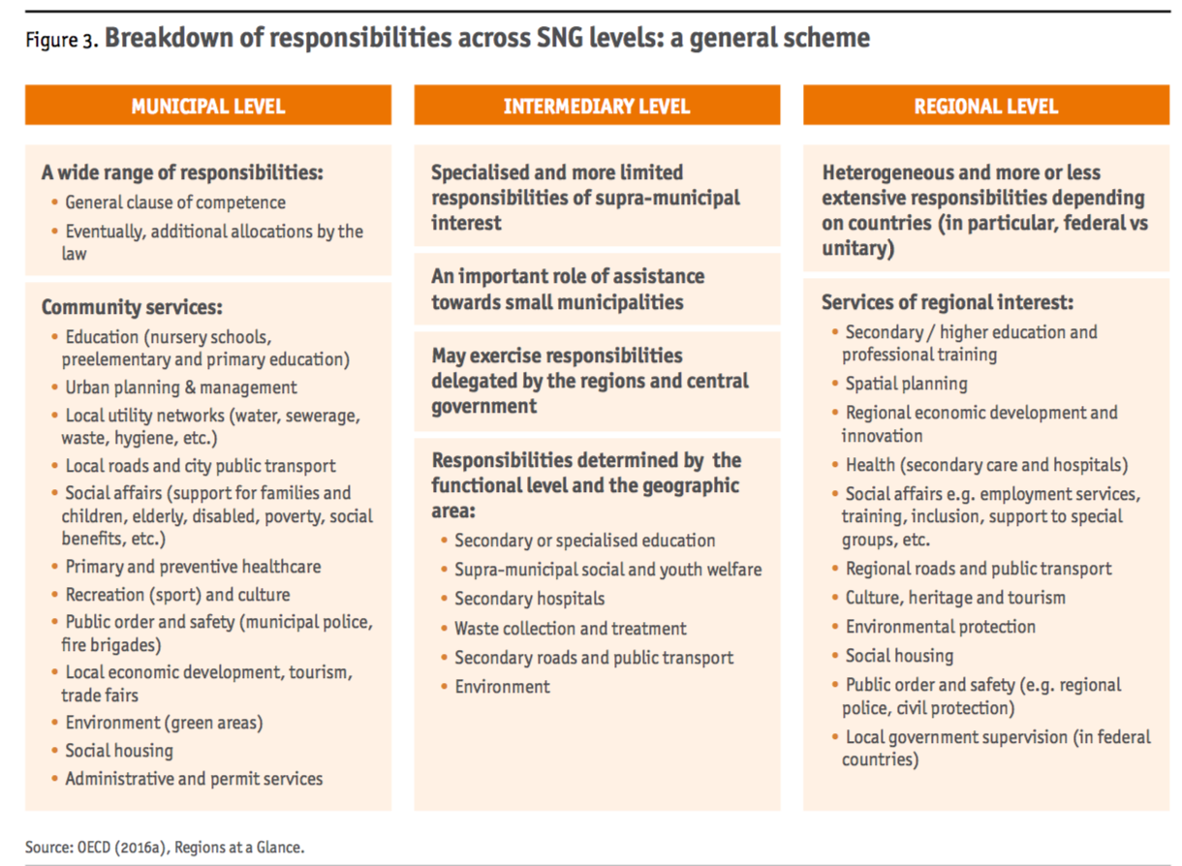

Spending as % of total public expenditure
Sub national government spending across the OECD global sample is on average 24% of public spending, but this varies widely. The variation can be captured in the following four groups.
In three countries, SNG spending is particularly high: Canada (78%), China (85%) and Denmark (63%).
In a second group of countries, sub national spending is high, over 35% of public spending, and accounting for a large share of GDP (between 15% and 25%). These are mostly federal countries, where the expenditure of the state and local government is combined. It includes 8 of the 9 OECD federal countries, plus Argentina, Brazil, India, Russia, South Africa, Finland, Korea, Japan, Vietnam and Sweden.
The third group of countries comprise lower public spending, from 15% to 35% of public spending, and lower share of GDP (8% to 15%). This covers many unitary countries from Europe, plus Colombia, Peru, Indonesia, Mongolia, Philippines, Kazakhstan and just one from Africa (Ghana).
The last group of countries comprises centralised countries where local authorities have limited spending responsibilities (from less than 20% of public spending down to zero). This group includes almost all African countries and several OECD countries, such as Chile, Greece, Hungary, Iceland, Israel, New Zealand, Portugal and Turkey. It also includes most of the Latin American countries and a few Asia pacific countries (eg Thailand, Cambodia).
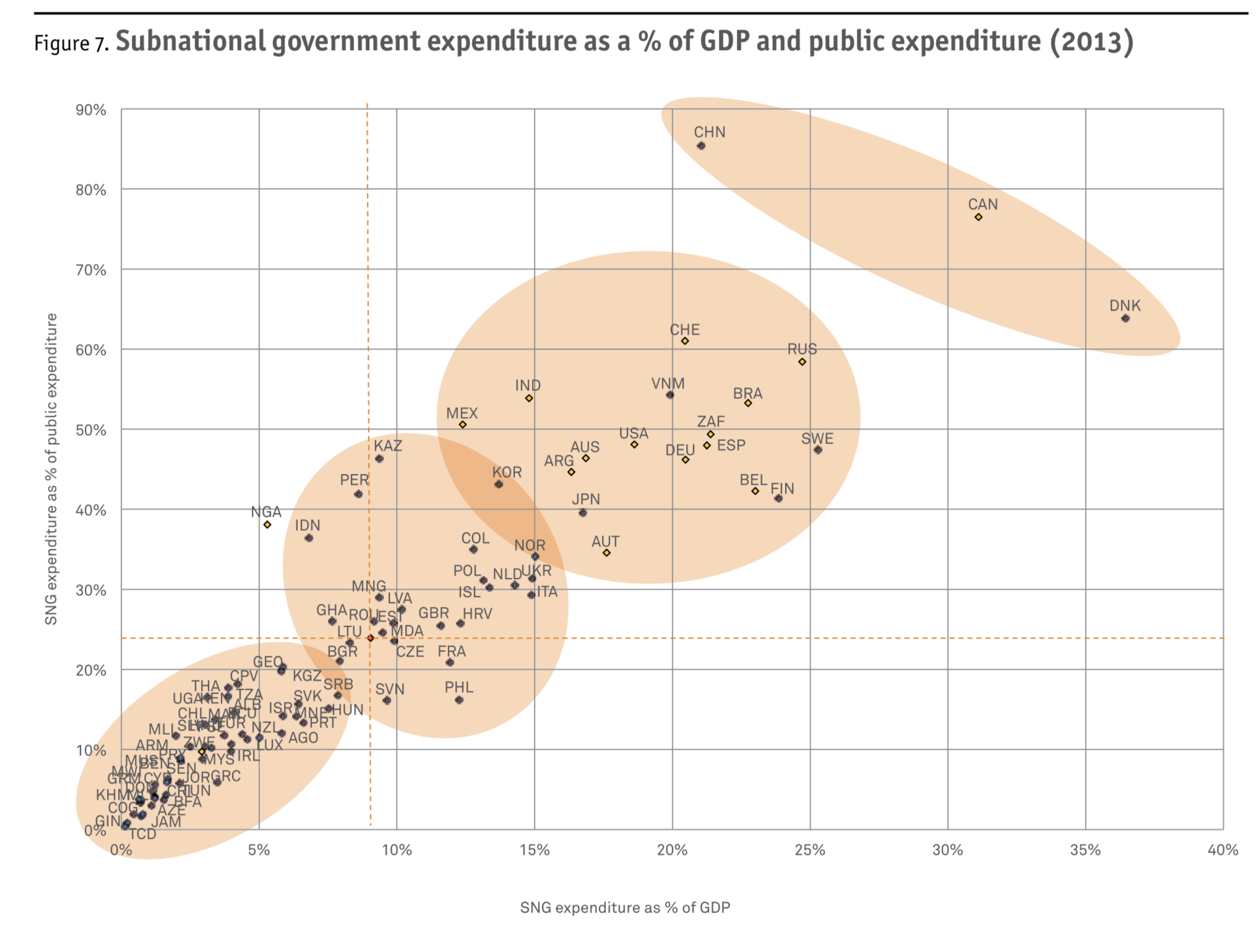
There is a positive correlation between high expenditure on sub national governments and the development level of the countries, as shown by the diagram opposite.
There is also a positive correlation between the extent of decentralisation and the development level of the countries. But the OECD is quick to point out that decentralisation is neither good nor bad and observes that it offers risks as well as rewards. The same is true on corruption, where some anti-corruption measures favour centralisation, whilst others are based on decentralisation.

Spending – by economic function
Across all the countries for which categorised data was available ( 61 of the 101 countries), about 70% of the spending was taken up by four categories: education, social protection (social services and benefits, plus social infrastructure), economic affairs and transport, and ‘general public services’, which covers all expenses relating to the organisation and operation of government.
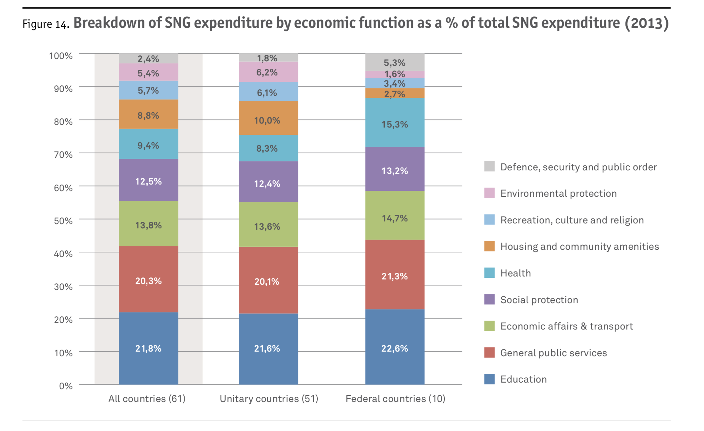
Staff salaries were on average 34% of total SNG expenditure. The next categories of spending were health, housing and recreation.

Public investment
Public investment at sub national level is on average 39% of total public investment. In low income countries it is almost nothing (7% of public investment) whilst in all other categories of country it ranges from 35% to 49%.

Sub-national revenues
Sub national revenues are on average 8% of public revenue for low income countries, rising to 31% of public revenue for high income countries. The OECD classifies SNG revenue into three broad categories: tax revenue, grants and subsidies, and other revenues. On average, SNGs receive 32% of their revenue from local taxes, 52% of its revenue from grants and subsidies from central government, and 16% from other sources. The pattern varies widely across the countries. At one extreme are Uganda, Malta, Mexico and Tanzania, where sub national government receives over 90% of its revenue from central government. At the other extreme, revenue from government is less than 5% for SNG in Jordan, Zimbabwe and Argentina.

Split of institutional responsibilities between central and local government
Sometimes initiatives are best if they are local, with no complexity introduced by seeking to align with other entities, whether local or central. Several of the early city anti-corruption initiatives were like this, for example from Mayors in Bogota, Colombia and La Paz, Bolivia in Latin America, and in several cities in Eastern Europe, such as Martin in Slovakia. More recently, other cities have been active in tackling corruption and fraud, driven by the pressure on budgets, for example Manchester in the UK.
If this is what you are doing, or planning to do, then you don’t need to read this Chapter.
On the other hand, it can be essential to set up formal arrangements and active coordination mechanisms, both formal and informal. These might be between central and local government, or across multiple local governments, or between the government agencies and private sector and/or NGOs
If this describes your situation, then one of the groups with the most knowledge of how to set up such arrangements is the OECD. Their public governance group is examining how integrity initiatives that span central and local government are being set up in many OECD countries. Here, for example, is their overview from 2017:
‘Countries vary extensively in how they organise their public integrity systems, and in many cases, responsibilities are shared between one or more institutions. A decentralised approach prevails, however, with individual line ministries within the executive branch being responsible for designing and leading the bulk of integrity policies: from integrity rules and codes of conduct to policies for the management of conflict of interest policies, the transparency of lobbying activities, and internal control and risk management.…Countries should clearly delineate institutional mandates as well as ensure organisations are equipped with the sufficient resources and capacities to effectively carry out their responsibilities (OECD 2017).’
And, as the understanding of ways to reduce corruption evolve, new roles are appearing for central government units, who can bring together diverse groups of organisations, often across diverse political and organisational boundaries. Here is OECD again:
‘Public integrity systems are composed of a multitude of actors responsible for various specific policy areas. Furthermore, these actors span both central and sub- national (i.e. regional and local) levels of government. mechanisms for vertical and horizontal inter-institutional co-ordination are therefore crucial to ensure effective implementation throughout the whole of government, as well as to prevent duplication or fragmentation which can lead to waste of public resources and/or ineffective policies. Many integrity systems are decentralised. In 71% of countries (22 countries), state or local governments are considered autonomous and able to determine their own integrity policies. this includes many (but not all) OECD federal and quasi-federal countries such as Belgium, Spain and Switzerland. Indeed, the notion of local integrity systems makes sense in many countries, given that integrity risks can vary considerably across territories and administrative jurisdictions, and one-size-fits all approaches would likely be ineffective.
Even where state and local governments are autonomous in the design and implementation of integrity policies, they are often supported by the central level through co-ordination mechanisms. Indeed, only few countries (3 countries) do not have in place any co-ordination mechanism. the most common forms of support are guidance by a central government integrity body (9 countries), regular meetings in a specific integrity committee or commission (11 countries), and involvement of state and local governments in the design of the policies themselves (7 countries).
Other countries have adopted more formal approaches to co-ordination. In Estonia, Japan, Mexico and New Zealand, for instance, legal agreements or contracts between central and sub-national governments are utilised.’
OECD (2017) survey data allows a more detailed understanding of how each OECD country organises this central/local coordination: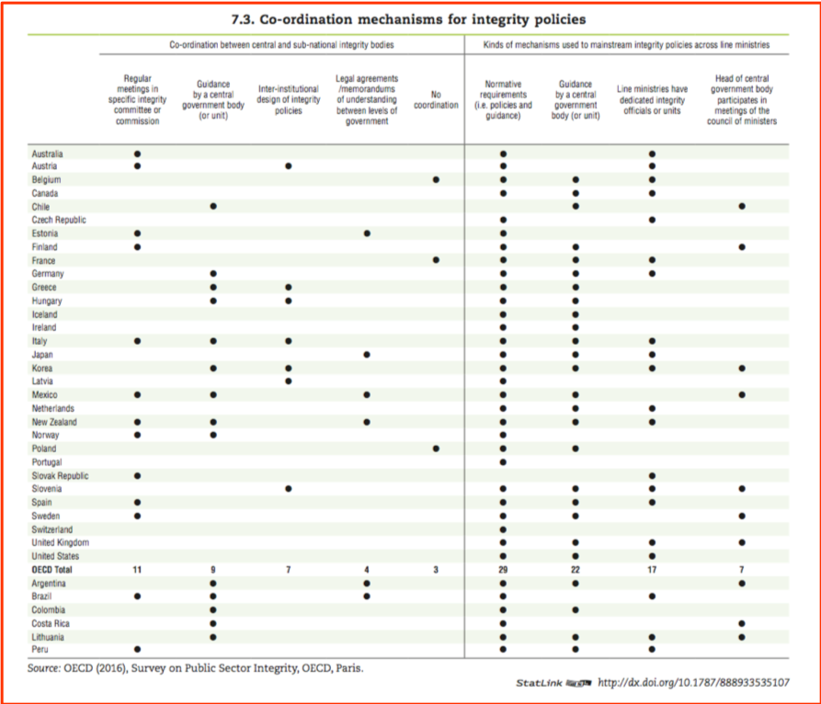
This is a good template to which to map your own country arrangements. Here is the example of Canada, looking to see how different arrangements are set up across its three levels to deal with Conflict of Interest. This comes from Anderson (2013) ‘Municipal best practices for dealing with fraud and corruption’:
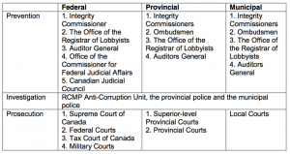

Relevance for curbing corruption
This overview makes it clear that local government is a huge part of the country’s economic activity, and that each country’s form of local government is very different. It is thus essential to know specifics of your own country when it comes to tackling local government corruption.

Reading and bibliography

ADDITIONAL READING
UK local government anti-corruption strategy
United Nations Habitat (2006): Restore the Health of Your Organization: A Practical Guide to Curing and Preventing Corruption in Local Governments and Communities, Volume 1, Concepts and Strategies. Author Fred Fisher
Council of Europe (2017): Strengthening public ethics and preventing corruption in public administration: toolkit for public authorities.Centre of expertise for local government reform.
Transparency International (2014): Local integrity system assessment toolkit.
Transparency International Norway (2016): Protect your municipality: An anti-corruption handbook.

BIBLIOGRAPHY
Local government sector: Full bibliography
Afghanistan Independent Monitoring and Evaluation Committee (2016) Vulnerability to Corruption Assessment of Municipalities Revenue Collection. http://www.mec.af/files/2016_07_11_Municipalities_VCA_(English).pdf
Albornoz, Facundo and Cabrales, Antonio (2013) Decentralization, Political Competition and Corruption https://pdfs.semanticscholar.org/1a0d/e0a2dd214472f2a79929063412948e017262.pdf
Anderson, Elizabeth (2013) Municipal “Best Practices”: Preventing Fraud, Bribery and Corruption, International Centre for Criminal Law Reform and Criminal Justice Police. https://icclr.law.ubc.ca/wp-content/uploads/2017/06/Municipal-Best-Practices-Preventing-Fraud-Bribery-and-Corruption-FINAL.pdf
Ang, Yuen Yuen (2017) How China escaped the poverty trap. Cornell University Press. http://www.cornellpress.cornell.edu/book/?GCOI=80140100715940
Camargo, Claudia Baez and Passas, Nikos (2017) Hidden agendas, social norms and why we need to re-think anti-corruption, Basel Institute on Governance, Working paper series 22. https://www.oecd.org/cleangovbiz/Integrity-Forum-2017-Baez%20Camargo-Passas-hidden-agendas-social-norms.pdf
Bertot, John, Jaeger, Paul and Grimes, Justin (2010) Using ICTs to create a culture of transparency: E-government and social media as openness and anti-corruption tools for societies. Government information quarterly 27, 264-271. https://ac.els-cdn.com/S0740624X10000201/1-s2.0-S0740624X10000201-main.pdf?_tid=ecfd14d6-a7fa-47be-8475-66521b58cc3c&acdnat=1531394490_cdfb5dbd8e0322690255eabe99df9579
Camargo, Claudia Baez (2013) Communities against corruption: Assessment framework and methodological toolkit, Basel Institute on Governance, Working Paper Series No 18. https://www.baselgovernance.org/sites/collective.localhost/files/publications/working_paper_18_-_communities_against_corruption.pdf
Centre for the Advancement of Public Integrity (CAPI) (2016) An overview of state and local anti-corruption oversight in the United States. https://www.law.columbia.edu/sites/default/files/microsites/public-integrity/files/overview_of_state_oversight_institutions_-_capi_issue_brief_-_august_2016_0.pdf
Centre of Expertise for Local Government Reform, Council of Europe. https://www.coe.int/en/web/good-governance/centre-of-expertise
CIPFA (2016) The local government counter fraud and corruption strategy 2016-2019.http://www.cipfa.org/services/counter-fraud-centre/fighting-fraud-and-corruption-locally
Conger, Lucy (2014) The private sector and public sector security: the cases of Ciudad Juarez and Monterrey, Mexico. Wilson Center, University of San Diego. https://www.wilsoncenter.org/sites/default/files/conger_private_sector.pdf
Council of Europe, Centre of Expertise for Local Government Reform (2017) Strengthening public ethics and preventing corruption in public administration: toolkit for public authorities. https://rm.coe.int/peb-public-ethics-benchmarking/1680746d52
Council of Europe (2015) Best Practices in Local Government, Council of Europe, Strasbourg. https://rm.coe.int/1680746d97
da Cruz, Nuno Ferreira, Tavares, António F., Marques, Rui Cunha, Jorge, Susana and deSousa, Luís (2015) Measuring local government transparency. Public Management Review, ISSN 1471-9037. DOI: 10.1080/14719037.2015.1051572. Also available from:http://eprints.lse.ac.uk/62312/1/__lse.ac.uk_storage_LIBRARY_Secondary_libfile_shared_repository_Content_Da%20Cruz,%20N%20F_Measuring%20local%20government_Da%20Cruz_Measuring%20local%20government_2015.pdf
European Commission (2017) Quality of public administration, a toolbox for practitioners.http://ec.europa.eu/social/main.jsp?catId=738&langId=en&pubId=8055&type=2&furtherPubs=no
European Commission (2015) Quality of public administration, a toolbox for practitioners. Theme 2: Embedding ethical and anti-corruption practices. http://ec.europa.eu/social/main.jsp?catId=738&langId=en&pubId=7757&furtherPubs=yes
http://ec.europa.eu/esf/BlobServlet?docId=13945&langId=en
European Commission (2014) Special Eurobarometer report 397 on corruption.http://ec.europa.eu/commfrontoffice/publicopinion/archives/ebs/ebs_397_en.pdf
European Parliamentary Research Service (2017) Corruption in the European Union: Prevalence of corruption, and anti-corruption efforts in selected EU Member States. Authors: Piotr Bąkowski and Sofija Voronova. http://www.europarl.europa.eu/thinktank/en/document.html?reference=EPRS_STU%282017%29608687
Gillet, Kit (2017) We must fight on: Romania’s crusader against corruption won’t back down. The Guardian, Feb 12th, 2017. https://www.theguardian.com/world/2017/feb/12/romania-corruption-chief-prosecutor-laura-codruta-kovesi–steely-vigilance
Grindle, Merilee (2012) Jobs for the Boys: patronage and the state in comparative perspective.Harvard University Press. http://www.hup.harvard.edu/catalog.php?isbn=9780674065703&content=reviews
Institute for Democracy and Mediation in Albania (2016) Challenges of local government units in the fight against corruption. An assessment of the anti-corruption system in 20 municipalities of Albania. http://idmalbania.org/wp-content/uploads/2016/10/Report_Challenges-of-LGUs-in-the-fight-against-corruption.pdf
Jacko, Tomas (2016) Bottom-up versus top-down local governance: local government anti-corruption approaches in the Slovak towns of Sala and Martin compared (case study). http://www.fos-unm.si/media/pdf/jacko_maj.pdf
Khan, Mushtaq, Andreoni, Antonio and Roy, Pallavi (2016) Anti-corruption in adverse contexts: a strategic approach. SOAS Research Online. http://eprints.soas.ac.uk/23495/1/Anti-Corruption%20in%20Adverse%20Contexts%20%281%29.pdf
Kirya, Monica (2011) Performing “good governance” Commissions of Inquiry and the Fight against Corruption in Uganda. PhD Thesis, University of Warwick, UK. http://wrap.warwick.ac.uk/47800/
Klitgaard, Robert (2015) Addressing corruption together,OECD.https://www.oecd.org/dac/conflict-fragility-resilience/publications/FINAL%20Addressing%20corruption%20together.pdf
Klitgaard, Robert, Maclean-Abaroa and Parris, Lindsay (2000) Corrupt cities: a practical guide to cure and prevention. http://documents.worldbank.org/curated/en/709171468743399124/pdf/multi-page.pdf
Landell-Mills, Pierre (2013) Citizens against corruption: report from the front line.Partnership for Transparency Fund. https://ptfund.org
Legatum Institute (2015) The spirit of Lviv.Author Lovovsky, Ilya. https://www.licom/activities/publications/the-spirit-of-lviv
Mungiu-Pippidi (2015) The quest for good governance: How societies develop control of corruption. Cambridge University Press.https://www.cambridge.org/core/books/the-quest-for-good-governance/4FC4343AEFA5A729C0C95979AAAA8FCE
OECD (2017) Integrity review of Colombia. Investing in integrity for peace and prosperity. OECD Public Governance Reviews, OECD Publishing, Paris. http://dx.doi.org/10.1787/9789264278325-en http://www.oecd.org/gov/ethics/oecd-integrity-review-of-colombia-9789264278325-en.htm
OECD (2017) Integrity review of Mexico. Taking a stronger stance against corruption. OECD Public Governance Reviews, OECD Publishing, Paris. http://dx.doi.org/10.1787/9789264273207-en.And https://www.oecd.org/corruption/ethics/mexico-integrity-review-highlights.pdf
OECD (2017) Multi-level governance reforms; overview of OECD country experiences. Edited by Chatry, Isobelle and Hulbert, Claudia.OECD Public Governance Reviews, OECD Publishing, Paris.
OECD (2017) Decentralisation and multi-level governance in Kazakhstan. OECD Public Governance Reviews, OECD Publishing, Paris.
OECD (2017) OECD Integrity Review of Colombia: Investing in Integrity for Peace and Prosperity.
OECD (2016) Subnational governments around the world: Structure and finance A first contribution to the Global Observatory on Local Financeshttps://www.oecd.org/regional/regional-policy/Subnational-Governments-Around-the-World-%20Part-I.pdf
OECD (2012) Reforming Fiscal Federalism and Local Government: Beyond the Zero-Sum Game.http://www.oecd.org/tax/reforming-fiscal-federalism-and-local-government-9789264119970-en.htm
OECD (2010) OECD Fiscal Decentralisation Database.http://www.oecd.org/tax/federalism/oecdfiscaldecentralisationdatabase.htm
OECD (2005) Public sector integrity: a framework for assessment.http://www.oecd.org/gov/ethics/publicsectorintegrityaframeworkforassessment.htm
Pagés, Luis Cembellín (2015) Tools to measure the local government, transparency and accountability. University of Malaga.http://www.namcb-org.bg/gga/images/2015/10.2015/Conference_1_Luis_Cembellin.pdf
Pyman, Mark, Eastwood, Sam, Hungerford, Jason, and Elliott, Jasmine (2018) Analysing the anti-corruption approaches of the 26 top-ranked countries: an opportunity for a new generation of strategies. Institute for Statecraft and Norton Rose Fulbright, March 2018.Available at:http://www.statecraft.org.uk/sites/default/files/documents/EMEA_2384_Bespoke%20brochure__Countries%20Curbing%20corruption%20final%20report_V3….pdf
Pyman, Mark, Eastwood, Sam, Hungerford, Jason, and Elliott, Jasmine (2017) Research comparing 41 national anti-corruption strategies. Insights and guidance for leaders. Institute for Statecraft and Norton Rose Fulbright. http://www.nortonrosefulbright.com/knowledge/publications/147479/countries-curbing-corruption
Reinikka, Ritva and Svensson, Jakob (2002) Measuring and understanding corruption at the micro level. World Bank. http://siteresources.worldbank.org/INTKNOWLEDGEFORCHANGE/Resources/491519-1199818447826/280210Measuring0corruption.pdf
Sampson, S (2015) The anti-corruption package. Ephemera. Vol. 15. No. 2.
Schenker, Jim (2016) Which are the most corrupt cities in the world?.The Guardian. Tuesday 21st June 2016.
Shah, Anwar (2007) ed. Participatory Budgeting. World Bank. https://siteresources.worldbank.org/PSGLP/Resources/ParticipatoryBudgeting.pdf
Tickner, Peter (2010) The successful frauditor. Routledge.
Tickner, Peter (2012) The successful frauditor’s casebook. Routledge.
Transparency International (2015) Local governance integrity: principles and standards,Authors: Nuno Ferreira da Cruz (EBES Consultores, Lda), Michel Gary. http://www.law.columbia.edu/sites/default/files/microsites/public-integrity/files/shifting_landscapes_panel_cle_materials.pdf
Transparency International (2014) Local integrity system assessment toolkit. https://www.transparency.org/whatwedo/publication/local_integrity_system_assessment_toolkit
Transparency International (2009) Corruption and Local Government, Working paper. https://www.transparency.org/whatwedo/publication/working_paper_05_2009_corruption_and_local_government
Transparency International Ireland (2018) National Integrity Index 2018: Local authorities.Authors McCarthy, Kelly and Devitt, John. https://www.transparency.ie/sites/default/files/18.05.14_nii_report_vf.3_web.pdf
Transparency International Norway (2016) Protect your municipality: An anti-corruption handbook. http://transparency.no/wp-content/uploads/sites/10/TI_kommunehandboka_eng_digital.pdf
Transparency International UK (2013) Corruption in UK local government: the mounting risks. http://www.transparency.org.uk/publications/corruption-in-uk-local-government-the-mounting-risks/#.Wp0rdracZYd
Transparency International Ukraine (2017) Methodology for rating the transparency of cities.https://knowledgehub.transparency.org/assets/uploads/kproducts/Methodology_en_PRINT-1.pdf
U4 Anti-Corruption Resource Centre (2018) Corruption and the city https://www.u4.no/publications/corruption-and-the-city
UK Government (2015) Local government transparency code 2015.Published by the Department for Communities and Local Government. https://www.gov.uk/government/uploads/system/uploads/attachment_data/file/408386/150227_PUBLICATION_Final_LGTC_2015.pdf
UNDP (2016) An integrated framework to support local governance and local development.http://www.undp.org/content/undp/en/home/librarypage/democratic-governance/local_governance/integrated-framework-to-support-local-governance-and-local-devel.html
UNDP (2014) Global Thematic Programme on Anti-Corruption for Development Effectiveness (PACDE), UNDP, 2014; Editors: Anga Timilsina and Diana Torres. http://www.undp.org/content/dam/undp/library/Democratic%20Governance/Anti-corruption/f_UNDP-PACDE13_report_Web.pdf
UNDP (2014) Global anti-corruption initiative (GAIN), highlights of the key achievements in 2014, Editors: Israel Marañón and Sabrina Hoque, UNDP. http://www.undp.org/content/undp/en/home/librarypage/democratic-governance/anti-corruption/global-anticorruption-initiative-2014.html
UNDP (2011) Local governance, anti-corruption and REDD+ in Latin America and the Caribbean: exploring synergies to strengthen transparency and accountability.
Beatriz García, UNDP REGIONAL CENTRE PANAMA, 2011. http://www.forestcarbonportal.com/sites/default/files/LocalGovernanceCorruptionREDD.pdf
UNDP Oslo Governance Centre (2008) A Users’ Guide to Measuring Local Governance,http://www.undp.org/content/undp/en/home/librarypage/democratic-governance/local_governance/a-users-guide-to-measuring-local-governance-.html
United Nations Habitat (2006) Restore the Health of Your Organization: A Practical Guide to Curing and Preventing Corruption in Local Governments and Communities, Volume 1, Concepts and Strategies. Author Fred Fisher. https://unhabitat.org/books/restore-the-health-of-your-organisation-a-practical-guide-to-curing-and-preventing-corruption-in-local-government-and-communities-volume-1-concepts-and-strategies/
URAIA (2017) Transparent and accountable cities: Innovative solutions for municipal management and finance. Workshop Report. UN Habitat and FMDV. Madrid, February 9-10 2017. https://www.oidp.net/docs/repo/doc209.pdf
USAID (2014) Analysis of USAID anticorruption programming worldwide 2007-2013. https://www.usaid.gov/sites/default/files/documents/1866/AnalysisUSAIDAnticorruptionProgrammingWorldwideFinalReport2007-2013.pdf
Weick (2001) Making Sense of the Organisationhttps://www.amazon.co.uk/Making-Organization-KeyWorks-Cultural-Studies/dp/0631223193
Wikipedia (2018) Corruption in local government.https://en.wikipedia.org/wiki/Corruption_in_local_government
Zaiderman A (2017) Urban uncertainty: Governing cities in turbulent times. LSE Cities Report. London School of Economics and Political Science. London.
Zinnbauer, Dieter (2017) Urban land: A new type of resource curse? In Williams, A. and P. Le Billon (Eds). Corruption, natural resources and development: From resource curse to political ecology. Edward Elgar Publishing. Cheltenham and Northampton (MA).
Zinnbauer, Dieter (2016) Corruption: Habitat III Agenda’s elephant in the room. http://hlrn.org/activitydetails.php?id=pHBoag==#.WxqwFrbMzOR
Zuniga, Nieves and Heywood, Paul (2015) Cleaning up La Paz.How Bolivia’s biggest city freed itself from a ubiquitous culture of corruption. Legatum Institute. https://www.li.com/activities/publications/cleaning-up-la-paz

