Sector | Police services

INTRODUCTION
‘Police work imposes a seemingly unique combination of pressure and temptations towards highly diverse forms of misconduct …even relatively mature democracies continue to struggle to control police conduct’. These words, from two eminent experts on police corruption (Porter and Prenzler 2016, p370) demonstrate the importance of continuous attention to corruption in policing.
Police corruption is routinely found to be among the most prevalent forms of corruption in societies. Citizens rate police corruption as one of the top three corruption concerns in all parts of the world except Western Europe: see the Figure opposite, extracted from Transparency International’s Global Corruption Barometer (Pyman et al 2012),showing how highly people rate police corruption in their country, compared with other forms of corruption.
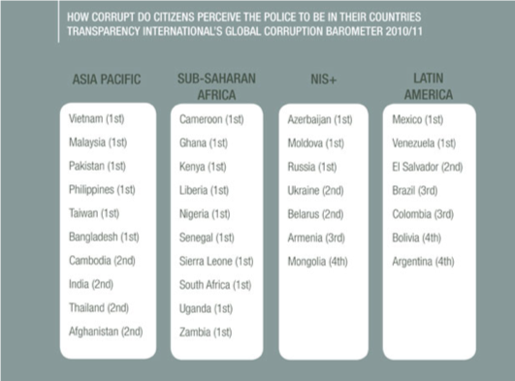
Only in Western Europe is policing not among the top three corruption issues but is still significant. For example, the UK has headlines such as The shocking truth about police corruption in Britain; It’s a growing problem, but they’re hunting whistleblowers instead (Darbyshire 2015). In its latest Anti-Corruption strategy, identifies corrupt insiders in the police, along with borders, customs and defence, for attention (UK Cabinet Office, 2017). Australia, too, is familiar with police corruption. Here is an extract from the conclusion of a Supreme Court judge in Australia chairing an enquiry into police misconduct: ‘The Police Force is debilitated by misconduct, inefficiency, incompetence, and deficient leadership. The situation is compounded by poor organization and administration, inadequate resources, and insufficiently developed techniques and skills for the task of law enforcement in a modern complex society. Lack of discipline, cynicism, disinterest, frustration, anger and low self-esteem are the result. The culture which shares responsibility for and is supported by this grossly unsatisfactory situation includes contempt for the criminal justice system, disdain for the law and rejection of its application to police, disregard for the truth, and abuse of authority’ (Prenzler 2009, p592).
This review. You can read the whole of this review, or you can jump to any one part of it. Here are the main sections:
- Police-specific corruption types
- Reforms and experience in policing
- Developing an overall strategy
- Transnational initiatives and expertise in policing
Plus recommended additional reading and a full list of sources in Reading and Bibliography
Or download the review as a pdf document:

Pyman Cohen Boardman Webster and Seymour 2012 Transparency International Defence - Arresting corruption in the police

Author and contributors. The originating author of this review is Mark Pyman, who is the managing editor of CurbingCorruption. Additional contributions were made by Paulo Costa of DCAF; (others).

1. Corruption types in policing

Guidance summary
STEP 1. We suggest you start by understanding in detail the different corruption types that you are faced with. You can do this in the following way:
- Look at the template of sector corruption types in our review, and adjust these according to your situation.
- Gather available data. We suggest that you do this first at a macro level, to get a sense of which corruption issues are big or small across the sector, across countries, across different regions. Often there is a lot of such macro data publicly available. Then, gather available data at the micro level, local to you.
- Decide if it would help to do a formal analysis of the corruption types and the levels of corruption risk. This takes time, but gives you a thorough baseline for your reforms. It also serves to show the level of danger and damage from corruption to staff and to the public.
- Finally, consider doing an analysis of the levels of support and opposition that you can expect. This is called a ‘political economy analysis’.
You can read more guidance on Step 1 here.
Most of the analysis of police corruption and corruption types originates from Public Commissions of enquiry that have been held since the 1970s in the USA, UK and Australia and other anglophone countries. Since then, attention from police academies, university academics, think tanks and NGOs, as well as more attention from police forces themselves, has contributed to a much better knowledge of the different sorts of corruption in policing, and mechanisms for addressing them. Now there are good typologies of the different sorts of police corruption that you can use and adapt.

1.1 EARLY ANALYSES OF POLICE CORRUPTION
In the early twentieth century, claims of corruption within forces were generally dismissed as the bad deeds of ‘rotten apples’, whose removal would leave the rest of the department clean. The early commissions of enquiry that arrived at these conclusions tended also to be under-equipped, wield insufficient legal powers, and were incapable of forcing long- lasting reforms (Prenzler 2002).
By the 1970s, however, political developments and public pressure, generally voiced through the media, contributed to the creation of strong commissions with the power to enact change. The most famous was the Knapp Commission in New York City between 1970 and 1972. It quickly became apparent, not just to the investigators and the commissioners, but to the world’s public – particularly through mass-distributed films like ‘Serpico’ – that the New York Police Department (NYPD) contained widespread corruption. Networks of corrupt and criminal activity permeated the department, protection rackets systematically extorted bribes from businesses, officers actively sought corruptible assignments in vice areas like prostitution and gambling, and law enforcement was almost universally discriminatory.
More on the history of tackling police corruption
The Knapp report undermined the ‘rotten apple’ explanation for corruption, showing that corruption could become systemicand involve many more officers than could plausibly be labelled as naturally ‘bad’ individuals. Subsequent commissions such as the Mollen Commission (1992-94, New York City) and the Wood Commission (1995-97, New South Wales, Australia) found further evidence of systemic rather than isolated or individual corruption. Punch (2009) suggests that whole ‘orchards’ rather than individual apples are to blame, pointing at a holistic, institutional failure as being responsible for corruption.
With the realisation that corruption needed to be combated on a large scale, some way of conceptualising the problem became necessary. The Knapp Report presented a simple typology, dividing corrupt officers into three categories:
- ‘grass-eaters’, who opportunistically accept offers of bribery and free gifts
- ‘meat- eaters’, who actively and aggressively pursue corrupt activities for personal or departmental gain, and
- ‘birds’, who ‘fly above’ corruption, choosing to shelter in high administrative positions, but who can later play a key role in the reform process if granted senior management positions.
Kuntjak Ivkovic and Haberfeld (2015), compare the perceptions of police integrity across multiple countries showed that while the most serious (‘meat-eating’) cases of corruption drew largely homogeneous responses, the least serious (‘grass-eating’), such as acceptance of gifts or off-duty employment, drew wide-ranging, heterogeneous opinions. This finding suggests that the problem of petty corruption, which is not just harmful in individual instances but because it can become widely accepted and even institutionalised, is exacerbated by differences in opinion over how serious it is.
These Commissions did a lot of good, and also provided a new, thorough basis for a better understanding of the particularities of corruption in the police. There is a good article that provides a synthesis of the lessons from 32 of these Commissions in ten English-speaking countries(What past scandals can teach us about police corruption Bayley and Perito (2011) – See list of the Commissions in Section 2.3.2). They conclude that:
- Police corruption takes predictable forms (the ‘typologies’ that are described below)
- Drugs have been the main driver of corruption since 1970, replacing gambling, prostitution and alcohol
- Police corruption is shaped by the specifics of police culture (more pervasive in developing countries; need everywhere for external monitoring)
- Knowledge about police corruption is limited by context (the authors can see no reason why major commissions have taken place in so few countries, eg USA and Australia, and not in other countries)
- Remedial strategies are recycled from one commission to another. The most common reform is a call for independent external monitoring.

1.2 POLICE CORRUPTION TYPOLOGY
Since the US Police Commissions of the 1970s, many experts and practitioners have produced lists of corruption types in policing, called a ‘typology’. These typically show 20-40 different specific policing corruption issues. The typology that we recommend you use as your template comes from Transparency International (Pyman et al 2012 Arresting corruption in the police: the global experience of police corruption reform efforts) and identifies 34 types of police service corruption in five categories, from strategic level political corruption through to ‘on the beat’ corruption in operations.
The table in the box below gives an explanation of each of the 34 corruption types.
Elaboration of the 34 policing corruption types shown in Transparency International’s typology
Category & Corruption type | Description
Political
1. Unclear domestic policing strategy | Poorly conceived strategy/policy can serve as the entry-point for high level corruption: a vague or unpublished policy not only sets the wrong ‘tone from the top’ but can encourage individual divisions within the organisation to be opaque in their dealings
2. Improper allocation & distribution of funds | The process through which money is allocated must be transparent accountable and thorough. Funds should be earmarked and distributed according to public and institutional needs.
3. Political interference | Politicisation of a force violates the necessary independence required for effective rule of law. Such interference can lead to high-level government officials influencing key decisions taken by those on the ground.
4. Malign influence of interest groups | A small group may control the police for their own group’s interests therefore undermining the police’s role as a service provider for all.
5. Penetration by organised crime | Organised crime penetrates police establishments through means such as facilitating protection from prosecution, turning a blind eye to illegal activities, or in the worst cases, active involvement of officers.
6. Unreasonable performance targets | Political requirements to attain unrealistic targets in policing may encourage officers to alter statistics in order to make them appear more favorable.
7. Weak independent oversight | Weak and partial oversight can reduce public confidence in the police if corruption allegations are inadequately addressed and improperly punished. Inadequate monitoring can lead to greater willingness to participate in corrupt activities.
Finance
8. Improper asset disposals | Illegal selling or disposal of assets in collusion with the purchaser without proper authority. Assets may outlive the purpose for which they were intended but remain valuable in monetary terms.
9. Weak financial control | Poor controls, especially over travel and expenses, are easily exploited by officers.
10. Misuse of resources for private security | Police personnel operating for profit by providing protection to groups or individuals.
11. Private business | Police groups or individuals using police resources to run private enterprises.
12. Facilitation payments | A payment made to secure or expedite the performance of a routine action to which the payer has legal entitlement.
Personnel
13. Poor leadership behaviour | Poor attitudes towards corruption and professional integrity have a rapid effect across the service. This is especially strong in policing, due to the inherent hierarchical command structure.
14. Abuse of payroll, promotions, rewards, appointments | HR system functioning on the basis of favouritism and/or bribery
15. Salary chain theft | Corrupt extraction of money due for police officer salaries from the passage of funds from treasury to ministry to local police forces
16. Integrity failures | Failure of values and standards
17. Criminal activities | Where officers are directly involved in illegal activities in collusion with others.
18. Personal problems (e.g. drugs, gambling) | Corruption due to officers open to extortion and/or in need of money to fund their habit.
19. False personal asset declaration | Knowingly false declarations of personal assets to hide corrupt proceeds.
20. Lack of post rotations | Lack of rotation between roles and locations, especially higher risk positions, allow corruption opportunities to develop
Procurement
21. Biased technical requirements/ specifications | It can be easy for officers or others within the procurement process to abuse their position by biasing the tender specification in favour of a particular bidder.
22. Improper contract award/ execution | There are many specific corruption issues within contract award and execution.
23. Misuse of confidential tenders | Sometimes there are valid reasons for restricting tenders from being open and competitive; however, corruption is easier in such situations
Behaviour & operations
24. Evidence tampering & theft | Planting, removing or altering evidence all undermine the proper investigative process.
25. Small bribes | Often cited by the public as the most common and visible manifestation of police corruption. Despite the amounts being small, they corrode the relationship of trust between the police service and the public.
26. Degree of operation independence | Police structures which give individual officers a high degree of operational independence still require a mechanism to ensure compliance with police codes of conduct and adherence to the rule of law.
27. ‘Noble cause’ | The use of corrupt or illegal means to achieve goals, such as a conviction, which are believed to be legitimate and worthy.
28. Illegal fines | Abuse of power in carrying out an official police function for personal profit.
29. Disclosure of privileged information | Abusing the trust of the public by improperly handling sensitive and private information for personal gain.
30. Misuse of informants | Abuse of the relationship between informant and police officer, often handled at the discretion of individual officers, for personal gain. Additionally, due to low oversight, officers may add ‘ghost’ informants to misallocate police funds.
31. Discriminating behaviour | Socio-cultural factors may lead to unfair and biased treatment of certain individuals. Apart from fostering tensions between social groups, such behaviour undermines trust in the police service.
32. Extortion | Abuse of a privileged position to enforce the rule of law in order to extract personal gain through intimidation and reprisals.
33. Lack of officer identification | Clearly identifiable names and police numbers reduce the risk of officers abuising their position and operational independence
34. ‘Bonds of loyalty’ | Camaraderie often prevents whistle-blowers from exposing incidents of corruption. Those who bring to light the malpractice of fellow officers may likely need protection from retribution.

And here is a one-page pictorial summary of the corruption types, which is often an easier way to communicate the corruption types to an audience:
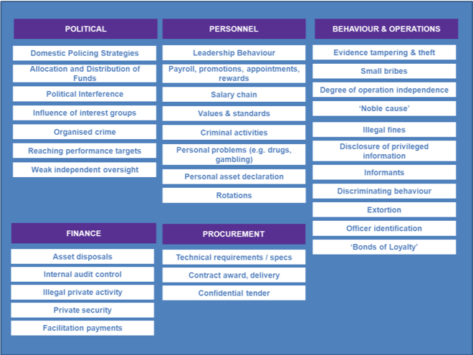

1.3 OTHER TYPOLOGIES OF POLICE CORRUPTION
Several other writers have also produced lists of police corruption issues, and they may also be based on the legal definitions of corruption, where these are suitably phrased. Some of these lists may be more attuned to your needs than the one above. Four more such typologies are shown below.
Additional policing corruption typologies
1.3.1 Police corruption typology from Roebuck (1974) amended by Punch (1985)
Type | Dimensions
Corruption of authority | When an officer receives some form of material gain by virtue of their position as a police officer without violating the law per se (e.g. free drinks, meals, services).
‘Kickbacks’ | Receipt of goods, service or money for referring business to particular individuals or companies.
Opportunistic theft | Stealing from arrestees (sometimes referred to as ‘rolling’), from traffic accident victims, crime victims and the bodies or property of dead citizens.
‘Shakedowns’ | Acceptance of a bribe for not following through a criminal violation (e.g. not making an arrest, filing a complaint or impounding property).
Protection of illegal activities | Police protection of those engaged in illegal activities (e.g. prostitution, drugs, pornography) enabling the business to continue operating.
‘The fix’ | Undermining of criminal investigations or proceedings, or the ‘loss’ of traffic tickets.
Direct criminal activities | A police officer commits a crime against person or property for personal gain ‘in clear violation of both departmental and criminal norms’.
Internal payoffs | Prerogatives available to police officers (e.g. holidays, shift allocations, promotion) are bought, bartered and sold.
‘Flaking’ or ‘padding’ | Planting of or adding to evidence (argued by Punch to be particularly evident in drugs cases).
1.3.2 Police corruption typology from Barker (1983)
Corruption (Involves a material reward or gain) | Misconduct (No material reward or gain)
Corruption of authority | Police perjury
Opportunistic thefts | Police brutality
Shakedowns | Sex on duty
Protection of illegal activities | Drinking on duty
Traffic fix | Sleeping on duty
Misdemeanour fix | Other violations
Kickbacks
Felony fix
1.3.3 Police corruption typology from the Centre for Democratic Control of the Armed Forces (DCAF). DCAFhas probably done more work internationally on integrity in policing than any other international organisation. Their 2011 Toolkit on Police Integrity is one of the recommended first reading texts of this review, and lists the following list of types of police corruption: Police disregard for the law, Police circumvention of the law, Deception, Denial, Bullying, Excessive violence, Prejudice and racism, Inappropriate selection and promotion procedures, Moonlighting and Off-duty behaviour.
1.3.4 Typology using legal definitions. Each country has a different legal definition of corruption crimes. Often, they are based on old legislation and are not suitable as the basis for a typology. Some more modern ones, though, may be adequate as the basis. Are, for example, is Finland (2016). Corruption offences reported to the police (115-150 each year) are categorised as being one of the following:
- Giving of bribes
- Aggravated giving of bribes
- Acceptance of a bribe
- Aggravated acceptance of a bribe
- Bribery violation
- Bribery in business
- Acceptance of a bribe in business
- Electoral bribery
- Aggravated acceptance of a bribe in business
- Aggravated giving of bribes in business
- Giving of bribes to a member of Parliament
- Acceptance of a bribe as a Member of Parliament
- Breach of official secrecy
- Negligent breach of official secrecy
- Abuse of public office
- Aggravated abuse of public office
- Violation of official duty
- Violation of official duty
- Violation of a business secret
- Misuse of a business secret
- Attempted violation of business secret
- Misuse of a position of trust
- Abuse of insider information
- Aggravated abuse of insider information

1.4 DO YOUR OWN DIAGNOSIS
Whatever the original impetus for instigating reform of police corruption, the starting point is to do a diagnosis of the problem, then determine its extent and characteristics.
Sometimes you may think you don’t need to do this analysis stage, that you already know the corruption problems. But this is probably not a good way to proceed: there may well be corruption issues that are not high on your radar but are even more important – or aggravating – than the ones you are most aware of. Furthermore, many of the analyses done in the last few decades have led to the realisation that the issues uncovered were not just the work of a few corrupt officers, revealing more deep-seated problems such as poor hiring, relaxed supervision, lack of investigations, collusion with criminals, and so on. Here is guidance on how to organise a simple analysis:
- Your own staff are usually well aware of the corruption issues. You can ask a group of them to develop the spectrum of the problems and their relative importance. They can use some of the guidance available in this website.
- There are likely to be good groups in your country who can do a diagnosis of corruption vulnerabilities in your Police Service and/or Ministry: commission one of them
- Review the available data on police corruption offences and surveys on perceptions of police corruption
- You may have specialist groups with extra knowledge, like internal audit, internal affairs units, and staff at your College of Policing. External groups often have relevant knowledge, e.g. civil society groups, police complaints commissions, ombudsman
- Internal affairs units and inspection directorates of police services in other countries or forces may be willing to assist you.
If you are working in an environment of endemic corruption, there may be a stronger political angle to the corruption, with elite groups taking advantage of the financial and patronage opportunities available in the police service and the MOI. In which case you may also need an analysis of the political economy of the police service and the Ministry. See here in the website for how to do this.
More formal approaches
If you are setting out to do a fuller analysis of the problems of corruption in your police services, we suggest you first consult with people who are deeply familiar with the problem and have a good knowledge of how such formal analyses and investigations might be structured and established. There are several groups worldwide with such knowledge: see Section 4 for more details.

2. Reforms in policing

Guidance summary
STEP 2. Reform measures will always be specific to the particular circumstances. Nonetheless, in order to get ideas and insights, it helps greatly to learn about reforms employed elsewhere and to have a mental model of the type of possible reforms. We recommend you consider each of these ten reform approaches:
- Functional approaches: improvement of institutions, processes, systems and controls
- People-centred approaches: building committed supporters, networks and coalitions
- Monitoring approaches: strengthen oversight groups and their independence
- Justice & rule of law approaches: prosecuting, raising confidence, improving laws
- Transparency approaches: making visible what others wish to keep hidden
- Integrity approaches: motivating and instilling pride
- Whistleblowing approaches: finding safe ways for people to speak up
- Civil society and media: external voices are essential
- Incentive approaches: aligning the different interests of stakeholders
- Nudge approaches: new science show how small changes can make a big difference
Talking through with colleagues and stakeholders how each of them might work in your environment enables you to ‘circle around’ the problem, looking at different ways and combinations to tackle it. A reform strategy might, for example, consist of some institutional improvement projects, plus strengthening integrity among staff, plus strengthened sanctions and discipline.
You can read more guidance on Step 2 here.

2.1 FUNCTIONAL REFORMS IN POLICING
This is a large category, including organisational reform, service delivery and other clinical reforms, reforms to non-clinical processes, reforms to management information systems, and technological reforms. There are usually more possible reform measures in this category than you can possibly accommodate. The question is one of prioritising for impact, feasibility and risk of slow implementation.
2.1.1 Gradual institution strengthening
Systems that are functional are usually improved by a non-stop process of small improvements, typically following audits and investigations. The classic example is the international air transport system, which improves by rigorous analysis and follow up to every situation where something has gone wrong. The review by Transparency International (Pyman et al 2012) summarises the various forms of institutional and policy reforms in the police:
- Structural changes: Separation of powers (e.g. in Georgia), Flattening of hierarchy (e.g. in New South Wales), Rebranding (e.g. in Georgia), Wage increases (e.g. in Venezuela, Georgia)
- Recruitment and training reforms: More rigorous police recruitment processes (e.g. in Kenya, Singapore), Ethics and integrity incorporated in training (e.g. in New South Wales, Singapore, Venezuela), Police Education and Training Reform (e.g. in Serbia and Montenegro).
- Rule of law reforms: Policy reforms; Legislation reforms; Reforms that address impunity to prosecution/ investigation of elites; Reforms that limit the problems of city officials, MPs and other elected officials abusing power; Reforms that increase the use of administrative sanctions, disciplinary measures, and other non-judicial dissuasive mechanisms.
- Public administration, systems and other functional reforms:Improving recruitment and training criteria and processes; System improvement of finances and accounts; Improved MIS for transparency and to identify anomalies; Systems’ improvement – open procedures; Whistle-blower/ complaint procedures. At the more extreme end, re-branding of the police service, reducing the size and scope of the Service, disciplining or firing and selectively re-hiring whole divisions within the Police Service
- Transparency and accountability improvements:Transparency – suggesting how transparency of policy, of process and of practice and open publication of policies, standards, plans, budgets, results and reports might contribute to reducing the corruption; Stronger recording and scrutiny of data; More robust information and management systems; Positive response to right to information requests.
Example: Police reform in Jamaica. The number of proactive corruption cases being worked on by the Jamaican police Anti-Corruption Branch (ACB) went from 41 in 2008 to 195 in 2011.The ACB also had success in carrying these out effectively, with 41 officers being criminally charged and 85 removed from the force between 2010 and 2011. The establishment of an anti-corruption hotline was a successful addition to the ACB’s work. Read more
The historical record shows that most countries go through a 10-year period of partially succeeded, partially failed police reforms. Here is an example of Jamaica extracted from Pyman et al (2012): The Jamaican Constabulary Force (JCF) prioritisation of public order over citizen-protective models of policing, widespread corruption and incompetency resulted in a crisis of public confidence and trust in the JCF by the early 1990s.It was against this background that the first outsider was appointed Police Commissioner in 1993. However, issues of corruption, and limited transparency and accountability persisted, to impeding the work of the JCF. Public cooperation with the police on all matters was low, with minimal public trust in the JCF to handle information properly. Increasing reliance of local communities on local leaders and identifying them as the primary source of security also not only reduced ability of the JCF to police effectively, but also magnified the major challenge posed by organised crime and criminal gangs.
In 2007, the Ministry of Justice ordered a review of the JCF chaired by Dr Herbet Thompson.The publication of the 2008 Strategic Review marks a significant watershed in the reformation process of the JCF and an important change in momentum on reform. The report made 163 recommendations for reform, labelled all three of the oversight committees at the time as ineffective, and identified five areas that have profoundly hindered the functioning of the JCF:
- the culture of the organisation
- failure of internal and external accountability
- failure of leadership and management
- lack of professional development
- significant corruption and disregard for human rights
Since the 2008 review, there have been a number of reforms to the structure of the JCF and relevant external bodies. These include the formation of the Anti-Corruption Branch (ACB) of the JCF, a reinvigoration of community policing efforts to rebuild trust between the public and policeand the establishment of an Independent Commission for Investigators in 2010 to improve accountability of the security services.The number of proactive corruption cases being worked on by the Anti-Corruption Branch (ACB) has gone from a total of 41 in 2008 to 195 in 2011.The ACB has also had success in carrying these out effectively, with 41 officers being criminally charged and 85 removed from the force between 2010 and 2011The establishment of an anti-corruption hotline has also been a successful addition to the ACB’s work. In addressing the problematic culture within the force, the JCF moved from a culture that would accept “that’s how we did it” instead of undertaking serious reform, to a police force that contains “a critical mass of people in the organisation [who] now have integrity”.
2.1.2 Radical institutional reform
There are many environments where police corruption has been a large scale, endemic issue and it has been tackled directly and energetically. This has been true in both developed countries such as the USA (in major cities) and Australia (in the States), and in developing countries. In the developed countries, the normal approach has been for an initiative to follow one of the Police Commissions mentioned above; some of the follows up were successful, most were not. In developing countries, notable efforts, with some success, have been made by China, Georgia, Serbia, Singapore and Slovenia. Some countries have had partial success, such as finding an innovative way to improve the credibility of the police complaints hotlines.
Example: Radical police reform in Georgia Saakashvili’s first waves of reforms in 2003 and 2004 were swift and decisive. 16,000 police of officers were dismissed in retribution for widespread inefficiency and corruption. Salaries were increased substantially. A thorough ‘rebranding’ exercise was undertaken that gave the police force a new name, new cars, and new uniforms in order to create a ‘clean slate’ effect and persuade the public that real change was happening. Read more
Efforts were made to redefine the police force as an entirely civilian body, distinguishing it clearly from the military, and directing it more exclusively to protect citizens and enforce the rule of law. An OECD report has stressed the imperative that military and civil powers are distinctly separated, especially in an unstable post-conflict situation such as Georgia. In this way, considerable structural alterations brought departments under central control: for example, placing the Border Protection Department under the command of the Ministry of Internal Affairs and making it a civilian rather than a militarised defence unit. Officers’ salaries were increased significantly, from an average of 80 to 90 Georgian Laris (GEL, equivalent to £30 to £35) to GEL 350 to 500 (£136 to £195), a strategy also recommended by Christen Michelsen Institute as a way of reducing the temptation for corruption.
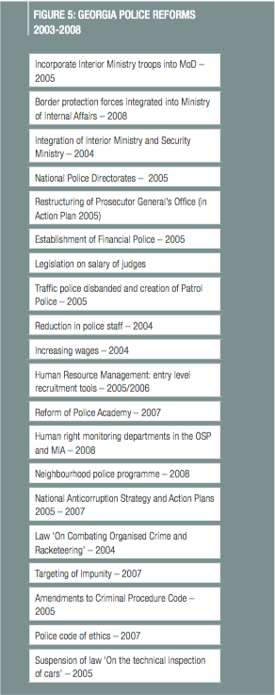
A second wave of reforms came between 2005 and 2007 in the form of international assistance projects: OSCE’s STAP (Short-Term Police Assistance) in 2005 and 2006 and PAP (Police Assistance Programme) in 2006 and 2007. In 2008, the OSCE attempted a ‘community policing’ project, but this was marred by a ‘lack of interest’ from the Ministry of Internal Affairs,perhaps because it was inefficiently tailored to the situation in Georgia. Internationally-led reforms are perhaps less vital in Georgia than in countries suffering from more recent conflict but have still aided the process considerably. See also Kupatadze (2015)and O’Shea (2017) for comparison of the success of Georgia’s police reform compared with the failure of similar police reform attempt in Kirghizstan.
These large-scale reform efforts may be intensive, but they also involve multiple reforms and take place over a number of years. Opposite, for example, are some of the formal changes that took place in Georgia as part of their police reforms, taken fromPyman et al 2012.
Example: Police reform starting in Afghanistan, after many failed attempts
Recently, in mid 2017, the President identified the Ministry of the Interior and the Police as the top target of its 2017 national anti-corruption strategy. He installed a reformist Minister, reduced the unwieldy size of the Ministry by relocating several major elements to other Ministries (eg Border Police have been moved to MOD), and prosecuting a number of the corrupt top officials. Read more “] Afghanistan has a recent history of almost total failure to reform their police force, despite hundreds of millions of dollars in international assistance for salaries, equipment and capacity building. The new Minister has set up an anti-corruption strategy that is aimed initially at the basics: putting in place basic meritocratic recruitment, which does not exist today; putting in place basic financial controls, which do not exist today; putting in place basic logistical and procurement controls, which do not exist today; and starting the process of moving towards a more civilianized force, as opposed to its current paramilitary shape. The new Interior Minister is at a stage where some of the more sophisticated tools, such as integrity checks and corruption typologies, are a step beyond the immediate priorities.
Example: Failed police reform in Burundi
Burundi started on a process of police reform, supported by a well thought-out international assistance SSR program (Ball 2014 Lessons from Burundi’s security sector reform process, ISSAT 2014). They developed a full analysis of the corruption risks (Transparency International Defence & Security 2014). However, the political climate then deteriorated rapidly, with the police as one of the architects of the instability, so the reform efforts came to naught.
Police reform in Queensland, Australia. This was one of the largest police reforms in developed democracies, after the pioneering reform Commissions in the USA in the 1970s. There has been extensive analysis of how fundamental reforms were subverted.For more detail, see Prenzler 2009 and 2011 which are well worth reading.
2.1.3 Increased community policing.
Community policing represents a widely-attempted anti-corruption method designed to better align the police with local communities in order to prevent crime and corruption. Bracey (1992) highlights the method as an effective way to combat the likelihood of corruption, as was witnessed in New South Wales after the Lusher Inquiry (1981). Mobekk (2003) agrees that community policing can overcome obstructive mistrust of the police service among the public but stipulates that community-oriented projects must be combined with education of both the society and the police force. They must be a model of policing tailored closely to its environment rather than a template or model imposed by an external or international organisation, as is the case with a reform or development project.
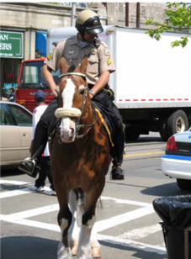
However, the model has run into some challenges. Notably, there are multiple models of community policing and not all practitioners agree as to its appropriate definition. Thus, if a community policing programme is being championed, all stakeholders involved must first be consulted and agree upon what they mean by the term. Second, it needs to be re-emphasised that the public as well as the police need to be educated as to what community policing implies and what their roles are in the model. For some populations emerging out of a totalitarian state, the notion of community policing can imply neighbours spying on each other for the state.
Example: Bolivia. Set up in 2009 also in response to the Conarepol reform suggestions, the Policía Nacional Bolivariana (PNB) constitutes a new national police service designed to work in closer collaboration with the community, through local communal councils overseeing units of up to 400 families.The new force has also been granted a 318 per cent wage increase over the previous forceAt least in theory, it is plausible that better working conditions for police officers would encourage greater service and limit the temptation to accept bribery or become involved in criminal activity. However, the former head of the investigative police’s anti- kidnapping division has stated that corrupt police are involved in 8 out of 10 kidnappings and since money is the principal lure behind these activities it seems unlikely that the wage increase has drastically reduced corruption; at least for the time being (Extract from Pyman et al 2012).

2.2 PEOPLE-CENTRED REFORMS IN POLICING
Since 2000, there has been a lot of attention paid to how police leadership can sustain a leadership style that has an overt atmosphere of integrity. From the UK, here is the Commissioner of the Metropolitan Police on the subject in 2009: “I believe that we need to demonstrate stronger leadership and supervision at all levels. This is why I have demanded ‘intrusive supervision’. There are, in any organisation, supervisors who sit back and do not confront or challenge poor performance. I want to see more active supervision, by sergeants of often young PCs, by inspectors and superintendents of the officers they lead, and by more senior officers”(Quoted in MacVean et al 2009, p195).
Why did Singapore’s reforms succeed? Singapore was under the colonial rule of the British Empire until 1963, during which time the Singaporean Police Force (SPF) was rife with corruption.Measures to tackle corruption in the police force were introduced as early as 1952, when the Corrupt Practices Investigation Bureau (CPIB) was established. Since then, a myriad of reforms has reduced corruption within the SPF and given it a role model status for change. The CPIB was granted extensive legal powers, the salaries of police officers were considerably improved, and the recruitment and training process redesigned to focus comprehensively on ethics and integrity in policing. The city-state has long been admired as a prime example of reforms that can extinguish corruption within the police force, and there is considerable evidence of its successes.
More on Singapore's police reforms
Both Holmes (2010) and Ali (2000) give credit for the success of Singaporean police reform to the determined commitment of successive governments. The Corrupt Practices Investigation Bureau (CPIB) enjoys extensive legal powers beyond those found in other countries. The powers awarded by the Prevention of Corruption Act in 1960 allow a CPIB detective to arrest any person under ‘reasonable suspicion’ without warrant, enter ‘any place by force if necessary’, and to do so without a search warrant on ‘reasonable grounds to believe that any delay in obtaining the search warrant is likely to frustrate the object of the search’.CPIB officers can also propose legislative reforms, seize passports, and freeze assets.With its motto ‘Swift and Sure’,the CPIB symbolises a zero-tolerance attitude to corruption.
Finally, there was the determination of a new government. The priority for police reform extended over several governments. ‘Police corruption was rampant in Singapore during the British colonial period, but that since then, through the commitment of the People’s Action Party government to curbing corruption in the country, the Singapore Police Force has succeeded in preventing and minimising police corruption.’ (Quah 2006,2018).

2.3 MONITORING REFORMS IN POLICING
Independent scrutiny is key to reducing corruption. Sometimes, for exactly this reason, independent scrutiny bodies are under-resourced, or populated with low-grade staff, or denied access to key people and records, bribed or threatened, and otherwise marginalised. Finding ways to get multiple forms of independent scrutiny into effect is a core part of almost all anti-corruption strategies, especially in policing, where these calls for external monitoring reflects one of the other routine findings of Police Commissions: the ‘abysmal record of police internal investigations’(Prenzler et al 2013, p155).
2.3.1 Regular auditing and analysis
Regular auditing and analysis of the status of integrity and anti-corruption controls is vital.An worth examining is the audit of police corruption across England and Wales in 2015 by the national police inspectorate, Her Majesty’s Inspectorate of Constabulary (HMIC (2015).) HMIC first did the analysis of complaints about corruption and the related issues such as use of force, breaching of confidentiality and discreditable conduct. Then they analysed how each case was pursued through to completion. Then they analysed how many professional staff in each of the 43 police forces in England and Wales were assigned to the anti-corruption teams.
HMIC (2015) first did the analysis of complaints about corruption and the related issues such as use of force, breaching of confidentiality and discreditable conduct.
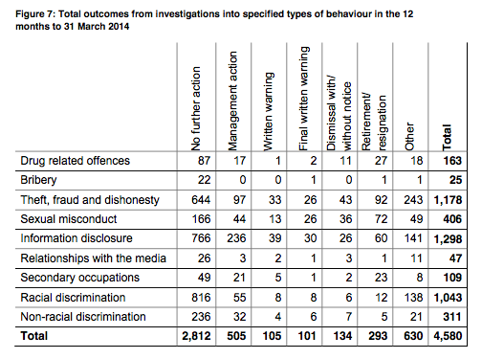
Then they analysed how each case was pursued through to completion:
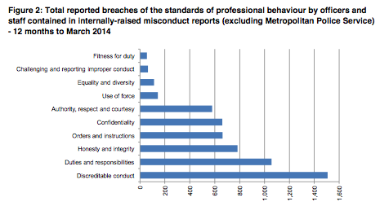
Then they analysed how many professional staff in each of the 43 police forces in England and Wales were assigned to the anti-corruption teams:
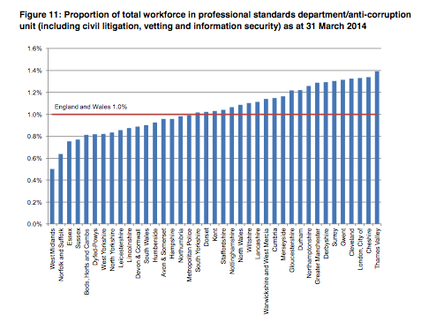
Then, finally, they follow up with an assessment of the relative efficacy of each of the police forces in tackling police corruption.
2.3.2 Establish a Commission of Enquiry
There have been thirty-two such Commissions in English-speaking countries that have investigated police corruption in ten countries (see list on the right).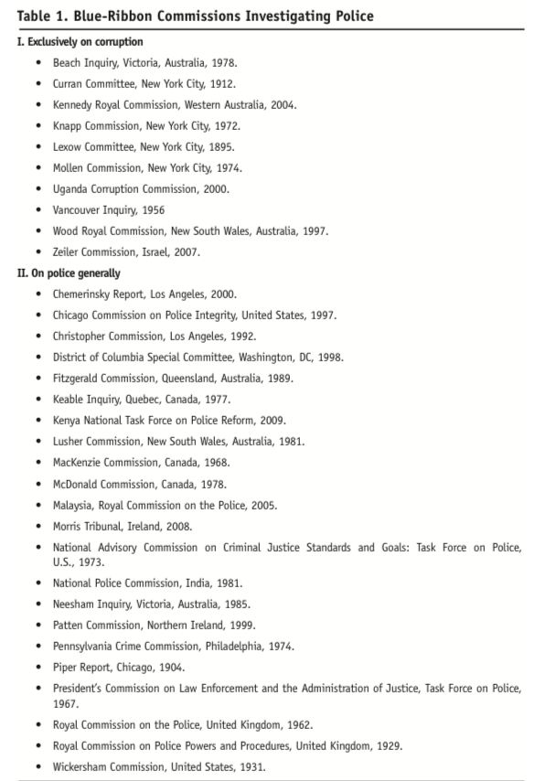
In a review of these, Bayley and Perito (2011) found that the main proposals were remarkably common from all the Commissions and consisted of the following six measures:
- Creating external oversight over the police with a special focus on integrity
- Improving recruitment and training
- Leadership from supervisors of all ranks about integrity
- Holding all commanders responsible for the behaviour of subordinates
- Changing the organisation’s culture to one with lower tolerance of misbehaviour
- Instituting a wide-ranging audit of corruption in the police
For example, there have been major changes to Australian police forces (in new South Wales, Queensland, Western Australia), including the establishment of an independent ‘Police Integrity Commission’ in New South Wales. Bayley and Perito also found that most of the articles on police anti-corruption reform tended to be based on recycling of these Commission findings.
Example: Commission of enquiry into corruption in the police in New South Wales, Australia, 1995-1997. The Wood Royal Commission exposed acts of bribery, drug trafficking, money laundering and instances of evidence fabrication numbering in the hundreds. Read more
The detective division of Kings Cross, in Sydney, was found to be guilty of corruption at virtually all ranks, refusing to attend crime scenes while essentially commandeering the local drug trade. Trevor Laken, then head of the Kings Cross Drug Unit, oversaw the corrupt extraction of payments from strip clubs and drug dealers for a significant period of time, probably remaining unnoticed because the volume of cases was high and the turnover of officers in the department was low.
At the time, then-Police Commissioner Tony Lauer defended the force as a whole, dismissing corruption as the fault of a few individuals rather than a systemic failing. However, since the Wood Commission uncovered a huge network of corrupt incidents, Lauer’s ‘rotten apple’ approach looked untenable and he was forced to resign. Peter James Ryan from the United Kingdom was recruited to join the New South Wales service because its senior ranks were too closely linked to corrupt officers. The Wood Report prompted a huge scandal and growing public awareness of the extent of corruption within the force led to a significant programme of reform.
During the late 1990s, the New South Wales police administration tried to implement the recommendations of the Wood Commission, which were designed to combat the cyclical nature of corruption. An ‘early warning system’ was developed to alert managers to officers who were the subject of recurring public complaints, and who should therefore be monitored closely for signs of misconduct that might develop into ‘meat-eating’ forms of corruption. Wood recommended the ‘flattening’ of the hierarchical structure to give greater management responsibility to operational patrols, which was enacted to a certain degree. There were also concerted efforts to integrate ‘ethics and integrity’ into a new training programme, developed jointly by the Employee Management Branch and the Special Crime and Internal Affairs, that included innovative guidance on internal grievances policies, conflicts of interest, and the process of internal investigations.
New internal disciplinary powers allowed for more effective and discreet handling of minor, grass-eating corruption cases than was previously possible. Less severe penalties for minor misconduct included managerial counselling and loss of pay increment, while the ‘Commissioner’s Confidence’ permitted the Police Commissioner to suspend from duty any officer deemed too unethical or incompetent to complete his/her work. As for external discipline, Wood denounced the existing joint investigative structures of the Office of Professional Responsibility, the Independent Commission against Corruption, and the Office of the Ombudsman as ineffective. Instead, he suggested the establishment of a single agency to monitor police conduct, which must be independent of the police force and hold sufficient coercive powers to investigate corruption. The Police Integrity Commission was established in 1996 on the basis of his suggestion and continues to operate today.
Yet, ten years after the Wood Report, the 2005-6 report of the Police Integrity Commission, which detailed 21 major investigations, suggested that corruption remained rife in the New South Wales Police. An audit of the reform process over a three-year period accepted the police executive’s use of ‘reform contractors to agree appropriate measures of reform performance’, but criticized its focus on a business-like approach, stating that if ‘the Executive continues to divert attention from reform towards continuous business improvement, it will defeat the purpose of securing this Reform Contract’. Dr Michael Kennedy, an ex-policeman and now university lecturer, has similarly blamed an inappropriate ‘business model’ applied to policing, with an emphasis on productivity that is at odds with the proper aim of policing.
Holmes blames flaws in the judicial system itself for ‘disillusionment’ amongst the police force leading to ‘noble cause’ corruption: a widespread perception of magistrates being too ‘soft’ on criminals can lead to an ‘if you can’t beat ‘em, join ‘em’ attitude among officers. Holmes also states that ‘greater dialogue’ is needed between the police and the judiciary to align their attitudes more closely and reduce the possibility of disillusionment leading to corruption – this can be done through direct interaction in workshops and seminars. Any attempt to change the processes of a law enforcement body should also examine the processes of its colleagues.
Example: How Commissions of Enquiry can have other benefits in making the corruption a more public topic of discussion, even when the outcomes are not robust, in countries where the rule of law is weak, such as Uganda. Read more
The anti-coruption specialist Monica Kirya (2011) writes that Commissions may not root out the problems, but may nonetheless play a useful function. She concludes that ‘The findings suggest that the global anti-corruption framework signified by the good governance agenda is hindered by various factors such as the self-interest of donors, the moral hazard inherent in aid and the illegitimacy of conditionality; all of which contribute to the weak enforcement of governance-related conditionalities. This in turn causes aid-recipient countries such as Uganda to do only the minimum necessary to keep up appearances in implementing governance reforms. National anti-corruption is further hindered by the government tendency to undermine anti-corruption by selective or non-enforcement of the law, the rationale being to insulate the patronage networks that form the basis of its political support from being dismantled by the prosecution of key patrons involved in corruption. Ad hoc commissions of inquiry chaired by judges, which facilitate a highly publicised inquisitorial truth-finding process, therefore emerge as the ideal way of tackling corruption because they facilitate ―a trial in which no-one is sent to jail. …
They also served to appease a public that was appalled by the various corruption scandals perpetrated by a regime that had claimed to introduce ―a fundamental change and not a mere change of guard in Uganda politics. Nevertheless, while they enabled the regime to consolidate power by appeasing donors and the public, they also constituted significant democratic moments in Uganda history by allowing the public – acting through judges and the media – to participate in holding their leaders accountable for their actions in a manner hitherto unseen in a country whose history had been characterised by dictatorial rule.’
2.3.3 Balance between internal and external monitoring
One of the major lessons of police reform over the last 20 years has been the inability of the police to police themselves, and therefore the need for external oversight. This can mean that there are a multitude of forms of oversights, both internal and external, many of limited value. The diagram below, from Kutnjak (2013), illustrates this well.
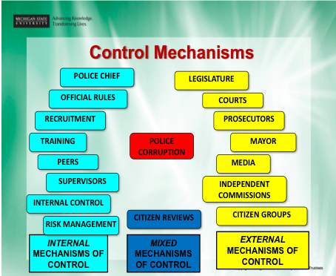
There is also guidance on getting a good balance between internal and external controls from Prenzler (2016), in Managing police conduct: finding the ideal division of labour between internal and external processes’.
If this is your situation, then a good first step might be to do a review of all the existing oversight mechanisms and their effectiveness.
2.3.4 Pro-active use of controls
Kutnjak and her colleagues have explored for many years how police organisations can take a pro-active approach, investigating the predisposition for corruption within police departments. The mechanisms vary from random integrity testing, to citizen reviews and through to undercover operations. These mechanisms form the base methodology of operations of Police Internal Affairs Departments.

2.4 INTEGRITY REFORMS IN POLICING
The recognition of a systemic problem can actually be a great motivator for integrity-based approaches to solving the problem. A well-developed holistic approach to professionalisation can encourage department leaders in the police to participate in reform programmes because it avoids the impression that a personal witch-hunt is the aim.
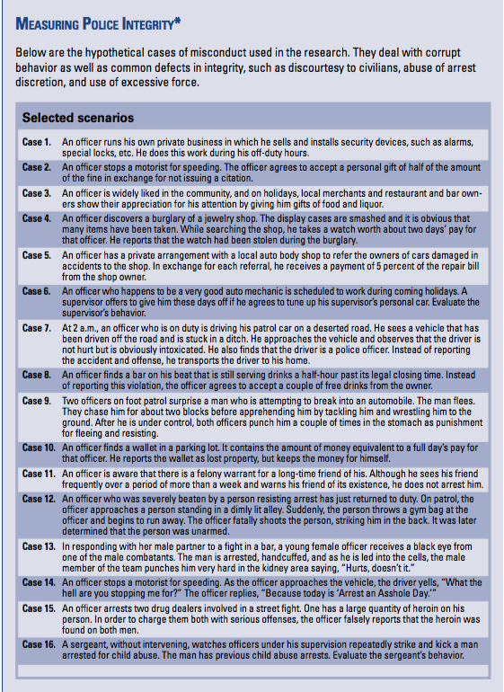2.4.1 Regular integrity testing of police officers
Because it can be tricky to measure corruption in the police, one useful approach has been to measure the opposite – police integrity. Kutnjak and her colleagues have done this over two decades and the methodology is now quite mature. Police integrity is defined as ‘the normative inclination among police to resist temptations to abuse the rights and privileges of their occupation’.
The methodology uses eleven hypothetical integrity scenarios, of which nine relate to corruption; and each scenario is followed by a number of questions.
This methodology has now been applied in many countries: Armenia, Australia, Austria, Bosnia, Canada, Croatia, Czech Republic, Eritrea, Estonia, Finland, Hungary, Japan, Malaysia, the Netherlands, Norway, Pakistan, Poland, Romania, Russia, Slovenia, South Africa, South Korea, Sweden, Thailand, Turkey, the UK, the USA. Probably the most relevant recent reference to this body of work and the international comparisons of the results is Kutnjak and Haberfeld (2015).
Here on the right is the set of sixteen scenarios that they use.
There is also a useful briefing paper on integrity testing in the DCAF (2012) Toolkit, pp175-177. In this paper, they give the experiences from Australia, USA, Hungary, Romania and Moldova.
2.4.2 Awareness raising, capacity building and education
DCAF, the ‘Geneva Centre for the Democratic Control of Armed Forces’ assists partner states, and international actors supporting these states, to improve the governance of their security sector through inclusive and participatory reforms based on international norms and good practices. DCAF creates knowledge products, promotes norms and good practices, provides policy advice, and supports capacity building of non-governmental security sector stakeholders. DCAF currently has operations in some 70 countries world-wide, and especially across the Balkans and North Africa. DCAF have two main handbooks related to police integrity, and their websites are also well worth reviewing for more detailed experience:
- Toolkit on Police Integrity. DCAF (2012)
- Training Manual on Police Integrity, DCAF (2015)
Here is their general approach to police integrity building work:
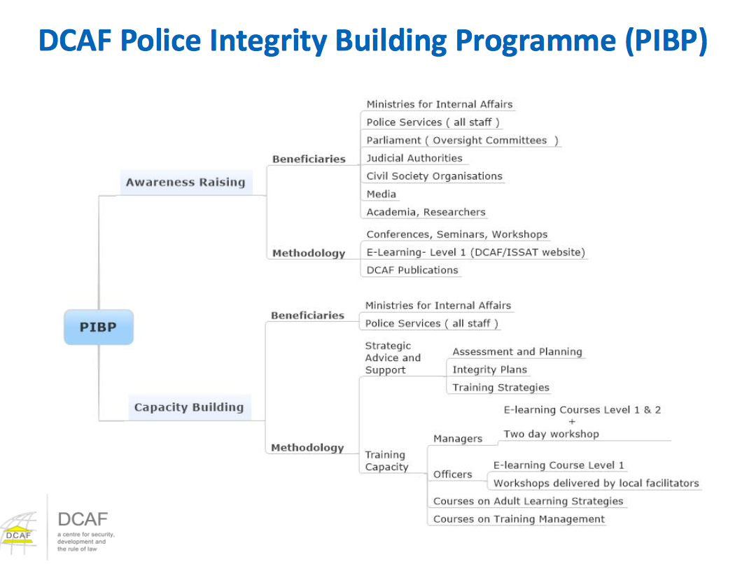
DCAF’s sister organisation, the International Security Sector Advisory Team (ISSAT) also provides support to the international community to reinforce and strengthen their individual and collective efforts to improve security and justice, primarily in conflict-affected areas and fragile states. They have a good website with lots of real examples.
Example: Venezuela. In 2008, the ‘Organic Law of Police Service and National Police’ (Ley Orgánica del Servicio de Policia Nacional) was passed. The National Experimental University for Security was created to run a five-year training programme with a strong emphasis on the ethics of policing. The curriculum includes specialist training by advisors from Cuba and Nicaragua (both with homicide rates among the lowest in Latin America) in ethics and community-based policing.
2.4.3 Internal integrity reform initiatives
Police departments can themselves reform, despite the many that fail. Here, for example, is a summary of several such cases from Prenzler: A small number of police departments are on the record in demonstrating large improvements in measures of ethical conduct, with lessons that have wide application. For example, in New York City, the introduction of a “courtesy, professionalism and respect policy” in two Bronx precincts in the 1990s led to reductions of 54% and 64% in complaints against the trend of increasing citizen complaints during the alleged “zero-tolerance” crackdown on crime. In Tasmania, Australia, police generated an extraordinary 87% reduction in citizen complaints over a decade through a combination of complaint pro ling and early intervention and complaint analysis and modified procedures and training. The main contribution of the Tasmanian Ombudsman was to verify the strategies and data. In both the Bronx and Tasmanian cases, reductions in complaints were achieved along with reductions in crime. Prenzler, Porter, and Alpert (2013) also reviewed case studies of successful force reduction in policing, using a range of measures including complaints, police and citizen fatalities and injuries, and use- of-force reports (Prenzler 2016).

2.5 WHISTLEBLOWING REFORMS IN POLICING
If there has been one ‘constant’ in tackling police corruption, it has been resistance by police services to external oversight and involvement in their complaints and disciplining systems. Over time, a number of models have evolved for such systems. Most of the research on this topic has been from the US (Kutnjak and colleagues) or from Australia (Prenzler and colleagues). Prenzler has a simple three-part summarisation of the different models – internal affairs, civilian review, and civilian control – which cover the range from in-house systems to fully developed independence models. The three models are summarised here (adapted from Prenzler 2016):
Model 1 – Internal Affairs
Internal affairs is a traditional American term for integrity units within police departments—what have also been called “internal investigation divisions” or “units” and are now normally referred to as “professional standards units” or similar. For much of the history of policing, complaints and discipline were managed in-house. Cases were assigned to supervising officers of different ranks, depending on seriousness. Corruption scandals and a high volume of complaints prompted larger police departments to create specialist units to investigate and adjudicate allegations and, to a lesser extent, initiate prevention programs. e system was meant to ensure department-wide consistency and some independence from local affiliations. Usually, there were direct lines of reporting from the internal affairs unit to the police chief or commissioner.
Read more about Model 1
In-house systems were not usually devoid of external scrutiny. Elected officials, including mayors or police ministers, provided one line of accountability to the electorate, although politicians tended to have a vested interest in hiding scandals and protecting police. In response to a citizen’s suit, a civil court could require evidence from police. Some oversight was also provided by criminal courts in scrutinizing police evidence and excluding material illegally obtained. One obvious problem here was that a great deal of police work never reached the courts. In addition, police were often adept at lying, and juries generally wanted to believe authority figures. Inquests and ad hoc inquiries provided other forms of judicial oversight. Since the 1970s, better equipped inquiries, armed with covert investigative capabilities and powers to indemnify witnesses, have almost always condemned the record of internal a airs units in detecting complainants and favouring police. Inquiries also found that internal affairs systems not only failed to bring individual officers to justice but also patterns of misconduct were ignored and primary prevention strategies were underdeveloped Furthermore, complainants were almost universally dissatisfied with police treatment of their complaint, often because of the inevitable conflict of interest entailed in the process of police investigating police. Scandals and inquiries in other domains have highlighted the natural tendency of all organizations toward self-protection. Police are not unique in their capacity to evade outside scrutiny and to intimidate and malign complainants and whistleblowers.
Model 2 – Civilian review
In response to recurring misconduct scandals, cover-ups, and inaction, a number of governments reluctantly introduced civilian review agencies. Civilian review takes diverse forms, but the principal idea is to provide an independent check on possible bias without excessive interference in police management. A review agency usually consists of a government-appointed citizen board, reflecting community interests and professional skills, with an executive arm, including a director, usually with legal qualifications, and civilian staff. Typically, police will carry out investigations and apportion discipline, with the external agency taking a monitoring role. is normally involves paper-based audits of complaint investigation les and responses to appeals by complainants, with a capacity to criticize police work and recommend alternative findings and outcomes. This is a minimalist model, with scope for some enlargement of authority, such as the capacity to conduct independent investigations of serious matters and appeal disciplinary decisions to a mayor or a tribunal, police commission, or board.
Read more about Model 2
Civilian review involves a mixed model and a clear political compromise between supporters and opponents of fully independent systems. It appears to have wide appeal and constitutes the dominant model internationally. Available performance indicators—such as public confidence, complain- ant satisfaction, complaint substantiation rates, and police conduct indicators—suggest some achievements. A capacity to hold open inquisitorial hearings and refer matters to a public prosecutor or administrative tribunal significantly enhances the democratic account- ability process, as is the ability to publish reports. Nonetheless, most review systems allow too much scope for police to control or subvert the process. One major problem is that civilian review holds out a false promise. Agencies look like they will investigate and adjudicate allegations against police. It is hardly surprising, then, that complainants’ anger and disillusionment with authorities are compounded when the oversight agency refers the complaint to the police.
Model 3 – Civilian Control
Although civilian control is used to describe a type of agency within a police “oversight” system, it implies much more than is suggested by the term over sight. Civilian control takes the problems of real and perceived internal bias and takes them to their logical conclusion: Police should not investigate nor adjudicate complaints against their own. This basic principle is increasingly being applied to organizations out- side police—whether it be churches, charities, defence forces, trade unions, or corporations—where victims of abuse and other stakeholders call for fully independent and transparent investigations. Independent regulatory agencies are now de rigueur for a wide range of occupations, including the health sector, construction, consumer and financial services, and the security industry. Remarkably, legal services commissions, which investigate and adjudicate complaints against lawyers, have come on the scene in recent years, with little controversy regarding the demise of a long tradition of self-regulation.
In policing, the trend internationally appears to be in the direction of the civilian control model, but in very limited forms.
Read more about Model 3
Hong Kong provides a good example of a mixed profile. The Independent Commission Against Corruption (ICAC), established in 1974, appears to embody the civilian control model. Its many successes include shutting down highly organized police graft. At the same time, police misconduct issues outside corruption, such as assaults, are dealt with by a limited review agency, the Independent Police Complaints Council. In other examples, police oversight agencies independently investigate a range of serious misconduct allegations, but the large bulk of cases remain in police hands, subject perhaps to some form of audit. Some agencies independently investigate all complaints, but their disciplinary recommendations can be rejected by the police department, which retains control over final outcomes. Others again are institutionally separate from police but so dependent on former or seconded police that they can hardly be said to be genuinely independent. In Northern Ireland, the Police Ombudsman, established in 2000, appears as the one agency that has gone the furthest in putting independence into practice across all aspects of the complaints and discipline process.
Example: Establishment of a police counter-corruption organisation in Kenya. In 2009, a new Police Commissioner began the redeployment of 600 officers with the specific remit of combating police corruption.This was one of the recommendations proposed by a government-commissioned investigation into police corruption headed by Justice Philip Ransley. The commission recommended the vetting of all police officers holding the rank of Assistant Police Commissioner and above.Read more
The Ransley Report (2009)recommended an extensive programme of reform over 3 years. The implementation of the 200 reforms was begun in 2010. In a bid to make the force more accountable, the inspector general of the Kenya Police Service now has to report to three separate bodies: the PSC, the Independent Policing Oversight Authority and the newly-established National Policing Council. The Ransley Report criticised the rigid hierarchy of the Kenya Police Service, which left departments ‘vulnerable to both political and hierarchical misuse’.As well as greater operational devolution to lower levels of the force, the report proposed a more efficient separation of powers: for example, the structural re-allocation of the Anti- Stock Theft Unit to the Administration Police, which was ‘more visible in the rural areas’ and therefore better suited to crimes involving livestock.While some of these measures might not directly target police corruption, their purpose was to clarify the overlapping organisation of police departments and therefore limit opportunities for hidden corruption.
In order to formalise ethical conduct within the police, the training curriculum was revised, in a shift away from a previous emphasis on ‘paramilitary training and drills’ that reinforced the idea that ‘policing is combative and confrontational’.As in several other countries, a focus on community-oriented policing has been promoted to tackle the problem of public mistrust of the force police. Such mistrust is not only fermented by frequent corruption, but also creates a culture so used to corruption that the latter becomes reluctantly accepted.

2.6 CIVIL SOCIETY & MEDIA REFORMS IN POLICING
Investigative journalism and an active civil society both play a significant role, and there are many examples of police corruption being addressed and reduced through their efforts.
2.6.1 Civil society demanding publicly visible signs of change
The lesson of past police reforms, that most fail, is in part due to a lack of connection between the public, who want the reforms, and the police service, who would often rather reform out of the public limelight. Connecting the reforms very directly to the public is one way of changing this narrative and bringing public enthusiasm to bear to strengthen the resolve of the police to continue reform.
Example: Radio programme engaging police on corruption issues in Uganda
This was a civic initiative started by Ugandan youth to address the widespread complaints about police demand for ‘fees’. “Police were feared by the general public as they had turned into armed robbers in uniform and police stations were converted into extortion and exploitation grounds”. The communities, via 600 volunteers, built bridges to senior police, and they developed that link through weekly radio programmes in which police participated and responded to callers. The process continued to be a collaborative venture, not a confrontational one, and was seen by all parties as a success. A fuller description of this initiative and other civil society initiatives can be found in Beyerle (2014), and in Landell-Mills (2013).
2.6.2 Police forces collaborating with civil society on reforms
Among other NGOs, Transparency international has been very active, both around the world, as already mentioned in this review, in seeking to work with police forces on corruption reform
Example: Police forces in Russia collaborating with civil society.
Here, for example, is one imaginative police reform from Russia: In March 2011, new laws came into force requiring all police officers to wear identity badges whilst on duty.
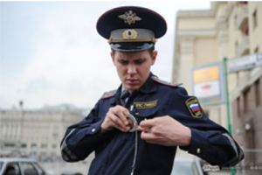
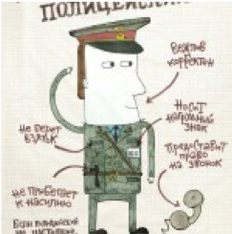One of Russian citizens’ major concerns over policing has been the anonymity of police officers in their interactions with citizens, which presents a serious barrier to making Russian police accountable. In March 2011, new laws came into force requiring all police officers to wear identity badges whilst on duty. Transparency international Russia had an important role in influencing the creation of these new laws, having run a successful online campaign raising awareness of the duties of Russian police officers.

They created ‘Badge checking Day’, during which citizens were encouraged to challenge police officers to display their official badges and state their name. as well as undertaking an advertising campaign raising awareness of the days of action (From Pyman et al 2012, p20).
Example: Police force in Burundi prepared to engage on police force reform.Transparency International’s Defence and Security programme worked with the Police forces in Burundi on anti-corruption. See Pyman et al (2014).
2.6.3 Civil society collaborating with MOI to strengthen police accountability
Example: Strengthening police anti-corruption capability in Romania.
A good example has been in Romania, with an EU project to strengthen integrity of the MOI and raise the Romanian police (200,000) to EU standards, develop an anti-corruption investigative structure, and improve the partnership with civil society. (From Pyman et al 2012) Among the outcomes was the Creation of a “Transparency Advisory Forum” (TAF) with NGOs; exposure of discrimination against minority groups; Improved public transparency of the MOI anti-corruption measures; Legislation enacted to allow the use of covert investigation techniques and the Establishment of an independent Anti-Corruption Department (ACD)AC Strategic Committee (ACSC) consisting of key senior MOI/police and TAF members, allows challenge of decision-making by the MOI
2.6.4 Civil society visiting and assessing police stations
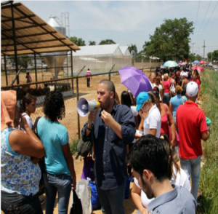
Example: Altus. Altus is a global alliance between civil society organisations. They organise an annual ‘Police Week’ during which citizens visit local stations to perform assessments. The purpose of these visits is to strengthen accountability and transparency, and to recognise current best practice. The most recent Police Week incorporated visits to 1044 stations across 20 countries (From Pyman et al 2012).

3. Developing an overall strategy

Guidance summary
STEP 3. After you have reviewed the specific corruption types and identified possible reform measures, you can develop an overall strategy. Because curbing corruption is about changing the status quo, so you need to be thinking about how to build support, how to spread the benefits, how to bring opponents on board or how to outflank them. This is where judgement and political skill are important. You also need to think carefully as to which combination of measures and management is likely to result in the most impact within the limited resources and time available. We suggest that you develop an overall strategy – in collaboration with those who can also own it with you – in the following way:
- Thinking through what impact you really want to achieve
- Challenging yourselves by considering strategic opposites
- Considering the people and the politics; where to build support
- Setting up a sound implementation programme
- Maximising supportive structures across government & stakeholders
You can read more guidance on Step 3 here.
Tackling police corruption is a subject on which there does now exist national and international expertise. We suggest that as a first step you be in touch with one or more of the groups whom we list in Section 4. Nonetheless, we know of no public document outlining a major police anti-corruption strategy. The nearest we have come is analyses of what happened to the police reforms after the major commissions of inquiry in the US, UK and Australia, all of which we have noted in this review,

4. Transnational policing initiatives
There are many international initiatives on police-related issues that are close to corruption, such as illicit finance and money laundering. However, to our knowledge there are no transnational initiatives directly on tackling corruption in policing. There was a first international conference in Mexico in 2013 on Internal Affairs Departments and Policing, but this seems not to have been continued.
The three groups who have bene most active internationally on tackling police corruption are the following:
The Centre for Democratic Control of the Armed Forces (DCAF) in Geneva, Switzerland DCAF. This organisation has long been active on integrity in police and security forces. The team is led by Paulo Costa, Head of the Police Program.
Australian criminologists. Professors Tim Prenzler and Louise Porter, at the University of the Sunshine Coast and Griffiths University, Queensland, Australia respectively have published for many years on police corruption and integrity issues.
Dept of criminology, Michigan State University, USA. Professor Sanja Kutnjak Ivkovich and her colleagues at Michigan State University, USA, have similarly published for many years on police corruption and integrity issues.
NGOs. There are also NGOs that have expertise in police corruption or policing abuses whom you might contact, such as Transparency International and the Open Society Foundation.
There are also individual police experts available. However, corruption within policing is quite a specialist area. Look for people with significant experience in managing or leading police ‘internal affairs’ departments, or in managing police complaints agencies.

Reading and Bibliography

ADDITIONAL READING
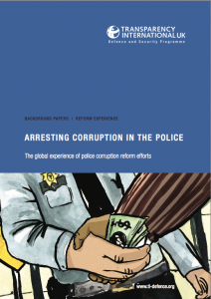If you want to read more, we recommend the following:
Transparency International (2012). Arresting corruption in the police: the global experience of police corruption reform efforts.
Also available in Spanish
Kutnjak Ivković & Haberfeld (2015)Measuring police integrity across the world: Studies from established democracies and countries in transition., New York: Springer.
Toolkit on Police Integrity.DCAF (2012): http://www.dcaf.ch/toolkit-police-integrity
Training Manual on Police Integrity,DCAF (2015) http://www.dcaf.ch/sites/default/files/publications/documents/DCAF-Training-Manual-on-Police-Integrity_ENG.pdf
Her Majesty’s Inspectorate of Constabulary (2015)Integrity matters:An inspection of arrangements to ensure integrity and to provide the capability to tackle corruption in policing. https://www.justiceinspectorates.gov.uk/hmicfrs/wp-content/uploads/police-integrity-and-corruption-2015.pdf
UNODC (2011)Handbook on Police Accountability, Oversight and Integrity.

WEBSITES
The websites following have useful material on police services and justice corruption reform:
ISSAT: http://issat.dcaf.ch
UNODC: http://www.unodc.org/unodc/en/corruption/publications.html
OSCE POLIS : https://polis.osce.org/library/
Council of Europe (Online Resources ): https://edoc.coe.int/en/
INPROL : https://www.inprol.org/inprol-publications
POINTPULSE: http://pointpulse.net/

BIBLIOGRAPHY
Police services: Full bibliography
Australian Police Integrity Commission (2006) Annual report 2005-2006. https://www.google.co.uk/search?ei=sohQW4HHE8eDgAbGlIOwDQ&q=Australia+Police+Integrity+Commission+annual+report+2005-6&oq=Australia+Police+Integrity+Commission+annual+report+2005-6&gs_l=psy-ab.3…30530.40136.0.41235.28.24.0.0.0.0.966.4101.0j4j5j2j1j0j1.13.0….0…1c.1.64.psy-ab..15.7.1845…33i22i29i30k1j33i160k1j33i21k1.0.hSUI617SJ9o
Ali, Muhammed (2000) Eradicating corruption – the Singapore experience.http://unpan1.un.org/intradoc/groups/public/documents/apcity/unpan002749.pdf
Ball, Nicole (2014) Lessons from Burundi’s security sector reform processAfrica Security Brief No.29. http://africacenter.org/wp-content/uploads/2016/06/ASB29EN-Lessons-from-Burundi’s-Security-Sector-Reform-Process.pdfAccessed 08/11/2017
Barker T (1983) Rookie police officers’ perceptions of police occupational deviance.Police Studies Volume:6 Issue:2 Dated: Summer 1983 Pages:30-38. https://www.ncjrs.gov/App/Publications/abstract.aspx?ID=90607
Bayley, David and Perito, Robert (2011)Police corruption: what past scandals teach about current challenges.USIP report, November 2011, available at https://www.usip.org/publications/2011/11/police-corruption. Accessed November 8, 2017
Beyerle, Shaazke (2014) Curtailing corruption: People power for accountability and justice. Lynne Riener Publishers. Details of the author are available here: https://www.usip.org/people/shaazka-beyerle Accessed 09/11/2017
Blanco F, Guillén M and Suggett, J (2009) Human Rights and Police Reform in Venezuela: A Venezuelan Perspective’(2009) retrieved June 2012, http://venezuelanaly- sis.com/analysis/4349.
Bracey DH (1992)Police Corruption and community relations, community policing.https://www.ncjrs.gov/App/Publications/abstract.aspx?ID=143648
Bracey DH (1992) In Policing corruption: international perspectives. Edited by Sarre, Rick, Das, Dilip and Albrecht, HJ. https://www.amazon.com/Policing-Corruption-International-Perspectives-Executive/dp/0739108093
Costa, Paulo (2016) Police Integrity in Western Balkans, Still work in Progress.Pointpulse network, 2016: http://pointpulse.net/magazine/police-integrity-western-balkans-still-work-progress/
Darbyshire, Neil (2015)The shocking truth about police corruption in Britain. It’s a growing problem, but they’re hunting whistleblowers instead. Spectator March 2015. https://www.spectator.co.uk/2015/03/the-shocking-truth-about-police-corruption-in-britain/
DCAF (2015) Training Manual on Police Integrity.http://www.dcaf.ch/sites/default/files/publications/documents/DCAF-Training-Manual-on-Police-Integrity_ENG.pdf
DCAF (2012) Toolkit on Police Integrity. http://www.dcaf.ch/toolkit-police-integrity
Finland (2016)Draft Anti-Corruption Strategy 2016-2020(Strategialuonnos ENGLANNIKSI) https://api.hankeikkuna.fi/asiakirjat/2174ec65-d433-41de-ae32-1356c1ba9683/2446ff21-fc03-4f29-87bc-9464cc130827/POYTAKIRJA_20170612224500.pdf
Harriot, Anthony (1997)Reforming the Jamaica Constabulary Force: From Political to Professional Policing?’, Caribbean Quarterly, 43 (3): 1 -12. http://mord.mona.uwi.edu/biblio/viewrefs.asp?rid=1222
Her Majesty’s Inspectorate of Constabulary (2015)Integrity matters: An inspection of arrangements to ensure integrity and to provide the capability to tackle corruption in policing. January 2015 © HMIC 2015 ISBN: 978-1-78246-697-0 https://www.justiceinspectorates.gov.uk/hmicfrs/wp-content/uploads/police-integrity-and-corruption-2015.pdf
Hickman, Matthew, Piquero, Alex, Powell, Zachary and Greene, Jack (2016)Expanding the measurement of police integrity. Policing 39, (2): 246-267, https://0-search-proquest-com.lib.exeter.ac.uk/docview/1784725236?accountid=10792(accessed May 31, 2018).
Holmes, Leslie (2010) Police corruption: essential readings. Edward Elgar Publishing. https://www.e-elgar.com/shop/police-corruption-essential-readings
ISSAT (2014) Review of the SSR process in Burundi. http://issat.dcaf.ch/Learn/SSR-in-Practice/Countries-Regions/Burundi/Security-Sector-Development-Programme-for-Burundi-SSDP/Review-of-SSR-Process-in-Burundi-From-Arusha-to-presentAccessed 08/11/2017
Kakachia, Kornely and O’Shea, Liam (2012)Why does police reform appear to have been more successful in Georgia than in Kyrgyzstan or Russia?Journal of Power Institutions in Post-Soviet Societies, Issue 13. https://pipss.revues.org/3964
Khan, Mushtaq, Andreoni, Antonio, Roy, Pallavi (2016) Anti-corruption in adverse contexts: a strategic approach. SOAS Research Online. http://eprints.soas.ac.uk/23495/1/Anti-Corruption%20in%20Adverse%20Contexts%20%281%29.pdf
Kirya, Monica (2011)Performing “good governance” Commissions of Inquiry and the Fight against Corruption in Uganda. PhD Thesis, University of Warwick, UK. http://wrap.warwick.ac.uk/47800/1/WRAP_Theses_Kirya_2011.pdf
Klockars CB, Kutnjak Ivkovic S, & Haberfeld MR (2006)Enhancing police integrity. Dordrecht Springer https://www.springer.com/gb/book/9780387369549
Knapp Commission Report (2002)https://en.wikipedia.org/wiki/Knapp_Commission
Kupatadze, Alexander (2015)Georgia: breaking out of a vicious cycle?European Research ERCAS, www.againstcorruption.eu/wp-content/uploads/2015/05/D3-Georgia_Kupatadze.pdf
Kutnjak Ivković, S and Haberfeld, M.R. (2015).Measuring police integrity across the world: Studies from established democracies and countries in transition. New York: Springer. https://www.springer.com/gb/book/9781493922789
Kutnjak Ivkovich, Sanya (2013)Controlling police corruption: lessons learned. Presented at the Conference Police accountability in democracies: First international conference on Police Internal Affairs, Los Cabos, Mexico, October 23-25, 2013. (no weblink).
Kutnjak Ivković, Sanja (2005)Police (mis)behaviour: a cross‐cultural study of corruption seriousness, Policing: An International Journal of Police Strategies & Management, Vol. 28 Issue: 3, pp.546-566, https://doi.org/10.1108/13639510510614609
Kutnjak Ivkovich, Sanja (2005)Fallen blue knights: controlling police corruption. Oxford University Press. https://global.oup.com/academic/product/fallen-blue-knights-9780195169164?cc=gb&lang=en&
Landell-Mills, Pierre (2013) Citizens against corruption: report from the frontline. Partnership for Transparency Fund. Author details available here: https://ptfund.org/staff/pierre-landell-%C2%ADmills/Accessed 09/11/2017.
Lusher (1981)Commission to inquire into New South Wales police administration. https://trove.nla.gov.au/work/11002347
MacVean, Allyson, Spindler, Peter and Self, Charlotte (Ed) (2013)Handbook of policing, ethics and professional standards.Routledge, Taylor and Francis. https://www.crcpress.com/Handbook-of-Policing-Ethics-and-Professional-Standards/MacVean-Spindler/p/book/9780415644693Accessed 09/11/2017
McCusker (2006)Review of anti-corruption strategies.Technical paper No. 23. Australian Institute of Criminology. https://aic.gov.au/publications/tbp/tbp023
Mobekk, Eirin (2003) Police Reform in South East Europe: An Analysis of the Stability Pact Self-Assessment Studies,in Defence and Security Sector Governance and Reform in South East Europe Self-Assessment Studies: Regional Perspective, ed. Eden Cole, Timothy Donais and Philipp H. Fluri (Geneva: Geneva Centre for the Democratic Control of Armed Forces (DCAF), 2003), 6. https://www.dcaf.ch/sites/default/files/publications/documents/DSSGR%2520in%2520South%2520East%2520Europe%2520Self-Assessment%2520Studies_Regional%2520Perspectives_2011.pdf
Ministry of Justice, Montenegro (2013)Guidelines for the development of integrity plan.
Newburn, Tim (1997)Understanding and Preventing Police Corruption: Lessons from the Literature (1999),p.13. 275 J. Chan, Changing Police Culture: Policing in a Multicultural Society (1997), pp.65-67.
OSCE (2016) Handbook on Combating Corruption http://www.osce.org/secretariat/232761
OSCE (2012)Police reform in Montenegro 2006-2011, assessment and recommendations. Organisation for Security and Cooperation in Europe. http://www.osce.org/montenegro/97001
O’Shea, Liam (2015)Addressing police violence in Russia. Report produced for the NGO ‘Public verdict’
O’Shea, Liam (2014) Police reform and state-building in Georgia, Kyrgyzstan and Russia.A Thesis Submitted for the Degree of PhD at the University of St Andrews. https://research-repository.st-andrews.ac.uk/handle/10023/5165
Porter, Louise and Prenzler, Tim (2016) The code of silence and ethical perceptions: Exploring police officer unwillingness to report misconduct, Policing: An International Journal, Vol. 39 Issue: 2, pp.370-386, https://0-doi-org.lib.exeter.ac.uk/10.1108/PIJPSM-10-2015-0108
Porter, Louise and Prenzler, Tim (2012) Police integrity management in Australia: global lessons for combatting police misconduct.CRC Press. https://www.crcpress.com/Police-Integrity-Management-in-Australia-Global-Lessons-for-Combating-Police/Porter-Prenzler/p/book/9781439895986
Prenzler, Tim (2016)Scandal, inquiry and reform: the evolving locus of responsibility for police integrity. In Prenzler, T., & den Heyer, G. (Eds.). (2016). Civilian oversight of police: Advancing accountability in law enforcement (266 pp.). Boca Raton: CRC Press – Taylor & Francis. https://www.crcpress.com/Civilian-Oversight-of-Police-Advancing-Accountability-in-Law-Enforcement/Prenzler-Heyer/p/book/9781482234183
https://www.tandfonline.com/doi/abs/10.1080/10854656.2009.10854656
Prenzler, Tim (2011) The evolution of police oversight in Australia.Policing and society, 21:3, 284-303.http://dx.doi.org/10.1080/10439463.2011.570866
Prenzler, Tim (2009) Reform in politics, criminal justice and the police in post-Fitzgerald Queensland.Griffith Law Review (2009) Vol 18 (3)576-595.
Prenzler, Tim, Mihinjac, Mateja and Porter, Louise (2013)Reconciling stakeholder interests in police complaints and discipline systems. Police Practice and Research, 2013, Vol. 14, No. 2, 155–168, http://dx.doi.org/10.1080/15614263.2013.767095
Prenzler, Tim and Ransley, Janet (2002)Police Reform: Building Integrity. Paperback, 2002. https://www.amazon.com/Police-Reform-integrity-Tim-Prenzler/dp/1876067152
Punch, Maurice (2009)Police Corruption and its prevention.https://link.springer.com/article/10.1023/A%3A1008777013115
Punch, Maurice (1985) Conduct unbecoming: the social construction of police deviance and control. https://www.ncjrs.gov/App/abstractdb/AbstractDBDetails.aspx?id=101615
Pyman, Mark, Eastwood, Sam, Hungerford, Jason, and Elliott, Jasmine (2018). Analysing the anti-corruption approaches of the 26 top-ranked countries: an opportunity for a new generation of strategies. Institute for Statecraft and Norton Rose Fulbright, March 2018.Available at:http://www.statecraft.org.uk/sites/default/files/documents/EMEA_2384_Bespoke%20brochure__Countries%20Curbing%20corruption%20final%20report_V3….pdf
Pyman, Mark, Eastwood, Sam, Hungerford, Jason, and Elliott, Jasmine (2017).Research comparing 41 national anti-corruption strategies. Insights and guidance for leaders. Institute for Statecraft and Norton Rose Fulbright. Available at: http://www.nortonrosefulbright.com/knowledge/publications/147479/countries-curbing-corruption
Pyman, Mark, Cover, Oliver, Vidal de la Bache, Eleonore, Kerr, Emma and Fish, Katie (2014) Étude sur les aspects de l’intégrité de la Police Nationale du Burundi. Transparenccy Inteernational Defence and Security programme. http://ti-defence.org/publications/etude-sur-les-aspects-de-lintegrite-de-la-police-nationale-du-burundi/
Pyman, Mark, Cohen, James, Boardman, Matt, Webster, Ben and Seymour, Nicolas (2012) Arresting corruption in the police: the global experience of police corruption reform efforts.Transparency International UK. http://ti-defence.org/wp-content/uploads/2016/03/2012-11_Arresting_Corruption_In_The_Police.pdf
Also available in Spanish:http://ti-defence.org/publications/arresting-corruption-in-the-police-spanish/
Quah, Jon (2018) Why Singapore works: five secrets of Singapore’s success. https://www.emeraldinsight.com/doi/full/10.1108/PAP-06-2018-002
Quah, Jon (2006)Curbing corruption: the elusive search for a cure.Wiley. https://onlinelibrary.wiley.com/doi/full/10.1111/j.1540-6210.2006.00709.x
Ransley report (2009)Report of the national task force on police reforms, October 2009. https://www.scribd.com/doc/245815329/Ransley-Report
Resig, MD and Lloyd C (2009)Procedural Justice, Police Legitimacy, and Helping the Police Fight Crime: Results from a Survey of Jamaican Adolescents, Political Quarterly, 12 (1): 42 – 62
Roebuck, Julian and Barker, Thomas (1974)A typology of police corruption.Social problems, Vol 21, 423-37. https://academic.oup.com/socpro/article-abstract/21/3/423/2925122
Transparency International Defence and Security(2014) Etudes sur les aspects de l’integrite de la police nationale de Burundi.http://ti-defence.org/wp-content/uploads/2016/03/2014-05_integrite_police_nationale_burundi.pdfAccessed 098/11/2017
Transparency International (2013)Global Corruption Barometer. https://www.transparency.org/gcb2013Accessed November 8, 2017
U4 (2015) Corruption risks in the criminal justice chain and tools for assessment. http://www.u4.no/publications/corruption-risks-in-the-criminal-justice-chain-and-tools-for-assessment/
UNDP (2015)Manual on integrity planning and integrity management (for police service in Kosovo).http://www.ks.undp.org/content/kosovo/en/home/library/democratic_governance/manual-on-integrity-planning-and-integrity-management.html
UNODC (2011) Handbook on Police Accountability, Oversight and Integrity.https://www.unodc.org/documents/justice-and-prison-reform/crimeprevention/PoliceAccountability_Oversight_and_Integrity_10-57991_Ebook.pdf

Weick, Karl (2001)Making sense of the organisation.Blackwell publishing. https://www.amazon.co.uk/Making-Organization-KeyWorks-Cultural-Studies/dp/0631223193

