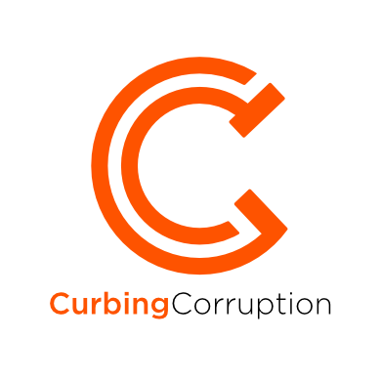

Practical action against corruption

Sector-by-sector reforms & strategies

Sector:

School Education

Updated: August 2018

Table of Contents

Introduction

1. Corruption types in education

1.1 Education corruption typology

1.2 Doing your own analysis

2. Reforms and experience in education

2.1 Functional reforms in education

2.2 People-centred reforms in education

2.3 Monitoring reforms in education

2.4 Justice and Rule of Law reforms in education

2.5 Transparency reforms in education

2.6 Integrity reforms in education

2.7 Whistleblowing reforms in education

2.8 Civil society and media reforms in education

3. Developing an overall strategy

3.1 Context for the strategy

3.2 General strategy guidance

4. Transnational educational initiatives & expertise

4.1 International Institute for Education Planning, UNESCO

4.2 U4 Anti-Corruption Resource Centre

4.3 Development agencies

4.4 United Nations Development Programme (UNDP)

4.5 World Bank

5. Useful resources

5.1 Recommended reading

5.2 Bibliography

## Introduction

School education is a vulnerable sector, in both developing countries and developed countries. The graphs opposite show the corruption in education across 27 countries from the *Global Corruption Report - Education* by [Transparency International 2013](https://www.transparency.org/whatwedo/publication/global_corruption_report_education.). This data shows considerable corruption in developed nations as well as in developing countries – the chart opposite also features OECD countries such as Greece, USA, Germany and UK.

Large amounts of money are involved, typically 20% of public sector expenditure, and it is one of the largest government employers. And, because of the dependence of the students and parents on the teachers and the educational authorities for the educational success of their children, it can be far more painful than to resist a request for a bribe or to complain about nepotism in such a setting than to submit.

**This review.** You can read the whole of this sector review, or you can jump to any one part of it. Here are the main sections:

1. Corruption types in education
2. Reforms and experience in education
3. Developing an overall strategy
4. Transnational educational initiatives and expertise
5. [Useful resources](#Useful resources)

**Author and contributors.** The originating author of this section is Mark Pyman, who is the managing editor of CurbingCorruption. Additional contributions were made by Ian Kaplan; (others).

# Corruption types in education

You need to have a good understanding of the different types of corruption that exist in your education systems. The corruption in your system won’t be the same as this listing below, but it's a good place to start. Various experts and practitioners have produced such lists which typically might show 20-40 different specific education corruption issues. Collectively, this list is called a ‘corruption typology’.

## 1.1 Education corruption typology

Here is the typology that we recommend you start with. It identifies 36 different types of corruption in education:



This typology comes from the Afghanistan Anti-Corruption Monitoring and Evaluation Committee (2017), which completed a large corruption vulnerability analysis of the entire Afghan school education system in 2017. They interviewed 550 stakeholders, from teachers, pupils and parents through to Ministry officials and development partners. Despite the severity of the corruption issues in that country, the typology itself closely resembles those of less corrupt countries. Their report [here](http://www.mec.af/files/2017_23_10_moe_english.pdf) is worth reading.

**Other education typologies you can look at** Expand >

Several other education-corruption typologies have been developed over the years by international development organisations such as UNDP, World Bank, U4 and UNESCO. More details can be found in Section 4 ‘Transnational initiatives’. And there are others, such as from OECD, Heynemann, Selic and Vukovic. Most of them start from the early work of Poisson and Hallak (2001) of UNESCO *Corrupt schools, corrupt universities: what can be done?*

They are all reasonably well developed, and they do not differ hugely from each other. This is good news, as in some other sectors there is still no general agreement on what the specific corruption issues are. Some of the typologies structure the issues by functional area (e.g. procurement, exams), or corruption type (bribery, coercion), whilst others structure them according to whether they occur in the Ministry, or at school level. Nonetheless, the differences are worth examining, as they may show up specific corruption issues that are more relevant to your own country.

Another possible way to structure your analysis of corruption issues is to use OECD’s six building blocks of an education system: Teachers, Quality of learning environment, Assessment, Funding, Provision of education, Governance and system management. Expand

1. **Teachers**: e.g. nepotism in appointments and postings, paying to postpone retirement, payment for licenses.
2. **Quality of learning environment:** e.g. schools not properly built, schools used for private purposes, duress payments for private tutoring, expert-bias in complaints and disciplinary procedures, human rights and related discrimination against certain groups.
3. **Assessment:** e.g. bribery to obtain school places, for good exam results or to obtain exam certificates.
4. **Funding:** e.g. school funding diverted by principals, stealing from grants, corruption in contracting, artificially high prices for textbooks or school equipment or school food.
5. **Provision of education**: e.g. certain provinces/locations favoured for funding or better education,excessive curriculum leading to cheating to pass students through exams.
6. **Governance & system management:** e.g. poor or constrained EMIS, tolerance of fraud and waste, poor controls, lack of independent control capabilities, e.g. on education quality, minimal public communication about performance and choices.

**Sexual exploitation is a corruption type in education.** Sexual exploitation in education is also a type of corruption, well within the definition of corruption as abuse of office for private gain. Exchanging school entrance, exam results, certificates and so forth for sex is a common problem. A study of sexual violence in Botswana, for example, revealed that 67% of girls reported sexual harassment by teachers, 11% of the girls surveyed seriously considered dropping out of school due to harassment, despite the fact that Botswana provides 10 years of free education, and 10% consented to sexual relations for fear of reprisals on grades and performance records (See Meier 2004, *Corruption in the Education Sector: An Introduction*, p7). Sexual exploitation may not be mentioned in some of the typologies, but it is. *There must be an end to the practice of male teachers demanding sex with schoolgirls or female teachers. It shows selfish disrespect for the rights and dignity of women and young girls. Having sex with learners betrays the trust of the community. It is also against the law*’(Kader Asmal, South Africa Education Minister, quoted in Meier 2004).

## 1.2 Doing your own analysis

A listing of education corruption types is the starting point, but it needs now to be adapted to your own situation: there may be different corruption types, some may be very common or uncommon, and the seriousness of the issue will vary from context to context.

**1.2.1 Informal analysis.** Your own staff are usually well aware of the corruption issues. You can ask a group of them to develop the spectrum of the problems and their relative importance. They can use some of the guidance available in this website. You may have specialist groups in your organisation with extra knowledge, like internal audit and educational quality audit groups: use them, bring them into this discussion. External groups often have relevant knowledge, e.g. civil society groups, school boards, school communities: again, use them and involve them.

**1.2.2 Formal analysis techniques.** In large initiatives, you are likely to want a full analysis of the corruption issues across the parts of the education system under study. Here are techniques such as Vulnerability to Corruption Analysis Public expenditure tracking surveys, Quantitative Service Delivery Surveys and others that are more community based, such as Citizen report cards. You can read more about the techniques available in Methodology>Sector-specific corruption types

**1.2.3 Commission analyses and surveys.** There are likely to be good groups in your country who can do a diagnosis of corruption vulnerabilities in your Ministry: commission one of them. Or, seek out education corruption expertise, either locally or internationally; such as from IIEP-UNESCO, U4, OECD or Transparency International, (See Section 4) and ask their advice/help/effort. Looking further ahead, most governments commission annual opinion surveys from citizens on a multitude of issues. You could arrange with whoever organises these in your country to add questions on corruption in education. Questions to ask include: what are the specific corruption problems in your education system? How common is each one? How serious is each one (for education outcome, for cost, for public trust, etc)? How are the corruption levels changing over time?

This way, you will have a good, granular understanding of the scale of each education corruption issue, and how it is changing over time.

**Example – Serbia.** 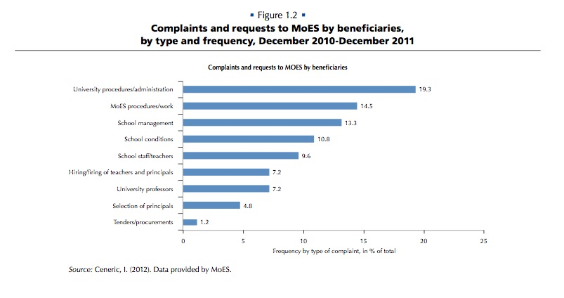Here for example, is a national survey result on corruption in education from Serbia (OECD, 2011). Besides ‘perceptions’ data, such countries also survey the real experience of citizens, usually expressed as how many times that they had paid a bribe in each month.

# Reforms and experience in education

This is the second part of developing an anti-corruption initiative in the education sector. The first part was to analyse the corruption types and their context (Section 1 here). The next part will be to think through an overall strategy (Section 3 here).

## 2.1 Functional reforms in education

There will likely be multiple institutional initiatives and reforms going on at any one time to improve educational quality and delivery in a national education system. The work of improving student outcomes is the ‘core business’ of an education system, and the corruption aspect will only be one element of this. This is a large category and there are usually more possible reform measures in this category than you can possibly accommodate. The question is one of prioritising for impact, feasibility and risk of slow implementation.

**Actions you can consider, with examples:**

**2.1.1 Institutional, system & process improvement – pedagogical**

In much education reform work, improvements to institutions, systems and processes are the bulk of the reforms. If so, your task is not to add to that list, but to review each reform programme from the point of view of corruption risk. You could be asking questions like the following:

* Will the reform it will actively reduce corruption current corruption risks?
* Might the reform inadvertently raise the corruption risk?
* Are the reforms carefully avoiding the question of corruption? Would they benefit by considering the corruption issues more explicitly?
* If the reforms say that they are targeting corruption, review this critically. Is this really true, or is it a way to satisfy donors or other stakeholders without any likely effect?
* Are there some aspects of the current institutional processes that are the most serious for corruption (for example, corruption in the exam system or in the appointment of teachers) where there really do need to be more specific or more energetic reforms?

**Example - Lebanon (2008).** The computerization and automation of examination administration – including the selection of tests and staff in charge of running the examinations, the distribution of candidates among examination rooms, the marking of tests, and the processing and diffusion of results – has facilitated the detection and punishment of those who break the rules governing the administration of examinations (Mneimneh, 2008, quoted by [Poisson 2010](http://etico.iiep.unesco.org/sites/default/files/190247E.pdf))

**2.1.2 Institutional, system & process improvement – administrative and financial**

Simplification, reducing procedural complexities, streamlined budgeting, automating cumbersome procedures, improving controls, finances and accounts; organisational simplification. Such administrative reforms do usually have a positive impact in reducing corruption. Again, like the pedagogical reforms above, you can improve the anti-corruption impact a lot by reviewing whether the reforms will really impact corruption, or if they can be made to be much more effective against corruption with just some modest changes.

**Example – Uganda.** A hugely effective example was the local checking of the Ugandan school budgets against what they were supposed to be receiving according to the treasury statements. This example is given in Section 4.2 ‘Transparency’, or you can find it here. Do not be doubtful about this. Most educational experts and system efficiency are not focused on reducing corruption, nor knowledgeable about it; there is every chance that your focus on the anti-corruption angle will lead to better reforms.

**2.1.3 Improved MIS and technology**

Improving the information system is core to many anti-corruption projects, as well as for improved governance and general performance improvement. . Very often though this is not the case: the official systems are often old, cumbersome and unsuited to any such intelligent query. In which case you have to decide if the problem is worth some sort of separate system or application. Good MIS data on both education al matters, such as exam results or teacher applications, are as important as transparent information on budgets and the use of budgets.

**Example - Gambia (2005).** In Gambia the introduction of an Education Management Information Systems (EMIS) provided an objective means of tracking and ranking teachers by seniority, language skills, specialisation, and other relevant factors for appointment. The information prevented appointments based on personal connections and other invalid grounds. See [Spector (2005).](https://www.amazon.co.uk/Fighting-Corruption-Developing-Countries-Strategies/dp/1565492021)

**2.1.4 Organisation reform of the Ministry**

Ministries can easily become corrupted in whole or in part, or, at the least, tolerant of dubious behaviour. The solution lens is to examine how improvement can be made through organisational improvement. This can range from improving staffing, or improving controls and oversight, through to more radical reforms, such as splitting up a Ministry, or making parts of it into independent agencies.

**Example – Afghanistan (2017).** One recent example is from Afghanistan, where one of the drivers of corruption had been the huge size and un-manageability of the Ministry, which employs 262,000 people, almost 70% of all public officials in the country. After a detailed analysis by the [Independent Corruption Monitoring Committee (MEC)](http://www.mec.af/files/2017_23_10_moe_english.pdf) in 2017 and approval of the recommendations by the President and High Council in 2017, reforms are starting. See also this summary blog from [Pyman (2018).](https://globalanticorruptionblog.com/2018/01/04/guest-post-tackling-corruption-in-afghanistans-education-sector/)

## 2.2 People-centred reforms in education

*‘Never doubt that a small group of thoughtful, committed citizens can change the world; indeed, it's the only thing that ever has’*. The truth of this famous quote, by the American anthropologist Margaret Mead, is confirmed in the anti-corruption sphere by recent research. For more background on this, see Methodology>Reform approaches>People-centred reforms.

**Actions you can consider, with examples.**

**2.2.1 Your leadership**

Being clear that your team can and will make a difference – can change the organisation’s culture to one with a much lower tolerance of misbehaviour. This sounds so straightforward as to be hardly worth a Chapter heading. But it is important because tackling corruption is not a ‘normal’ thing to be talking about or doing. Being clear that your team can and will make a difference can change the organisation’s culture to one with a much lower tolerance of misbehaviour can inspire people to work with you and to put in much more than ‘normal’ effort.

**2.2.2 Building committed supporters**

Building a team of officials across the ministry and related agencies who share the vision of what can be achieved with less corruption is a key place to start. This task is important but is easily overlooked. A reality of corruption is that ***most people in most organisations hate corruption,*** but they feel trapped and disempowered by it. This means that bad practices develop with limited challenge, that the corrupt individuals can easily come to dominate a department, and that patronage systems of corruption develop, whereby the ‘higher level’ corrupt actors direct lower level ones to do their bidding - usually against their will – with their acquiescence assured by a modest cut of the corruption proceeds.

Do take this ‘building commitment’ stage seriously. Ask someone to open up these discussions across the organisation. 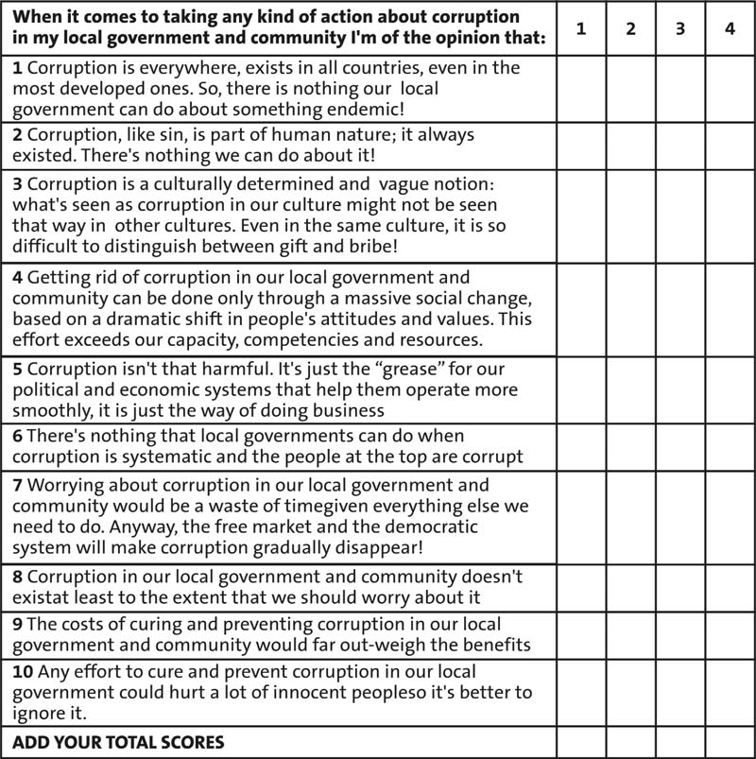I have been present at such discussions in numerous professional leadership groups, from global companies to Ministry leadership teams, from clean Scandinavian countries to endemically corrupt conflict countries. Each of them was initially reluctant to engage in open discussion about corruption. This changes quickly once you make it clear that this is not a taboo subject, and that your purpose in tackling it is not punitive but is constructive because it will actively improve access and service for your students. You can do this in round table conversations.

**Example: UN questionnaire.** You could use a questionnaire to bring out peoples’ opinions. Read more >Here is one for local government employees from [UN Habitat (2006),](https://unhabitat.org/books/restore-the-health-of-your-organisation-a-practical-guide-to-curing-and-preventing-corruption-in-local-government-and-communities-volume-1-concepts-and-strategies/) but it could easily be adapted for education. For each of the ten statements, there are four choices, to register whether you agree (score 1) or disagree (score 4) with the statement, and how strongly. The results indicate to the respondent and to you how big a barrier there may be to tackling corruption and is one way to start the conversation.

**2.2.3 Tackling problems collaboratively with company executives**

Working collaboratively with companies to address particular issues can be a powerful way of tackling complex corruption problems. There are many such initiatives around the world. Though this is less of an opportunity in education than in other sectors, it can still be important, for example in school construction, working with private schools and with external monitoring companies. For examples, see the reviews on health and construction.

**2.2.4 Benefiting from expertise in transnational initiatives**

There is a trend now in anti-corruption for centres of anti-corruption expertise to be developing sector-by-sector. One of the first such centres in 2001 was in Education, housed at the International Institute for Educational Planning, part of UNESCO in Geneva. See Section 4for more on transnational initiatives and expertise.

**2.2.5 Enlisting the international community**

In countries where part of the education budget is provided by partners from other nations, whether this be in the form of aid, or regional projects like in the EU, the international partners have considerable power that you may be able to leverage. You could press them, for example, to require strong integrity clauses, transparency of contracts, and intrusive audit rights. You can encourage the international bodies to take corruption more seriously. In the past, donors seem to have been reluctant to speak explicitly about corruption in education, to judge, for example, from the [USAID 2014](https://www.usaid.gov/sites/default/files/documents/1866/AnalysisUSAIDAnticorruptionProgrammingWorldwideFinalReport2007-2013.pdf) review of anti-corruption programming 20017-2013. There has also been a trend in the past few years for donors to be more concerned about their fiduciary responsibility – i.e. safeguarding the funds that they provide, rather than helping to solve the corruption problems in the national education system (See [Kenny (2017)](https://www.cgdev.org/publication/results-not-receipts-counting-right-things-aid-and-corruption) *Results not receipts: counting the right things in aid and corruption*, for example). Nonetheless, we do recommend that you seek to engage and collaborate actively on this with donors.

## 2.3 Monitoring reforms in education

Independent scrutiny is key to reducing corruption. Sometimes, for exactly this reason, independent scrutiny bodies are under-resourced, or populated with low-grade staff, or denied access to key people and records, bribed or threatened, and otherwise marginalised. Finding ways to get multiple forms of independent scrutiny into effect is a core part of almost all anti-corruption strategies.

**Actions you can consider, with examples:**

**2.3.1 External and Independent monitoring**

Auditing and inspection are important, and often underused, resource in education.

**Example – Philippines.**  *“The Government Watch (G-Watch) of Ateneo School of Government has implemented ‘Constructing Philippine education, one school building at a time’ (Bayanihang Eskwela) since 2005. The programme is a community-based monitoring of the Philippines government’s school-building projects that aims to ensure that high quality school-building projects are implemented at the right time where they are needed most. The programme has mobilized over 700 community-based monitors in its three rounds, who have ensured that 133 classrooms costing 122.8 million Philippine pesos (US$2.8 million) were constructed according to standards. The programme has been officially adopted by the Department of Education as the community-based monitoring component of its school- building programme that ensures transparency and accountability in programme execution. This social accountability experience has generated rich lessons in preventing anomalies and corruption in service delivery, thereby improving effectiveness of services, through citizen engagement in governance.”* (From [UNDP 2011](http://www.undp.org/content/dam/undp/library/Democratic%20Governance/IP/Anticorruption%20Methods%20and%20Tools%20in%20Education%20Lo%20Res.pdf), p27)

**Example - Lithuania** Kazakevičius (2003) has described how Lithuania, while setting up an effective internal and external auditing system, also ushered in mechanisms for the stakeholders in the school system to evaluate themselves. (Quoted by [Poisson 2010](http://www.iaoed.org/downloads/WEB_11_corruption%20and%20education_final_.pdf))

**Example - Lesotho.** Lesotho determined specific building standards according to which all school construction work was to be examined so as to ensure quality. Lesotho enforced these standards through construction project inspection teams that were supported with the mobilization of local communities (Lehohla, 2003, quoted by [Poisson 2010](http://www.iaoed.org/downloads/WEB_11_corruption%20and%20education_final_.pdf))

**Example – Australia; State of Victoria.** The outsourcing of certain management and scrutiny functions in the form of “external audits” can provide organizations with important supplementary information that can be used in the fight against corruption***.*** Some of the powers they enjoy would be better performed by external autonomous agencies that are acknowledged to be impartial and independent. Levačic & Downes, quoted by Poisson 2010) illustrated that the degree of transparency in formula funding of schools was directly linked to the ability to collect statistical data independently of the schools. The state of Victoria, Australia, gathers enrolment statistics four times a year with one such collection performed by an outside entity.

**2.3.2 Establishing a Commission of Inquiry**

In some circumstances, it can make sense to establish or press for a formal Commission of enquiry as a way of bringing about improvement. This is a way of raising awareness of the corruption issues in a very visible public forum. It means that there will be huge attention to the health sector and may result in greater momentum for reform. A detailed analysis of the rationale and potential benefits of choosing such a reform measure in a country like Uganda has been made by [Kirya (2011)](http://wrap.warwick.ac.uk/47800/1/WRAP_Theses_Kirya_2011.pdf) in *‘Performing good governance: Commissions of Inquiry and the Fight against Corruption in Uganda’*. Here is her overview:

*‘The findings suggest that the global anti-corruption framework signified by the good governance agenda is hindered by various factors such as the self-interest of donors, the moral hazard inherent in aid and the illegitimacy of conditionality; all of which contribute to the weak enforcement of governance-related conditionalities. This in turn causes aid-recipient countries such as Uganda to do only the minimum necessary to keep up appearances in implementing governance reforms. National anti-corruption is further hindered by the government tendency to undermine anti-corruption by selective or non-enforcement of the law, the rationale being to insulate the patronage networks that form the basis of its political support from being dismantled by the prosecution of key patrons involved in corruption. Ad hoc commissions of inquiry chaired by judges, which facilitate a highly publicised inquisitorial truth-finding process, therefore emerge as the ideal way of tackling corruption because they facilitate ―a trial in which no-one is sent to jail. …*

*They also served to appease a public that was appalled by the various corruption scandals perpetrated by a regime that had claimed to introduce ―a fundamental change and not a mere change of guard in Ugandan politics. Nevertheless, while they enabled the regime to consolidate power by appeasing donors and the public, they also constituted significant democratic moments in Ugandan history by allowing the public - acting through judges and the media - to participate in holding their leaders accountable for their actions in a manner hitherto unseen in a country whose history had been characterised by dictatorial rule.*

**Example Sierra Leone and the** [**Gbamanja Commission of Enquiry into Education (2018)**](https://awoko.org/2009/06/30/at-gbamanja-commission-of-enquiry-education-minister-admits-failure/) ‘*The corrupt system in the educational sector is responsible for the poor performance of students in public exams because the rules and regulations of the educational system are being by passed resulting to the admission of unqualified students at colleges’.*

**Example** [**Guyana: Commission of Inquiry into Education (2017)**](https://guyanatimesgy.com/education-coi-report-handed-over-to-govt/) ‘*Too (many) people (teachers), during the consultations, complained that they can only do what have been demanded and directed by the officers.’*

**Example** [**Australia: Education access: National Inquiry into rural and remote education (2000)**](http://www.humanrights.gov.au/sites/default/files/content/pdf/human_rights/rural_remote/Access_final.pdf) Examples of discrimination and segregation.

**2.3.3 Focused audits and reviews**

Internal audits are not usually focused on corruption, but focused audits, regular intrusive review and/or active follow up of corruption risks can make problems visible. They also signal a change in the culture and show that certain areas of the education system are being targeted.

**Example - Slovakia (2004).** In her study of auditing, Kopnicka 2004 (quoted by Poisson 2010)) demonstrated that whereas an internal audit had detected no infringement of the public procurement rules in a Slovak university, an external audit found eight such breaches.

**Example - Romania (2015).** *‘This paper analyses the implications of the fight against corruption in a setting of endemic fraud, cheating, and grade selling in the public education system in Romania. Particularly, we investigate the efficiency and distributional consequences of a national anticorruption campaign targeting the Romanian high school exit exam— the Baccalaureate. We find that exam outcomes dropped sharply already in 2011 and that the drop came from both the monitored and non-monitored counties, yet it was larger in the monitored ones. Moreover, we show similar patterns for pass rates at the Baccalaureate exam in Moldova, a country with almost the same educational structure as Romania, which was also facing corruption problems and introduced a very similar policy—harsher punishments in 2012 and CCTV cameras in the examination centres in 2013. From this exercise we conclude that: (i) monitoring and punishment work best when interacted and, more specifically, that monitoring enhances the effectiveness of punishment threats; and (ii) that our main results are not driven by some other possible changes that happened to occur in Romania around that time.’* ([Borcan et al 2015](https://www.hhs.se/contentassets/7d17990209d94ae991036a603353014c/andreea-mitrut.pdf)).

**Example; Useful experience from local government auditors.** 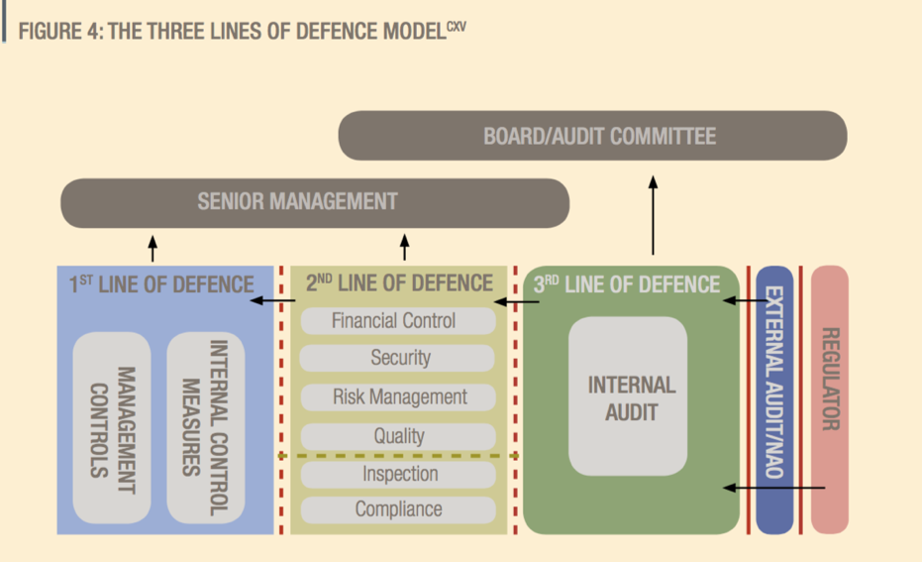Internal auditors are potentially an extremely powerful tool against corruption. However, the experience of many ministries across many sectors is that all too often their internal audit department is under-resourced and not competent. In some countries the audit department is even a source of the corruption by way of threatening target departments with exposure unless paid off.Possibly the sector where internal audit has been used most to detect and deter corruption is local government. Internal audit is regarded as the ‘Third line of defence’ in organisations, the first line being management and line management controls, the second line being broader management control measures, such as quality control and inspection.

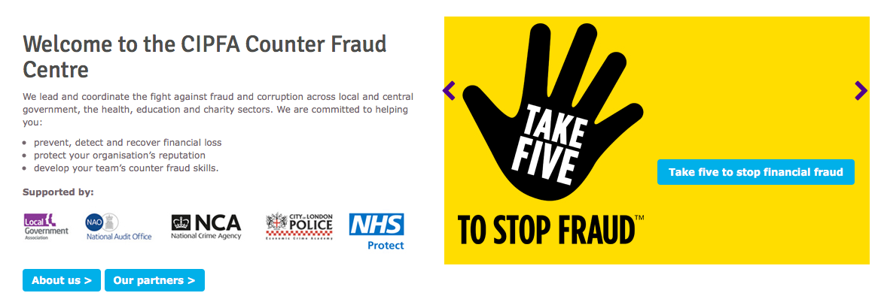One of the best such resources is in the UK, where the Chartered Institute of Public Finance and Accountancy (CIPFA) has a ‘[Counter-Fraud Centre’](http://www.cipfa.org/services/counter-fraud-centre). This is a useful centre to access, with many useful case examples.

**2.3.4 Stronger professional education agencies**

Examples in education are examination boards, education quality inspection agencies and curriculum board. Such agencies and boards needregulating, but the regulation is often not robust, or is more easily controlled by the leadership or other special interest groups than they should be. The independence, competence and diversity of their members is important. The opposite problem is also common, where there are too many such agencies and their overlaps and organisational confusion simply enables the corruption.

**Example – Reform of education quality inspectorate, Afghanistan.** One of the conclusions from the [report](http://www.mec.af/files/2017_23_10_moe_english.pdf) from the Afghanistan Anti-Corruption Monitoring and Evaluation Committee (2017), known as MEC, was that inspection of school education quality was ineffective and not independent. Recommendations, accepted by the Ministry and the President, included setting up a robust and independent education quality inspectorate.

## 2.4 Justice and Rule of Law reforms in education

Sometimes, everybody knows that what is going on is corrupt, but no one dares to be the first to say so: speaking out or putting a senior individual under investigation can change the culture. Sometimes you can change the organisation dynamics if you make it clear that sanctions or disciplinary action will definitely be taken.

**Actions you can consider, with examples:**

**2.4.1 Prosecution, discipline, sanctions and penalties**

You need to apply the ‘stick’ as well as the carrot. In some cases, high profile investigation or referral of known corrupt officials or company executives can jolt the system and show that there is a change of tolerance. In other cases, where prosecution may be too slow or too difficult, more active use of sanctioning, discipline or penalty procedures sends a strong signal of change, that corruption is no longer acquiesced to. For example, in one major community development programme in Indonesia, donors were nervous that a planned scaling up of a large development programme that included education, from $200mln to $1bln, would come adrift because the provincial leaders would help themselves to too much of the enlarged fund. The solution was for the government to show its seriousness by vigorously prosecuting the first few offenders in the first year of the expanded programme, in the expectation that this would deter others. This was indeed the actual outcome.[1]

**2.4.2 Changes to policy**

Corruption issues can be directly or indirectly hidden within policy, and they can also arise directly as a result of good reforms that have not been thought through from a corruption perspective.

**Example – World Bank silence in Zambia.** Education experts are also sometimes over-reluctant to identify corruption as one of the issues influencing education policy. For example, in the recent World Bank report on the education system in Zambia, the Bank does not make a single reference to corruption. The nearest they can get is this: ***‘Weak implementation of policies undermines the effectiveness of the education policies.*** *Despite the presence of policies to ensure the quality of learning, such as school grants for primary and secondary education, weak implementation of programs undermines the effectiveness of education policies. For example, primary schools are supposed to receive school grants from the government to support the free primary education policy, but 30 percent of schools do not receive any government grants and therefore end up collecting fees from students despite the free primary education policy. Schools are often unaware of how much they are supposed to receive, and the weak transparency of the scheme adds to the implementation challenge. In an example of higher education financing, the bursary scheme is a loan scheme by law. However, none of the bursary beneficiary has ever been repaid due to a lack of mechanisms to collect the loans. While the government has been successful in mobilizing public resources for the education sector, efficiency of use and effectiveness of implementation are the key remaining challenges’* ([World Bank, 2016. Education public expenditure review in Zambia](https://openknowledge.worldbank.org/bitstream/handle/10986/23883/K8640.pdf?sequence=2&isAllowed=y.))*.*

**Example – Over ambitious curriculum leads to corruption issues in implementing it in Afghanistan.** The 2017 [report](http://www.mec.af/files/2017_23_10_moe_english.pdf) from the Afghanistan Anti-Corruption Monitoring and Evaluation Committee (known as MEC), accepted by the High Council and now under implementation, evaluated the corruption vulnerabilities across the education system and how they needed to be addressed. Among other conclusions, it concluded that the school curriculum is too ambitious, making it impossible for most teachers to teach the required material to students in the limited time available. While this might not immediately seem like a corruption problem, in fact it is, because teachers are unable to teach the full curriculum, so select what to teach; Teachers and principals sell the questions and results in order to get students through their tests; and this is combined with cramming and corruption to pass the main examination.

**2.4.3 Regulatory improvements**

All countries have deficiencies in their national laws and regulations and you and your team will know which legal issues need clarifying or correcting. Sometimes, such legal reforms are essential, and there is no question but that they must be pursued, even at the expense of other reforms. However, the opposite is perhaps more often true: such changes can be slow, difficult, and lead to unexpected political outcomes. In this situation, the amount of energy, effort and political capital that you have available would be better utilised pursuing other reforms.

## 2.5 Transparency reforms in education

Along with independent review and monitoring, transparency is one of the central tools in reducing corruption. Corruption problems naturally thrive when the relevant data is not going to be made public. The concept of transparency is so powerful that we give it a separate category of its own. Transparency is an easy word to say – it is almost ‘motherhood’ - but if you find the right way to use it – or the right information that needs to be made transparent - and you can do it in a way that people recognise, then the impact can be massive. The most famous example is in fact an education one, in Uganda:

**Example:** **Uganda (2004).** This is perhaps the most well-known data transparency example of them all. The following text from the World Bank: *‘Uganda is a good and frequently given example of a country that successfully closed a window of major corruption opportunity in its education system by boosting transparency. A Public Expenditure Tracking Survey (PETS) carried out in 1996 revealed that only 13 percent of the central grant for education actually reached the schools; 87 percent of it was captured by corrupt officials at the district level, leaving 73 percent of all schools in the country with less than 5 percent of the intended funds. As schools had no information on the amount of funding they were entitled to, and the central tier of governance did not verify the use of funds, these actions remained unchallenged. At the core of policy changes triggered by this dramatic finding was a massive information campaign in which authorities started to publish and broad- cast information on intergovernmental transfers of public funds and requested schools to publicly post information on their financial inflows. A follow-up study estimated that the campaign led to as much as a 75 percent improvement: between 1995 and 2001, the leakage of capitation grants to schools fell from 80 percent to 20 percent.*’ ([Reinikka & Smith 2004](http://www.iiep.unesco.org/sites/default/%20les/public-expend-track-surv.pdf.))

**Example: Colombia (2005).** In order to improve transparency, it is indispensable for policy-makers to review the different standards applied to financial, human, and material resource management. For example, the city of Bogotá in Colombia acted on school staffing procedures by publishing specific descriptions of staff recruitment procedures, postings, and transfer standards. is measure boosted school enrolments by more than one third, with only a limited number of extra teachers taken on due to the gains in efficiency that were made (Peña & Rodriguez, 2005, quoted by [Poisson 2010](http://etico.iiep.unesco.org/sites/default/files/190247E.pdf)).

## 2.6 Integrity reforms in education

Reducing corruption is as much about establishing a strong integrity framework among public officials and the population as it is about directly addressing corruption. The norms of almost all societies and of all religions include acting with integrity. However much this may seem to be overly optimistic, it strikes a strong chord of emotion and pride in people, especially in service organisations like teaching.

**Actions you can consider, with examples:**

**2.6.1 Improving the integrity of teachers and officials**

Local officials easily can be both part of the problem and an essential part of the solution. Attention to the basics – the legality and reality of hiring, firing, promoting and disciplining staff is always necessary. In addition, there is usually a need to regulate official discretion, maintain or improve an ethical employee culture, address absenteeism, have clear standards and codes of conduct, have credible internal reporting procedures, have mechanisms for identification and resolution of conflicts of interest, etc. This is a major topic, and there is much general material to be found on strengthening the integrity of public officials.

**Example – Teacher code of conduct in Canada.** A comparative study undertaken in Bangladesh, India, and Nepal (Nuland & Khandelwal, 2006) revealed that the effectiveness of teacher codes of conduct is often constrained by several factors. Nevertheless, good practices have also been observed in Ontario, Canada. Poisson (2009) explained how the success of a code of conduct was closely linked to the ways in which the teachers themselves espouse the code. She detailed the mechanisms that fostered such ownership: involvement of teachers in developing the code through a participatory process; joint identification of the specific ethical problems they faced; the establishment of mechanisms for regular reviews of the code; validation of the code by teachers’ organizations; wide dissemination of the code in different forms (also as part of pre-service and in-service training); the establishment of appropriate monitoring and control systems; and, the publication of punitive measures meted out under the code. (Quoted by [Poisson 2010](http://etico.iiep.unesco.org/sites/default/files/190247E.pdf)).

**Example – Sri Lanka.** Within education, curiously, education specialists often do not refer to corruption as one of the problem factors. For example, in a recent major World Bank study of the education system in Sri Lanka, a country where there is rampant corruption, the word corruption is only mentioned once in the whole report. Instead, they express the problems as follows: *‘The incentive system, however, is feeble. Although government institutions have explicit performance incentives through such rewards as appointment to higher-status positions, promotions, greater responsibility, job security, more interesting and stimulating work, and decreased supervision, two factors undermine the actual operation of the incentive system for all public employees: (a) The financial incentives for better performance are minimal. Because the government wage and salary structure are highly compressed and annual increments are small, non-performance has little opportunity cost. (b) Promotions are still mainly based on seniority, with performance incentives having at best a secondary role. Those two elements are likely to be a drain on teacher effectiveness’.* From [World Bank 2017](https://openknowledge.worldbank.org/handle/10986/27042) *Sri Lanka Education Sector assessment: achievements, challenges and policy options.*

**2.6.2 Awareness, education and capacity development**

General anti-corruption education for staff and teachers; Anti-Corruption Education in schools with pupils; Building the capability of locally accountable school and community oversight bodies.

**Example – Right to information in India** Several studies have shown that the administration often finds it difficult to recognize the public service users’ right to information. …Recognizing these difficulties, educators from Karnataka and Rajasthan put together recommendations aimed at consolidating the effectiveness of the right to information. These recommendations covered the involvement of governments, NGOs, and other partners in the organization of awareness campaigns on the right to information; the organization of training sessions for all government staff members (including administrators and teachers) on the right to information, its precise interpretation, and its enforcement procedures; citizens’ education on how, and in which circumstances, to use the right in order to obtain information; the speedier dissemination of any information that is of use to the public, and in a form that is accessible to different types of users (literate, illiterate, urban, and rural); the consequent consolidation of information systems; the establishment of incentive and punitive mechanisms designed to encourage civil servants to provide accurate and up-to-date information; and, the regulations associated with charging for the supplying of information (Devi 2003, quoted by [Poisson 2010](http://etico.iiep.unesco.org/sites/default/files/190247E.pdf)).

**2.6.3 Insert anti-corruption directly in the school curriculum**

Various countries have started on teaching anti-corruption directly in schools, for example in South Korea. Reformers are thinking more about how to do this: see for example the [Accountability Lab (2017)](https://www.weforum.org/agenda/2017/03/why-we-have-to-reimagine-education-to-fight-corruption/) ‘*Why we have to reimagine education to fight corruption* and [Shinta Nurfauzia (2015)](https://globalanticorruptionblog.com/2015/04/20/making-anticorruption-education-work-the-to-do-list/) *Making Anti-Corruption Education work: the to do list.*

## 2.7 Whistleblowing reforms in education

Almost all large bureaucracies have mechanisms for complaints and or whistle-blowers. At the same time, these mechanisms are almost always weak and may exist on paper only. Yet these mechanisms are vital in identifying and calling out corruption: the challenge is to find a way to make them effective. Civil society has shown many ways in which it can be a more honest and independent way of checking performance and/or being a trusted place that complainants speak with.

We do not have any examples of whistleblowing systems against corruption. Let us know if you have examples.

## 2.8 Civil society and media reforms in education

At local level, you have much opportunity to enlist citizens for change, or to be pushed forward by citizens who are determined to achieve change. The involvement of civil society can be unpredictable – they are of course not under your control – but for the same reason it gives your initiative more of an external reality. Parents committees in schools are probably the most powerful form of civic society for change in education.

**Actions you can consider, with examples:**

**2.8.1 Reform through civic engagement and collaboration with civil society**

At local level, you have much opportunity to enlist citizens for change, or to be pushed forward by citizens who are determined to achieve improvements to their children’s’ education system. This may involve a ‘call to action’ for citizen involvement, or it may happen naturally. Besides civic engagement, civil society organisations have a much greater freedom to intervene when there is misbehaviour than official hierarchies do; and they can help in reaching out to the wider community to build trust.

**Example - Argentina: getting the textbooks right.** One recent example of a successful strategy was a consultation procedure, implemented by Poder Ciudadano *(*Quoted by[*U4 2006*](http://www.u4.no/publications/corruption-in-the-education-sector/)*),* Transparency International’s national chapter in Argentina, on the procurement of 3,315,000 books for use nationwide. An initial textbook selection phase was halted by objections to the textbook selection criteria, to the jurors that intervened in the selection and to the local management procedures. The Ministry of Education, Science and Technology then invited Poder Ciudadano to participate in the second attempt and to help them to develop a transparent process. The TI chapter introduced three strategies. 1) They organised participatory discussions of the criteria for selecting the textbooks to be procured and of the tender documents to procure them. These discussions involved representatives of the Ministry and textbook publishers and were mediated by Poder Ciudadano. 2) They implemented a no-bribes TI Integrity Pact, which was subscribed to by both the bidders and the Ministry to create common and clear ground rules for the procurement process. 3) They set up mechanisms to prevent and manage conflicts of interest among members of the advisory committee in charge of pre-selecting the texts. This, in addition to transparency and publicity measures during the contracting procedure, resulted in a transparent process with no objections and a broader diversity of textbooks and publishing houses: 56 publishers participated and 48.3% of those were awarded at least one contract *(*Quoted by[*U4 2006*](http://www.u4.no/publications/corruption-in-the-education-sector/)*, p21).*

**Example - Lobbying for change to parent payments in Russia.** ‘In Russia, schools request money from parents using a number of excuses. Such practices are not legal, but parents pay out of fear that their children will otherwise face retribution. Neither the funds themselves nor their use is subsequently accounted for. With small grants to NGOs in Samara and Tomsk actions were taken to work with parents and school districts to improve the transparency of budget planning and expenditure, and to increase parents’ influence over the process. The aim was achieved successfully through intensive lobbying of school administrations. (Management Systems International 2003, quoted by [*U4 2006*](http://www.u4.no/publications/corruption-in-the-education-sector/), p9).’

**Example – School corruption can be worse at the bottom than at the top in Peru.** ‘This is a programme to get milk to schools, known as “glass of milk,” or Vaso de Leche”, program presents an excellent example of how the flow of complex resources can be traced through multiple levels (World Bank 2002). Read more >

**2.8.2 Citizen Report Cards**

Report Cards are a national tool, which have been in use since their pioneering application in Bangladesh. The following explanatory text is from [Poisson (2010):](http://etico.iiep.unesco.org/sites/default/files/190247E.pdf) *“Report Cards are used to generate information on the quality and efficiency of the public service as perceived by users. is approach to information collection may be used to mobilize local communities in a participatory approach, and also to question them on particular matters, such as the payment of illegal school fees. Data can be collected by way of questionnaires administered to civil servants, teachers, pupils, and parents chosen at random from a sample of schools. ese data can be “subjective” (based on the perception of the people interviewed) and “objective” (based on their experience and actual facts). In the case of Bangladesh, a citizen evaluation based on Report Cards showed that over 96 per cent of pupils had been made to pay illicit fees to sit for first term exams, and that a total amount of 20 million Bangladesh Takas had been paid by parents in eight Bangladeshi districts (Karim, 2004). The ease with which this type of survey can be performed in very different contexts has led various organizations and donors, such as the World Bank, the Commonwealth Education Fund, and the Hewlett Foundation, to fund and implement such probes”.*

Comparative studies of these various types of inquiry have shown that their success depends on the involvement of public authorities in the investigation process (even if data collection and data analysis are performed by an independent and impartial entity); on the authorities’ resolve to pursue the findings of the survey, for instance by “cleaning up” the teacher list; on the wide dissemination of survey findings; and the incorporation of these new tools into diagnostic methods for use by members of the public through inclusion in evaluations, audits, etc.

**Example – Bangladesh.** ‘*Public feedback, organised through civil society, can be a powerful tool for making social services more responsive and accountable. TI Bangladesh uses report cards to draw attention to perceived problems in the delivery of services. Report cards are filled in by users of public services and subsequently analysed. The results are made available to Committees of Concerned Citizens, who then exert pressure for change on the basis of the findings.’* Quoted in [U4 2006](http://www.u4.no/publications/corruption-in-the-education-sector/), p9.

# Developing an overall strategy

Now that you have done the analysis of the health-specific corruption issues (Section 1), and you have brainstormed with colleagues and others on what reform approaches and specific reform measures may be feasible in your context (Section 2), the third part is to think through and develop an overall strategy.

If ever there was a contest for the most over-used word in language, ‘strategy’ would be on the short list. The word came originally from the Greek word for leadership in a military context: how to conceive and craft a successful strategy against your enemy. It means, in brief, picking the right battles, ignoring lesser objectives and about simplicity: strong determination in carrying through a simple idea is seen as the route to success. However, since the idea of strategy entered the civilian world in the 1970s, it has become more sanitised. It tends now to mean the overall programme of activities to achieve a formal objective and may consist of little more than a wish-list of measures, without consideration of how to achieve them or how to overcome resistance. This is a pity, because the essence of the original meaning – how to achieve something that will be resisted - is important.

## 3.1 Context for the strategy

1. International: How serious is the education corruption in your country compared with other countries and countries you regard as your peers?
2. National and cross-government: How serious is education corruption compared with the other government activities in your country, such as corruption in health or police?
3. What are the main factors driving the corruption? For example, is it part of the general national context, or arising from the influence of particular groups or individuals, or from a sclerotic system?
4. Sub-national: Does the corruption in education vary a lot from one part of your country to another?
5. Feasibility and achievability

Internationally, the graph at the beginning of this review gave you an overview. Nationally, most countries now have surveys about corruption, and these surveys show how extensive is corruption in one domain, such as education, compared with another, say health or police services. In the more developed countries, education is usually one of the less corrupt functions of government. In the less developed countries, it is typically seen as less corrupt than the police or politicians. But every country is different, so it is worthwhile gathering this data for your own situation.

Regarding the factors driving the corruption in education, you and your colleagues are likely to know the political and power context. It is worthwhile considering this more formally, especially in relation to how groups might react to your reform measures. Top of the list of context questions is to think through who your supporters are and who are the possible spoilers. Who might gain, who might lose from reducing corruption in your education system? What does this mean for your strategy and how you can build a broad coalition of people who will support you? In the language of economists, which ‘rents’ are they extracting, and who is paying them? These political angles to the strategy are discussed further in Section 3. If you are doing a large diagnostic analysis, you might consider adding a ‘political economy analysis’ to the work, which would lay out these issues in a structured way.

The fourth question, about regional variation, is very relevant to education, because responsibility for education is often shared between national and local government, and in very different ways in different countries. It can be the case that the education system is operating with limited corruption in one province but is known to be endemically corrupt in another. Similarly, education leadership in one province or city can be very energetic in tackling corruption, but this may not be reflected elsewhere. In recent research on corruption, these variations within a country – by sector and by city or province - have been found to be bigger than the variations between countries.

Finally, right from the start, be aware of what you might realistically be able to achieve. Most findings are that the narrower the scope the better, so have in mind that you may be wanting to start with just a few reforms. Other context aspects that you might think about include:

* ***Organisation capacity:*** most public-sector organisations are highly stretched. Officials will only have limited time and energy and commitment to pursue another initiative, however worthy
* ***Motivations:*** Most people are keen to reduce corruption, but it is not usually a strong motivator on its own. People are much more motivated by pride or shame (they value being seen as not corrupt), and by tangible outcomes (eg making exams results really meritocratic, widening school access).
* ***Stakeholders:*** There are a wide range of people involved in education: students, parents, teachers and officials, local government, politicians. Gaining a thorough view of what they all think is useful.
* ***Economic.*** And, of course, is there any money? Knowing what is possible, or could be possible, will guide you on the sorts of reforms that you pursue, how much effort you can afford to devote to them, and how much you will need to rely on commitment and volunteering as opposed to paid help.

## 3.2 General strategy guidance

We do not have any examples of overall anti-corruption reform strategies in education. If you have examples, please let us know.

Our general guidance on how you develop an overall strategy is to follow these steps:

1. Desired impact: *Knowing clearly what you want to achieve; important and often not obvious*
2. Strategic choices: *Thinking how to achieve each objective;* w*hat to prioritise and what to discard.*
3. Collaboration and political skill: ‘*In the long history of humankind those who learned to collaborate and improvise most effectively have prevailed’ (Charles Darwin)*
4. Implementation: *Managing, measuring and coordinating progress*
5. Formality and alignment: *Linking the initiative across government and other stakeholders*

You can read more on each of these steps in Methodology>Overall strategy.

# Transnational educational initiatives & expertise

There are no transnational anti-corruption initiatives that we are aware of in school education, though there are calls for such initiative. See, for example, *Why we have to reimagine education to fight corruption*, by the NGO [Accountability Lab 2017](https://www.weforum.org/agenda/2017/03/why-we-have-to-reimagine-education-to-fight-corruption/).

## 4.1 International Institute for Education Planning, UNESCO

One of the first such centres in 2001 was in Education, housed at the International Institute for Educational Planning, part of UNESCO in Geneva.

IIEP-UNESCO provides support to countries that are in the process of launching public expenditure tracking surveys, [report cards](http://etico.iiep.unesco.org/priority-topics/diagnostic-tools/report-cards/), and audits, or who are conducting an [integrity assessment of their education sector](http://etico.iiep.unesco.org/news-detail/news/corruption_risk_assessment_in_kosovo/?tx_ttnews%5bbackPid%5d=1321&cHash=55315c915367dbfd5b817273bdfb5123). They also carry out research projects and activities to document successful strategies to promote transparency and accountability in a variety of educational planning/management domains. The IIEP Ethics and Corruption in Education Programme develops an understanding of how to reshape educational planning by considering transparency and accountability concerns.

They suggest six different categories of reform measures, from Poisson (2010): see below:

UNESCO reform measures

1. Transparency of standards and procedures

2. Capacity building and management automation

3. Outsourcing of management and verification processes

4. Teacher codes of conduct

5. The right to information

6. Concerted action using multiple approaches

They have a comprehensive web-based resource platform, ETICO, with various resources on the issue of ethics and corruption in education, including higher education. For example, in [Addressing Plagiarism](http://etico.iiep.unesco.org/sites/default/files/addressing_plagiarism.pdf).

The mission of their governance and accountability group, according to their website, is: as follows *Education’s primary governance challenges derive from weaknesses in inclusiveness (democratic governance), fairness (equitable governance), and public accountability (transparent and incontestable governance). Good governance is regarded today as a major prerequisite for improving effectiveness and efficiency in service delivery and for meeting the needs of the poorest. During the MTS, IIEP will build on its strong work in the area to translate good governance principles into systematic institutional and sector policies and measures. Since launching its programme on*[*Ethics and corruption*](http://www.iiep.unesco.org/node/1765)*in Education in 2001, IIEP has drawn invaluable insights into the importance of a sectoral approach for diagnosing risks and formulating relevant measures. Integrity planning has emerged as a path for assessing the possible risks of corruption and addressing issues of transparency and accountability. In the next years, IIEP will build an* [*evidence base*](http://www.iiep.unesco.org/en/our-mission/governance-and-accountability) *for the most critical and effective use of open education data for improving integrity planning in education.’*

## 4.2 U4 Anti-Corruption Resource Centre

The Norwegian-based expert resource centre ‘[U4](https://www.u4.no/)’ has written on tackling corruption in education. In their 2006 publication ‘Corruption in the education sector’, they list the corruption types as follows:

1. Illegal charges levied on children’s school admission forms which are supposed to be free.
2. School places ‘auctioned’ out to the highest bidder.
3. Children from certain communities favoured for admission, others subjected to extra payments.
4. Good grades and exam passes obtained through bribes to teachers and public officials. The prices are often well known, and candidates can be expected to pay up-front.
5. Examination results only released upon payment.
6. Removing the consequences of failing exams by (re-)admitting students under false names.
7. Embezzlement of funds intended for teaching materials, school buildings, etc.
8. Sub-standard educational material purchased due to manufacturers’ bribes, instructors’ copyrights
9. Schools monopolising meals and uniforms, resulting in low quality and high prices.
10. Private tutoring outside school hours given to paying pupils, reducing teachers’ motivation in ordinary classes, and reserving compulsory topics for the private sessions to the detriment of pupils
11. School property used for private commercial purposes.
12. Pupils carrying out unpaid labour for the benefit of the staff.
13. Staff exploiting and abusing pupils in many different ways (physically, sexually, etc.).
14. Teacher recruitment and postings influenced by bribes or sexual favours.
15. Exam questions sold in advance.
16. ‘Ghost teachers’ - salaries drawn for staff who are no longer (or never were) employed for various reasons (including having passed away).
17. High absenteeism, with severe effects on de facto student-teacher ratios.
18. Licences and authorisations for teaching obtained on false grounds via corrupt means.
19. Inflated student numbers (including numbers of special-needs pupils) quoted to obtain better funding.
20. Bribes to auditors for not disclosing the misuse of funds.
21. Embezzlement of funds raised by local NGOs and parents’ organisations.
22. Politicians allocating resources to particular schools to gain support, especially during election times.

And they list the range of reform measures as follows:

* politically independent administrations
* clear-cut management rules and procedures
* clear standards and rules for merit-based teacher recruitment and promotion
* clear criteria for student admissions and examinations
* codes of conduct
* systems for monitoring compliance with rules and applying punitive measures in case of non-compliance
* rules on conflict of interest
* autonomous examination agencies
* involvement of parents, teachers, and civil society in planning and management
* access to information
* complaint mechanisms available for all interested parties (including rights for whistleblowers)
* internal and external control of accreditation boards for private institutions
* Local stakeholder ownership
* Education Management Information Systems (EMIS) Development agencies

## 4.3 Development agencies

Development agencies have prioritised education reform for many years and have developed cadres of experts on education. If you are working with any such agency, ask for their help on reducing corruption in education.

One word of warning, though. Development agencies tend to focus mostly on institutional reform, and not so much on corruption issues. Furthermore, most global programmes, such as USAID, have focused their anti-corruption programmes on governance generally rather than into individual sectors. The chart opposite makes clear from the [USAID (2014)](https://www.usaid.gov/sites/default/files/documents/1866/AnalysisUSAIDAnticorruptionProgrammingWorldwideFinalReport2007-2013.pdf) review of all their anti-corruption programming 2007-2013 that there is limited experience with sector anti-corruption reforms, like education, compared with more generalised anti-corruption efforts. See [USAID (2014)](https://www.usaid.gov/sites/default/files/documents/1866/AnalysisUSAIDAnticorruptionProgrammingWorldwideFinalReport2007-2013.pdf) p4,8,27,48 (Health programmes are in Annex 4).

4.4 United Nations Development Programme (UNDP)

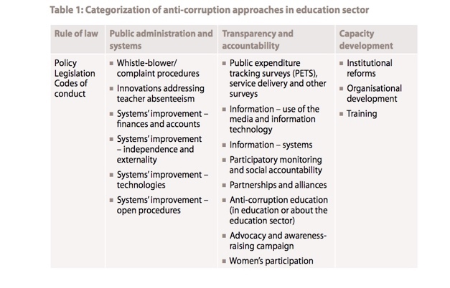UNDP has published a lot on education and corruption. See, for example, the [UNDP 2011](http://www.undp.org/content/dam/undp/library/Democratic%20Governance/IP/Anticorruption%20Methods%20and%20Tools%20in%20Education%20Lo%20Res.pdf) report *Fighting corruption in the education sector: methods, tools and good practices*.

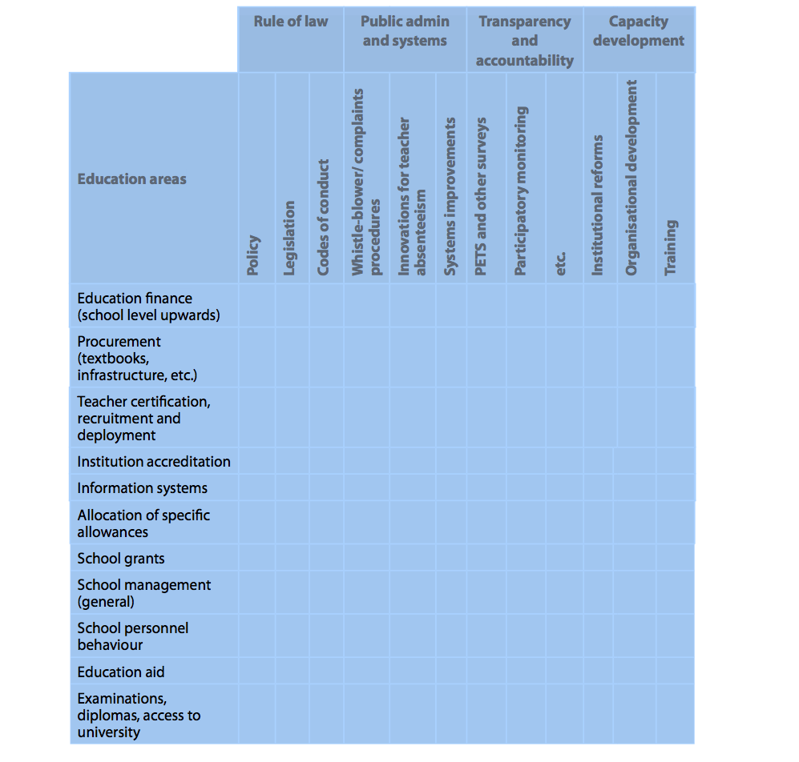They have four overall categories of measures: Rule of Law, Public Administration and systems, Transparency and accountability, and Capacity development. Within each of these they list a number of types of reform measures; see for example the one for ‘Rule of Law’ above.

UNDP (2011) also suggests using a matrix, opposite, in which each ‘education area’ can be analysed in respect of each reform type.

## 4.5 World Bank

The World Bank has invested heavily in improving education, spending [$45 billion worldwide](http://www.worldbank.org/en/topic/education/overview) since 2000 on improving education. In respect of anti-corruption, the published a [World Bank 2013](https://papers.ssrn.com/sol3/papers.cfm?abstract_id=2358480) guide called *‘Fighting corruption in education; a call for sector integrity standards*’ which is worth reading. Below is one of the World Bank education corruption typologies (from page 379):

|  |  |
| --- | --- |
| Area of Deliverables/ Expectations | Sample Offenses |
| Quality of education | * Provision of better learning conditions to individual students whose parents provide financial support to the school, at the expense of “regular” students * Rigged examinations, i.e., through the sale of examination questions * Forced purchase of learning materials authored by the teachers * Purposeful reduction of teaching effectiveness during regular school hours in view of stimulating demand for private tutoring * Private tutoring by the same teacher in exchange for grades |
| Access to education | * Bribing to ensure access to education, or to allow for transition to higher levels of education * Rigged entrance examinations * Provision by students of intellectual or other services to  university teachers in exchange for academic success * Sale of academic credentials |
| Sound management of staff | * Teacher recruitment based on political or family affiliations, rather than on qualifications and performance * Teacher absenteeism |
| Sound management of resources | * Manipulation of local data on numbers of students, admission of minorities, or on examination results to obtain more favourable resource or staff allocations * Embezzlement of funds * Use of school infrastructure for generating revenue at the  expense of the teaching and learning environment * Use of student labour for generating school revenue under the pretext of providing practical training |

# Useful resources

## 5.1 Recommended reading

If you want to read more external reports, we suggest the following:

1. **UNDP (2011)**. Fighting corruption in the education sector: methods, tools and good practices.
2. **Poisson, Muriel (2010)**. Corruption and Education: International Academy of Education.
3. **Transparency International** (**2013)**. Global Corruption Report – Education.
4. **World Bank (2013).** Fighting Corruption in Education: A Call for Sector Integrity Standards.
5. **Selic and Vujovic (2009)**. Policy for fighting against corruption in education.
6. **Afghanistan Anti-Corruption Monitoring and Evaluation Committee (‘MEC’) (2017)**. Analysis of corruption vulnerabilities across the Afghan school education system.
7. **Hallak and Poisson (2007)**. Corrupt schools, corrupt universities: What can be done?
8. **OECD (2013)**. Strengthening integrity and fighting corruption in Education: Serbia.
9. **Sahlberg (2009)** International organisations in fighting education corruption
10. **U4 (2006);** Corruption in the education sector

If you want to read more on developing anti-corruption strategies:

1. **United Nations Office on Drugs and Crime (2015).** The United Nations Convention against Corruption National Anti-Corruption Strategies: A Practical Guide for Development and Implementation.
2. **Pyman et al (2017)** Research comparing 41 national anti-corruption strategies; insights and guidance for leaders.
3. **Afghanistan Independent Anti-Corruption Monitoring and Evaluation Committee (2017).** Ministry-wide vulnerability to corruption assessment of the Ministry of Education.

## 5.2 Bibliography

**Accountability Lab (2017)** *Why we have to reimagine education to fight corruption*. <https://www.weforum.org/agenda/2017/03/why-we-have-to-reimagine-education-to-fight-corruption/>

**Afghanistan Anti-Corruption Monitoring and Evaluation Committee (MEC) (2017)** *Ministry-wide vulnerability to corruption assessment of the Afghan Ministry of Education.* <http://www.mec.af/files/2017_23_10_moe_english.pdf>

**Ang, Yuen Yuen (2017)** *How China escaped the poverty trap*. Cornell University Press. <http://www.cornellpress.cornell.edu/book/?GCOI=80140100715940>

**Borcan, Oana, Lindahl, Mikael and Mitrut, Andreas (2015)** *Fighting corruption in education: what works and who benefits?* [*https://www.hhs.se/contentassets/7d17990209d94ae991036a603353014c/andreea-mitrut.pdf*](https://www.hhs.se/contentassets/7d17990209d94ae991036a603353014c/andreea-mitrut.pdf)

**DFID (2010)** *DFID How-to Note; addressing corruption in the Health sector, November 2010.* <https://www.gov.uk/government/uploads/system/uploads/attachment_data/file/67659/How-to-Note-corruption-health.pdf>

**European Union (2010)** *Project against corruption in Albania (Paca). Technical paper: Corruption risk assessment methodology guide*. <https://www.coe.int/en/web/corruption/completed-projects/paca/technical-papers>

**GIZ (2004)** Deutche Gesselschaft fur Techniche Zusammenarbeit. *Preventing Corruption in Education Sector: a practical guide.* Eschborn (quoted on page 42 of Selic and Vujovic )

**Hallak, Jacques and Poisson, Muriel (2007)** *Corrupt schools, corrupt universities: What can be done?* Paris: UNESCO Publishing. Available at: <http://unesdoc.unesco.org/images/0015/001502/150259e.pdf>

**Hallak, Jacques and Poisson, Muriel (2001)** *Ethics and corruption in education.* International Institute for Education Policy, Policy Forum No 15. Available at: http://unesdoc.IIEP-UNESCO.org/images/0012/001292/129290e.pdfhttp://unesdoc.unesco.org/images/0012/001292/129290e.pdf<http://unesdoc.unesco.org/images/0012/001292/129290e.pdf>.

**Heynemann, Stephen (2016)** *Corruption in education: consequences and proposals for amelioration* World Bank, April 21, 2006.

**Kenny, Charles (2017)** *Results not receipts: counting the right things in aid and corruption*. Center for Global Development. <https://www.cgdev.org/publication/results-not-receipts-counting-right-things-aid-and-corruption>

**Khan, Mushtaq, Andreoni, Antonio, Roy, Pallavi (2016)** *Anti-corruption in adverse contexts: a strategic approach.* SOAS Research Online. <http://eprints.soas.ac.uk/23495/1/Anti-Corruption%20in%20Adverse%20Contexts%20%281%29.pdf>

**Kirya, Monica (2011)** *Performing “good governance” Commissions of Inquiry and the Fight against Corruption in Uganda*. PhD Thesis, University of Warwick, UK. <http://wrap.warwick.ac.uk/47800/1/WRAP_Theses_Kirya_2011.pdf>

**Meier, Bettina (2004)** *Corruption in the Education Sector: An Introduction.* Transparency International*.* Available at: <https://www.atositchallenge.net/wp-content/uploads/2016/11/Meier2004corruption-in-education.pdf>

**Nurfauzia, Shinta (2015)** *Making Anti-Corruption Education work: the to do list.*  <https://globalanticorruptionblog.com/2015/04/20/making-anticorruption-education-work-the-to-do-list/>

**Ochse, Katharina (2004)** *Preventing Corruption in the Education System: A Practical Guide* (Deutsche Gesellschaft für Technische Zusammenarbeit 2004).

**OECD (2012)** *Strengthening integrity and fighting corruption in Education: Serbia* Available at: <http://www.oecd-ilibrary.org/education/strengthening-integrity-and-fighting-corruption-in-education-serbia_9789264185777-sr>

And:<http://www.oecd-ilibrary.org/docserver/download/9112181e.pdf?expires=1499175757&id=id&accname=guest&checksum=C2F2F4F7B9B1243EE5C595C796FCAFC9>

**Patrinos HA (2013)** *The Hidden Cost of Corruption: Teacher Absenteeism and Loss in Schools*. In *Global Corruption Report: Education*, edited by G. Sweeney, K. Despota, and S. Linder, 70–73. New York: Routledge; Berlin: Transparency International. (quoted in World Bank Sri Lanka report)

**Poisson, Muriel (2010)** *Corruption and Education* International Academy of Education, Education Policy Series Booklets No11. Available at: http://etico.iiep.unesco.org/sites/default/files/190247E.pdf

**Poisson, Muriel and Hallak, Jacques (2001)** *Corrupt schools, corrupt universities: what can be done?* <http://unesdoc.unesco.org/images/0015/001502/150259e.pdf>

**Pyman, Mark (2018)** *Tackling corruption in Afghanistan’s education sector.* <https://globalanticorruptionblog.com/2018/01/04/guest-post-tackling-corruption-in-afghanistans-education-sector/>

**Pyman, Mark, Eastwood, Sam, Hungerford, Jason, and Elliott, Jasmine (2018)** *Analysing the anti-corruption approaches of the 26 top-ranked countries: an opportunity for a new generation of strategies.* Institute for Statecraft and Norton Rose Fulbright, March 2018.Available at:<http://www.statecraft.org.uk/sites/default/files/documents/EMEA_2384_Bespoke%20brochure__Countries%20Curbing%20corruption%20final%20report_V3....pdf>

**Pyman, Mark, Eastwood, Sam, Hungerford, Jason and Elliott, Jasmine (2017)** *Research comparing 41 national anti-corruption strategies. Insights and guidance for leaders.* Institute for Statecraft and Norton Rose Fulbright. <http://www.nortonrosefulbright.com/knowledge/publications/147479/countries-curbing-corruption>

**Reinikka, Ritva, and Nathanael Smith (2004)** *Public Expenditure Tracking Surveys in Education: Peru, Uganda and Zambia. Ethics and Corruption in Education.* Paris: UNESCO International Institute for Educational Planning. Available at: http://www.iiep.unesco.org/sites/default/ les/public-expend-track-surv.pdf. http://etico. iiep.unesco.org/uploads/media/136267e.pdf.

**Reyes (2010)** *The Philippine Department of Education: challenges of policy implementation amidst corruption*. <http://www.tandfonline.com/doi/abs/10.1080/02188791.2010.519696?journalCode=cape20>

**Sabic-El Rayees and Mansur (2016)** *Favor reciprocation theory in education: New corruption typology.* International Journal of Educational Development 50 (2016) 20–32. Available at: <http://www.sciencedirect.com/science/journal/07380593/50>

**Sahlberg P (2009)** *The role of international organisations in fighting education corruption***.** Available at:<https://pasisahlberg.com/portfolio-writings/selected-writings/articles/sahlberg-p-2009-the-role-of-international-organisations-in-fighting-education-corruption-in-s-heyneman-ed-buying-your-way-into-heaven-education-and-corruption-in-international-perspective-ro/>

**Selic and Vukovic (2009)** *Policy for fighting against corruption in education* Available at: <https://core.ac.uk/download/pdf/18619273.pdf>

**Spector, Bertram (2005)** *Fighting corruption in developing countries*. Kumerian press. <https://www.amazon.co.uk/Fighting-Corruption-Developing-Countries-Strategies/dp/1565492021>

**Transparency International (2013)** *Global Corruption Report - Education*. Edited by Gareth Sweeney, Krina Despota and Samira Lindner. Routledge, 2013. Available at: <https://www.transparency.org/whatwedo/publication/global_corruption_report_education>.

**U4 (2006)** *Corruption in the education sector.* Available at: <http://www.u4.no/publications/corruption-in-the-education-sector/>

**UNDP (2011** *Fighting corruption in the education sector: methods, tools and good practices.* Available at <http://www.undp.org/content/dam/undp/library/Democratic%20Governance/IP/Anticorruption%20Methods%20and%20Tools%20in%20Education%20Lo%20Res.pdf>

**United Nations Habitat (2006**) *Restore the Health of Your Organization: A Practical Guide to Curing and Preventing Corruption in Local Governments and Communities, Volume 1, Concepts and Strategies*. Author Fred Fisher. <https://unhabitat.org/books/restore-the-health-of-your-organisation-a-practical-guide-to-curing-and-preventing-corruption-in-local-government-and-communities-volume-1-concepts-and-strategies/>

**United Nations Office on Drugs and Crime (2015)** *National Anti-Corruption Strategies: A Practical Guide for Development and Implementation*. Accessible at <https://www.unodc.org/documents/corruption/Publications/2015/National_Anti-Corruption_Strategies_-_A_Practical_Guide_for_Development_and_Implementation_E.pdf>

**United Nations Office on Drugs and Crime (2005)** *PROACTIVE ‐ Programme on Assessing Corruption Through Evidence‐based methods.* <http://www.unodc.org/unodc/en/corruption/publications.html>

**USAID (2014)** *Analysis of USAID anticorruption programming worldwide 2007-2013.* <https://www.usaid.gov/sites/default/files/documents/1866/AnalysisUSAIDAnticorruptionProgrammingWorldwideFinalReport2007-2013.pdf>

**USAID (2006)** *Corruption Assessment Handbook.* <http://pdf.usaid.gov/pdf_docs/Pnadp270.pdf>

**Vujovic et al (2010**) *How to make institutions more efficient*. At <http://pasos.org/wp-content/archive/may_2010.pdf>

**Weick (2001)** *Making Sense of the Organisation* <https://www.amazon.co.uk/Making-Organization-KeyWorks-Cultural-Studies/dp/0631223193>

**World Bank (2017)** *Sri Lanka Education Sector assessment: achievements, challenges and policy options.* World Bank Group. <https://openknowledge.worldbank.org/handle/10986/27042>

**World Bank (2016)** *Education public expenditure review in Zambia*. World Bank Group. <https://openknowledge.worldbank.org/bitstream/handle/10986/23883/K8640.pdf?sequence=2&isAllowed=y>.

**World Bank (2016**)*Madagascar - Public expenditure review 2015: education* (English). Available at: <http://documents.worldbank.org/curated/en/271911468185343596/Madagascar-Public-expenditure-review-2015-education>

**World Bank (2014)** *Public Expenditures in Georgia: Strategic Issues and Reform**Agenda.* Available at: <http://www.worldbank.org/en/country/georgia/publication/public-expenditures-review>

**World Bank (2013)** *Fighting Corruption in Education A Call for Sector Integrity Standards.* Author Mihaylo Milovanovitch. World Bank Group. <https://papers.ssrn.com/sol3/papers.cfm?abstract_id=2358480>

**World Bank (2013)** *Policy notes on public expenditures in Tajikistan*. Available at: <http://documents.worldbank.org/curated/en/989271468312633854/pdf/891820NWP0P14700TJK0NOTE30final0web.pdf>

**World Bank (2012)** *Philippines: basic expenditure public expenditure review’* Available at: <https://openknowledge.worldbank.org/handle/10986/13809> (Just a single general reference to corruption, p73)

**World Bank (2009)** *Summaries of Vulnerability to Corruption Assessments.* <http://siteresources.worldbank.org/AFGHANISTANEXTN/Resources/305984-1237085035526/5919769-1249254211329/VCAsSummaryReportFinalJuly172009.pdf>

**World Bank (2002)** *Peru: Public expenditure tracking study*. World Bank Group. <http://siteresources.worldbank.org/INTPUBSERV/Resources/peru.pets.concept.sep9.2002.pdf>

**Longer bibliographies.** Besides the references above, a more detailed bibliography is also available in case users want to search through a larger volume of material for articles relevant to their particular country or set of circumstances.

We think that these references are not of broad interest, so they have not been referred to in this review. They comprise the following:

* Articles quoted by Poisson 2010: 43
* Articles quoted by UNDP (2011): 89
* Articles quoted by Sahlberg (2009): 24
* Articles quoted by Sabic-El Rayees and Mansur (2016): 28
* Education articles in Professor Stephenson’s bibliography (As at Sept 2017): 68

1. # Child pages

   **Example – School corruption can be worse at the bottom than at the top in Peru.** (World Bank 2002)

   This program distributed to low-income families milk in any form, milk substitutes, or other foods such as soybean, oatmeal, quinoa, and kiwicha.

   The project measured ‘leakages’ through surveys at each level in the transfer process from the central authority down to the household. Specifically, it traced the flow and leakage of central funds from the top of the chain to the last link at the bottom, by using survey data at the level of the municipality, at the level of the local milk-distribution committees, and, finally, at the level of the beneficiary household. The methodology is very complex, not only because it involved multilevel comparisons, but because the input itself was transformed from cash to commodities as the funds moved from the top to the bottom, and as “the commodity” itself actually became commodities, since the program was not limited to milk or milk products alone. The product was then transformed at the household level, as the food products were mixed with other foods before being served. Yet, despite this complexity, the survey was able to determine the relative magnitude of leakages at each level. …

   Surprisingly, the leakages were much higher at the bottom levels (the Vaso de Leche committees and households) than at the top (central government and municipalities). The findings turn on its head the conventional belief that every local body is necessarily more accountable than the national and public authorities. In addition, the Peru case highlights the importance of good program design and of transparent and accountable local organizations.

   The relationship between the direct beneficiaries and the local Vaso de Leche Committees has two important features. First, final beneficiaries had limited information about decisions made by the committees, the amount of resources to which households were entitled, and effective ways to secure the resources. Second, the committees operated without transparency or accountability to either the beneficiaries or the upper echelons of government. In fact, the committees so dominated the running of the program at the local level that they could divert resources from their original purpose, without being held accountable or sanctioned for doing so, since neither the higher authorities nor the intended beneficiaries knew about it. The committees then distributed the resources at their own discretion and sometimes ended up diluting, even unwittingly, the program’s expected effects. These findings highlight the design flaws of the program. The local committees were not accountable to the beneficiaries, and they were frequently dominated by rent-seeking “representatives” of the program beneficiaries.’ See [World Bank (2002)](http://siteresources.worldbank.org/INTPUBSERV/Resources/peru.pets.concept.sep9.2002.pdf) Peru: Public Expenditure Tracking Study p55ff.